Quick Guide to Accessing Subscription Content via the new LPDS Website – V1, Summer 2026

User
The route to accessing subscription content should be followed, as below:
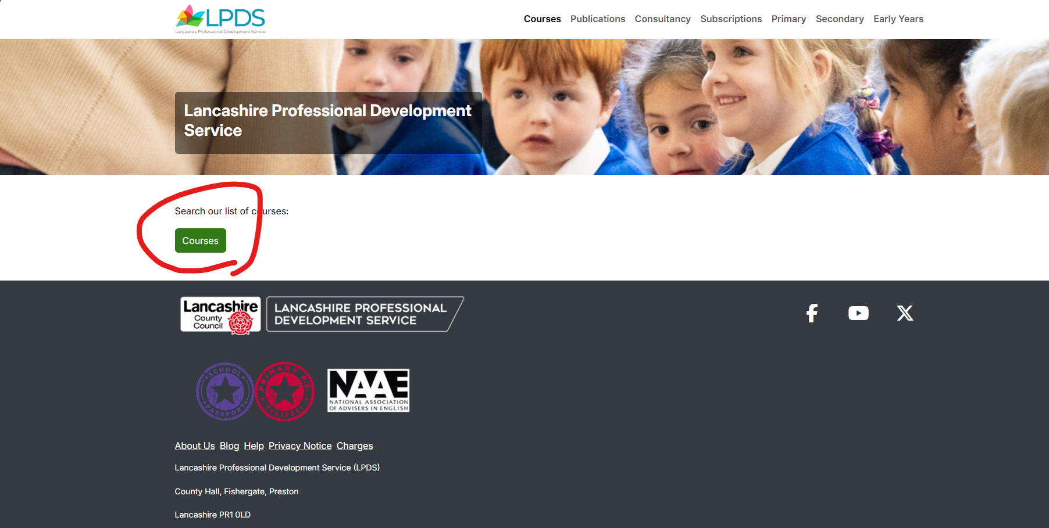
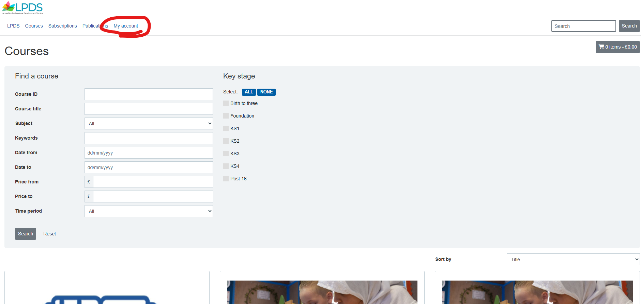
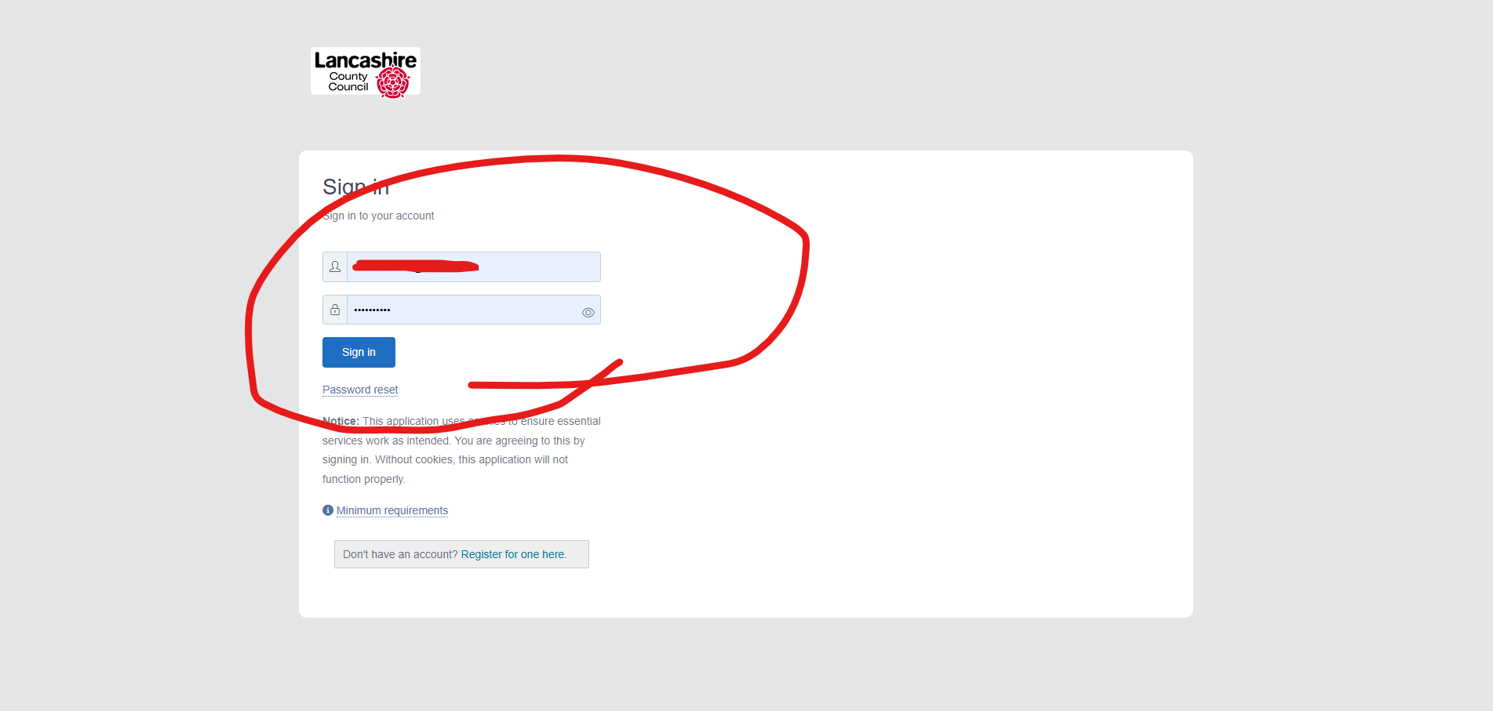
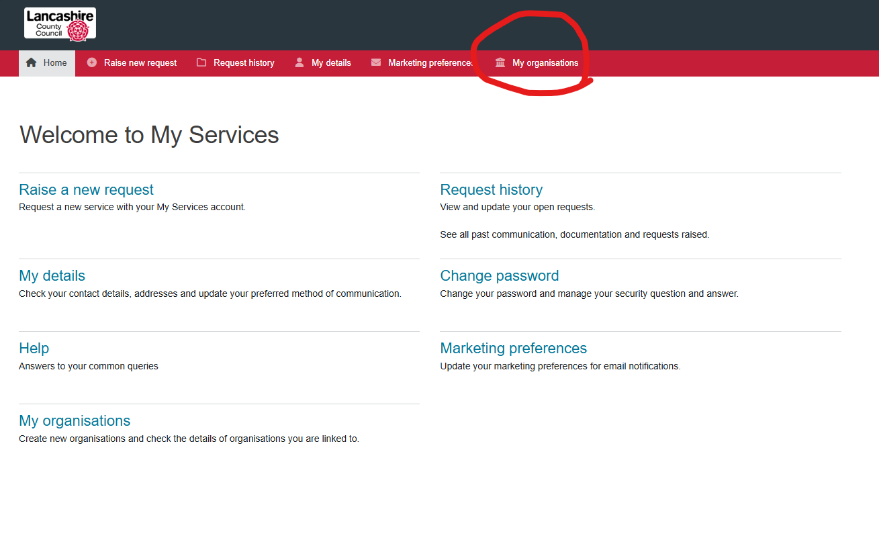
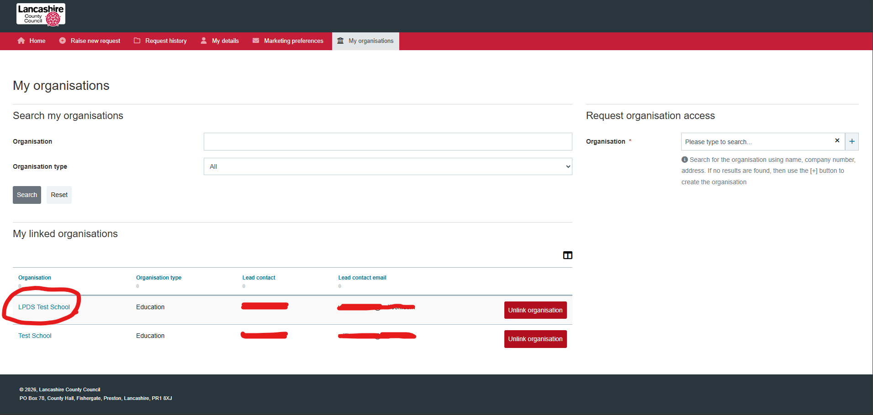
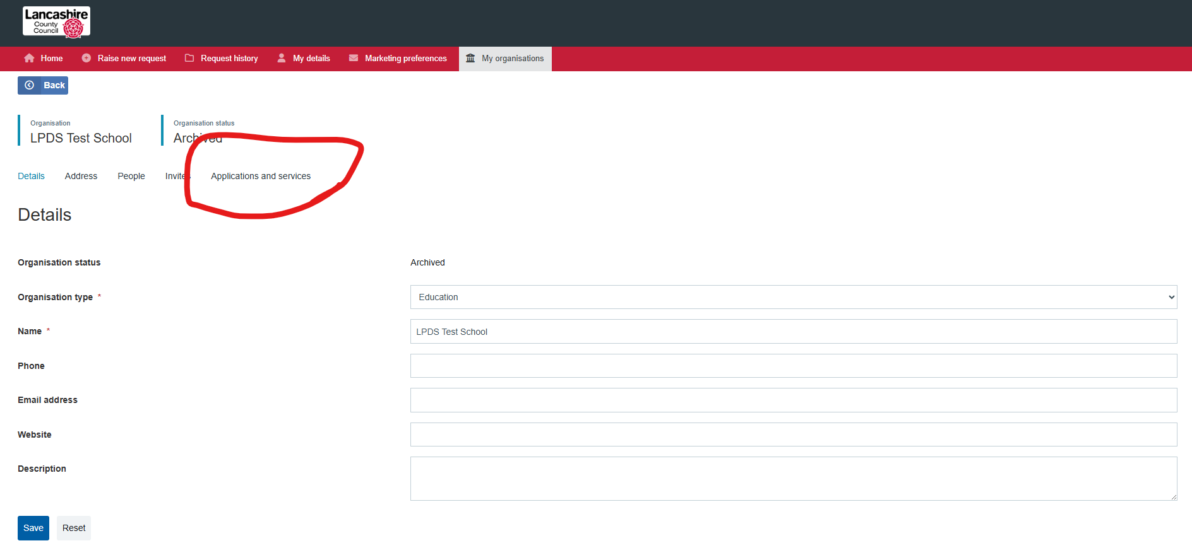
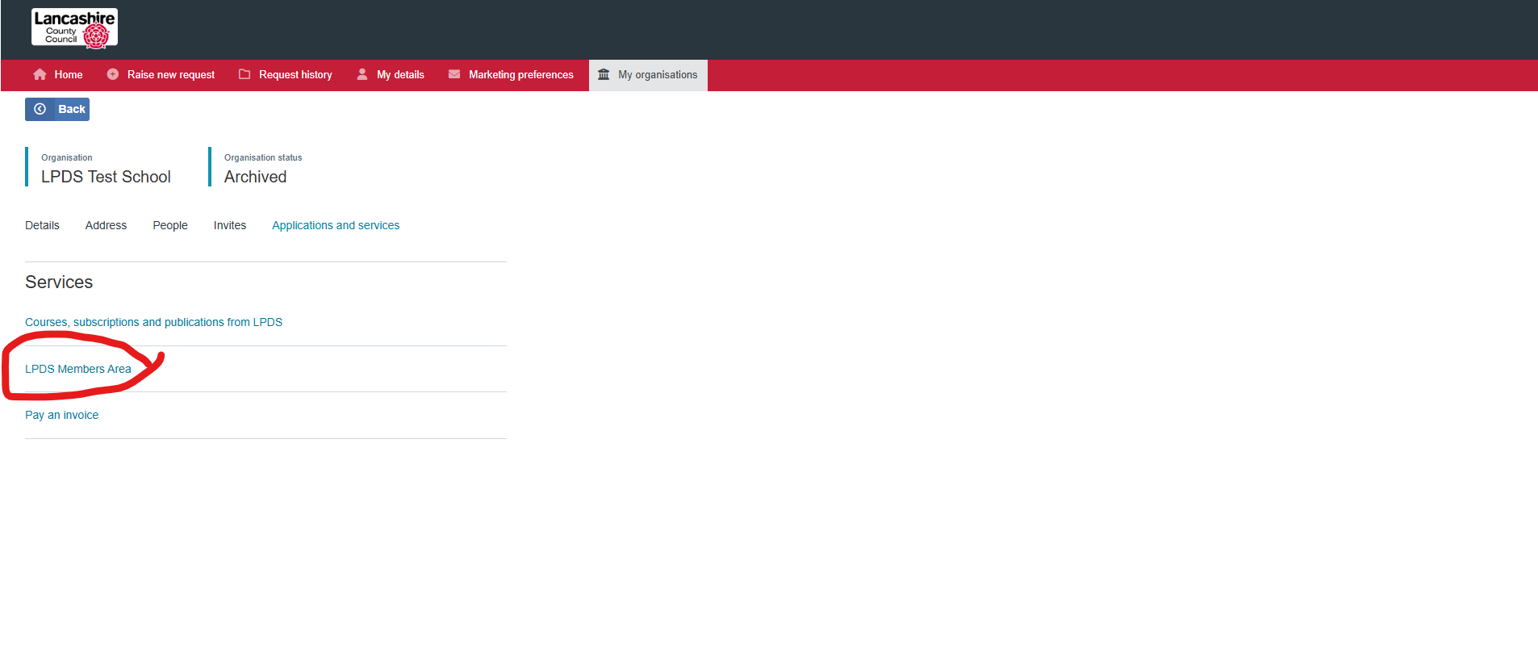
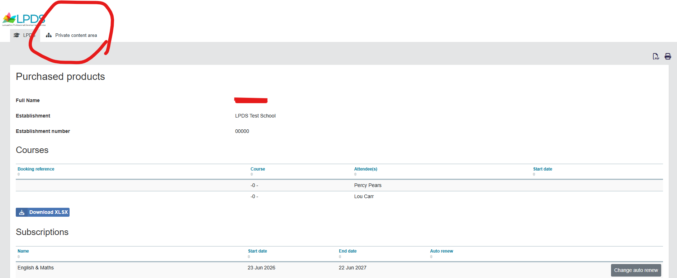
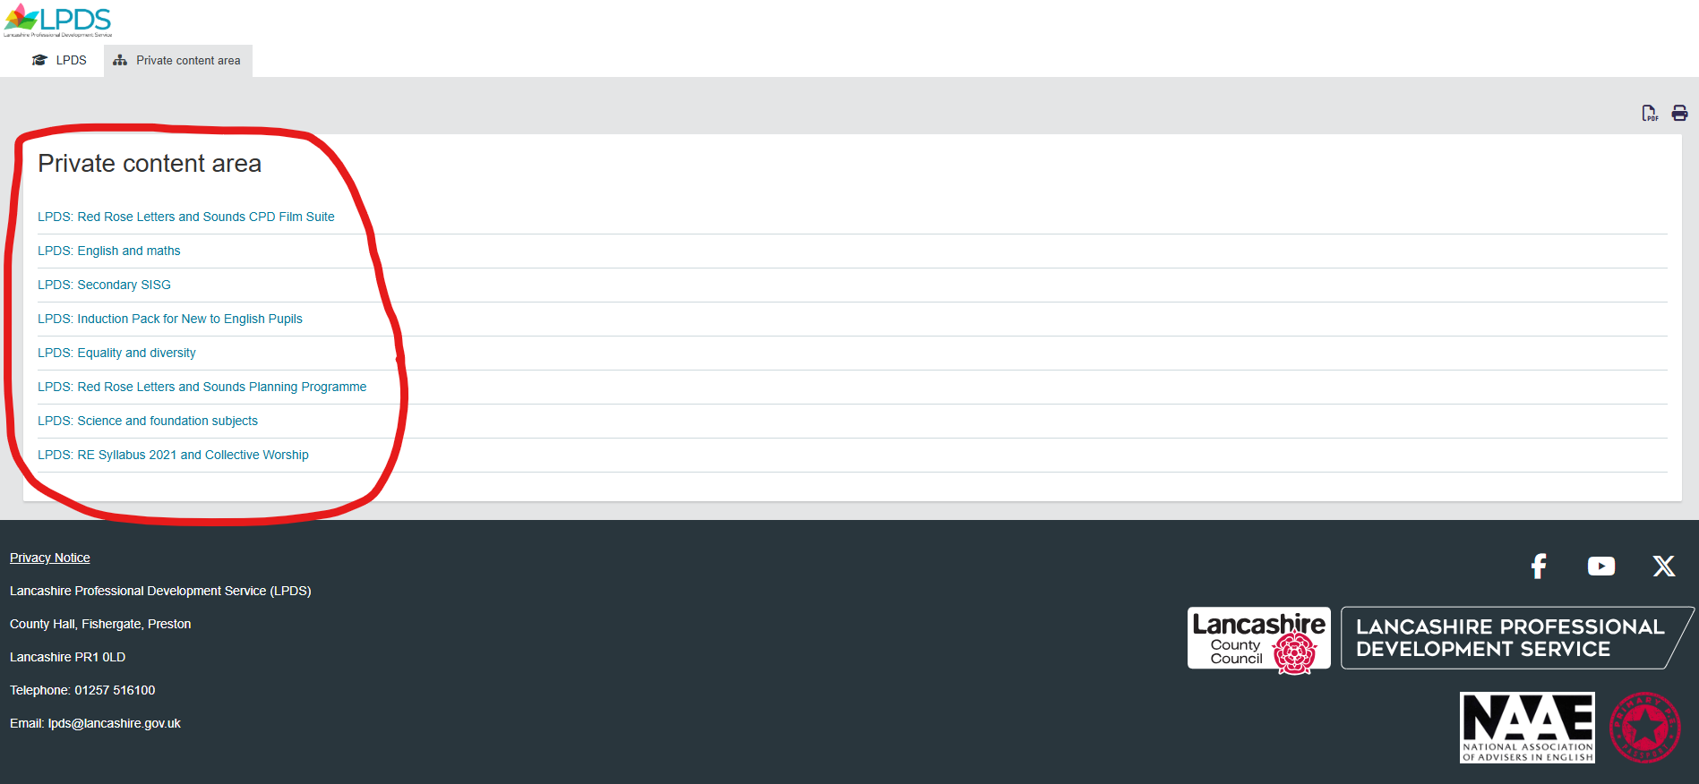

The user may also have to clear their internet history.

If a user is not connected to a school, they should request access by logging in (steps 1 – 3 above) and then selecting 'My Organisations'. If their organisation isn't listed, they should request organisation access in the box in the top right hand corner:
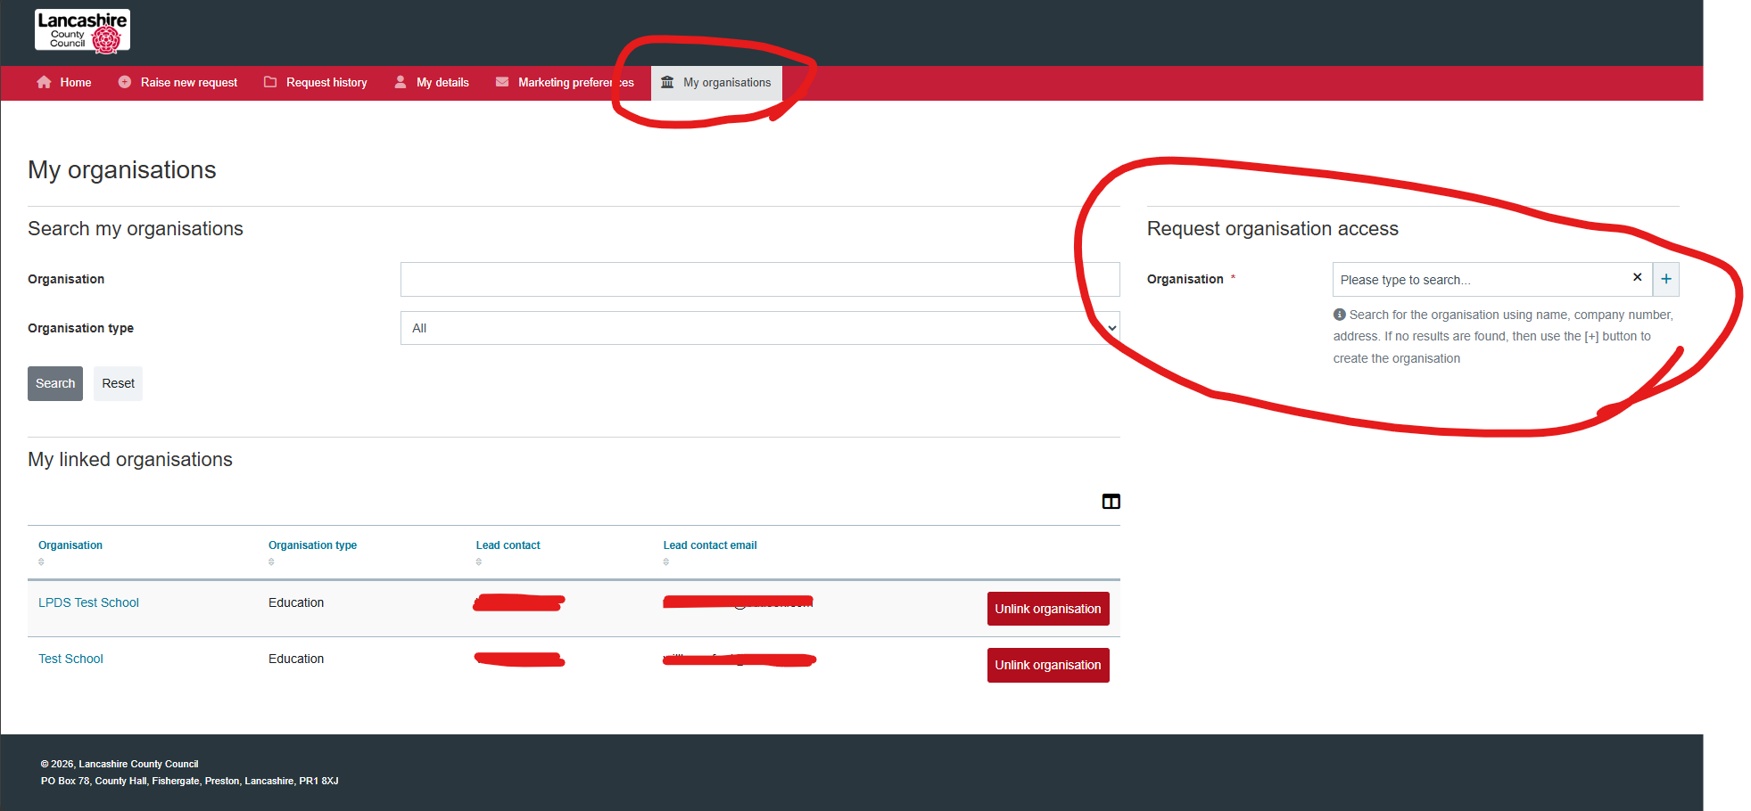
The administrator account from the previous version of the LPDS website are the ones who can grant access to an organisation, but these should have been carried across in migration of data from the previous system.

