



z

GET SMART


Join the fight against the spread of infection



An Outbreak Guide to G.E.R.M.S: Gastrointestinal Post-Infection Framework (PIF)
v1.0
Scan for more
Information

Or find us at:
Lancashire County Council – Infection Prevention & Control

Contents
Version Control Information 3
Chain of Infection 4
Line listing 5
Outbreak flow chart 8
Cleaning 9
Outbreak communication log 10
Outbreak reflection sheet 11
Post Infection Framework (PIF) 12
1. Overview of the Outbreak 12
2. Timeline of Events 12
3. Contributing Factors 12
4. What Went Well 12
5. Areas for Improvement 12
6. Action Plan 13
7. Staff & Resident Feedback 13
8. Lessons Learned 13
9. Next Steps 13
Example: Post Infection Framework (PIF) 14
1. Overview of the Outbreak 14
2. Timeline of Events 14
3. Contributing Factors 14
4. What Went Well 15
5. Areas for Improvement 15
6. Action Plan 15
7. Staff & Resident Feedback 15
8. Lessons Learned 15
9. Next Steps 15

Version Control Information
Title
Version number | v1.0
Document author(s) name and role title | Infection Prevention and Control Team
Document owner name and role title | Emma Dawson
Document approver name and role title | Tanya Shaw

Date of creation | 20/11/2025 | Review cycle | Annual
Last review | - | Next review date | 20/11/2026

Version | Date | Section/Reference | Amendment
1.0 | 20/11/2025 | Whole document | Document created

Chain of Infection

Please use the chain of infection below to help with your post infection framework for Gastrointestinal infections.
Have a look at each part of the chain and see what actions can be taken to break the chain to influence the management of future infections.
Break the Chain of Infection
*Staff education in IPC *Recognising symptoms

*Hand hygiene *Environmental cleaning. * IPC audits *Waste management

*PPE *Isolation *Hand hygiene *Food handling *Environmental and equipment cleaning
*Hand hygiene of staff and service users *Use soap and water if C. diff – alcohol gel does not kill C. diff spores
.
*Antibiotic stewardship *Nutrition and hydration

*Recognition of high-risk service users

Chain of Infection: Gastrointestinal

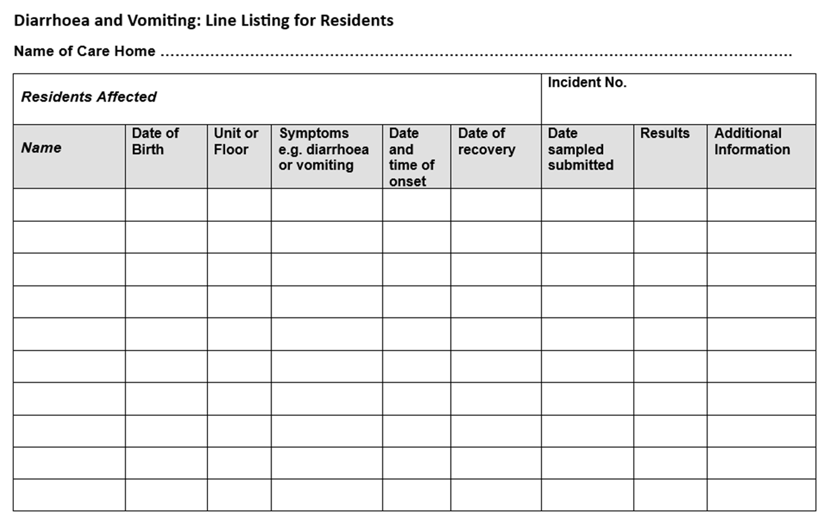
Line listing
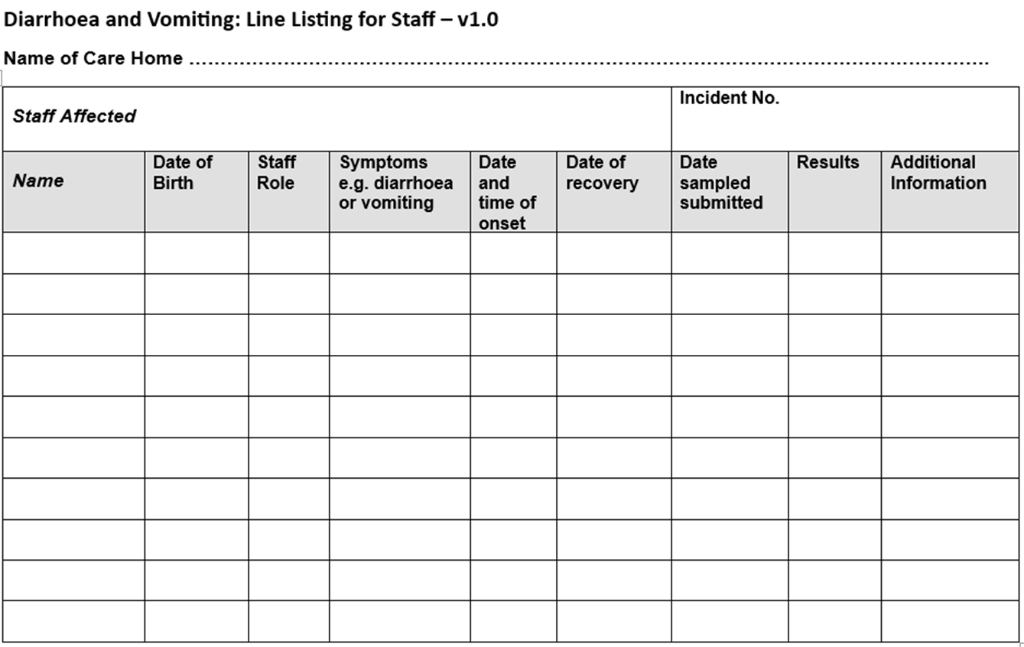
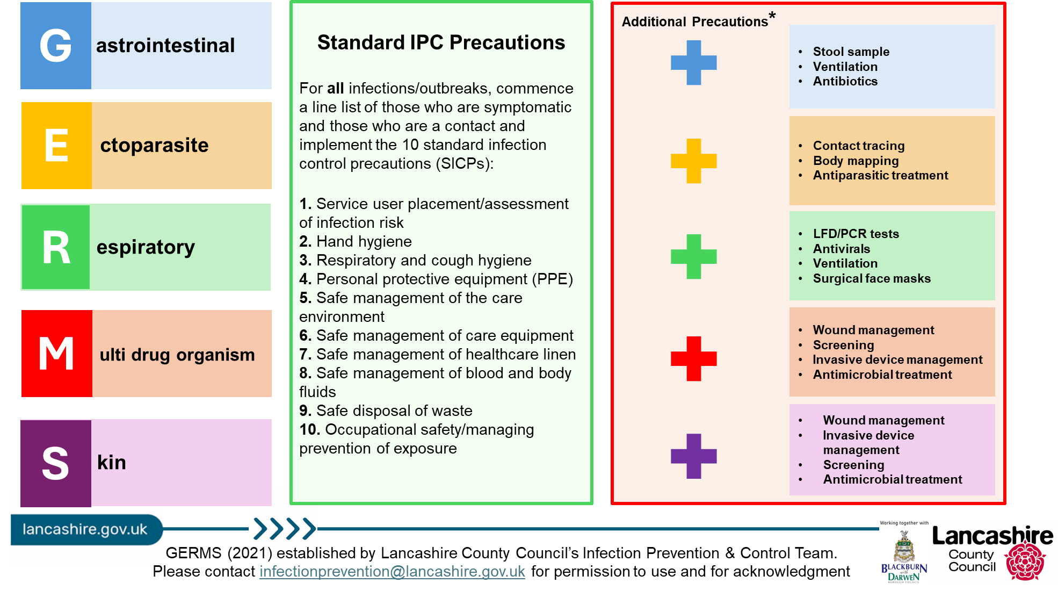

Outbreak flow chart

If an outbreak of diarrhoea and vomiting is suspected inform UKHSA and IPC team as they can offer support and advice

Minimise staff movement and footfall throughout the home where possible

Create a line listing of symptomatic residents and staff

Ensure clear communication regarding effective handwashing and use of PPE is covered in handovers/safety huddles

Isolate symptomatic residents until 48 hours symptom free
Staff must remain off work until they are 48 hours symptom free

Visiting and new admissions should be restricted to exceptional circumstances only (essential care givers and end of life).
Declutter the setting for easier cleaning, increase cleaning frequency using chlorine-based products

Treat waste as infectious and dispose if appropriately
Wash clothes and bedding separately to other laundry using red alginate bags

Stool samples to be obtained if advised to do so by UKHSA

A deep clean will be required once 48 hours clear of latest episode and before easing restrictions

Cleaning

Cleaning should be enhanced during an outbreak of diarrhoea and /or vomiting. Key control measures include increased frequency of cleaning, environmental disinfection and prompt clearance of soiling caused by vomit or faeces.
Effective cleaning and removal of organic soiling prior to decontamination is essential to maximise the effectiveness of surface disinfectants. Disinfection should be carried out with a solution of 0.1% sodium hypochlorite (1000 ppm available chlorine*) considering manufacturer’s guidance with regards to preparation, usage, contact times, storage, and disposal of unused solution.
Staff should wear appropriate protective clothing and follow standard infection control precautions. All communal areas: toilets and bathrooms and high touch points to be thoroughly cleaned at least three times daily.
The cleaning schedule should include all fittings, e.g., door handles, door frames, sinks, taps and handrails. Use disposable mops and cloths. National and local colour coding for PPE and cleaning equipment should be adhered to, to avoid cross contamination.
At the end of the outbreak (48hrs after all staff & residents have been symptom free) a ‘Terminal Clean’ must be undertaken. This is a thorough clean and disinfection of all areas before normal business resumes.
- All carpeted areas should be steam cleaned.
- All soft furnishings (curtains, cushions, and duvets) should be laundered, or steam cleaned, where fabrics allow.
- Radiator covers removed and behind radiators cleaned.
- Portable fans and extractor air fans cleaned.
- All surfaces including low, mid and high levels e.g., Door frames, picture frames and curtain rails.
- Any furniture that is soiled but cannot be cleaned should be discarded.

Outbreak communication log
To be updated daily and communicated to staff at handover

GERMS (see table below)
First case
Latest case
Total number of service users to date
Total number of staff to date
Units/floors/areas affected
Outbreak measures implemented (select all that apply - line listing, isolation, PPE, hand hygiene, limiting staff movement, notified visitors, testing, coordinating treatment, respiratory etiquette, ventilation, touch point cleaning, infectious laundry and linen processes, risk assessing admissions)
Any concerns? (severe illness, hospitalisation, deaths, delays in review/treatment, further supported/escalation needed)
Expected end date
End of outbreak cleaning arrangements
(estimated completion time, which staff are involved- internal/external)
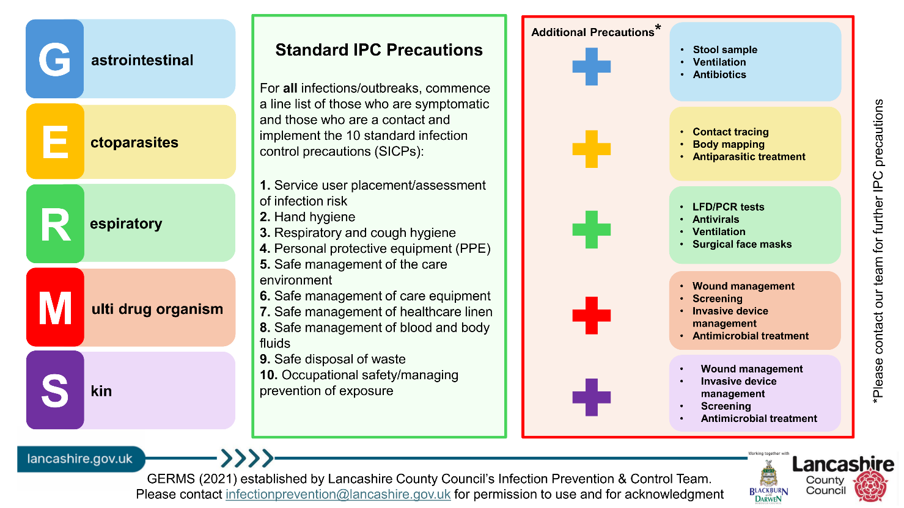

Outbreak reflection sheet

Use this sheet throughout the outbreak to record what went well and what could be improved. Share your findings with staff, service users and visitors.
Some things to consider:
- Was there prompt recognition and reporting of the outbreak?
- Effective communication throughout?
- Were outbreak measures followed by all staff, service users and visitors? (If not, why not? List barriers/solutions)
- Which staff members managed the outbreak? (include at evenings and weekends)
- Are staff confident on the chain of infection? (discussions to be had on return to work for any staff affected in the outbreak)

Post Infection Framework (PIF)

Residential Setting Name:
Date of Outbreak:
Review Date:
Lead of Outbreak Management:

1. Overview of the Outbreak
- Type of Infection:
- Number of Confirmed Cases:
- Affected Areas:
- Duration of Outbreak:
- Outcome:

2. Timeline of Events
Date | Event | Action Taken

3. Contributing Factors
- Environmental:
- Staffing:
- Compliance:
- Communication:

4. What Went Well

5. Areas for Improvement
- Infection prevention & control measures:
- Staff training & education:
- Communication:
- Monitoring & surveillance:

6. Action Plan
Action | Responsible | Deadline | Status

7. Staff & Resident Feedback
- Staff [Insert summary of feedback]:
- Residents/Families [Insert summary of feedback]:

8. Lessons Learned
- Outbreak protocol:
- Infection prevention & control measures:
- Staff training & education:
- Communication:
- Monitoring & surveillance:

9. Next Steps

Example: Post Infection Framework (PIF)

Residential Setting Name: Evergreen Grove
Number of Residents: 56
Number of Staff: 45
Names of Floors/Units: Floor 1, Floor 2, Floor 3
Date of Outbreak: 02/01/2025
Lead of Outbreak Management: Hilary Swane, registered manager

1. Overview of the Outbreak
- Type of Infection: Diarrhoea & vomiting
- Number of Confirmed Cases: 12
  - Residents: 9
  - Staff: 3
- Affected Areas: Floor 1 and Floor 2
- Agency Staff Used:
- Duration of Outbreak: 10 days
- Outcome: 1 resident hospitalised with dehydration

2. Timeline of Events
 | Date | Event |  |  | Action Taken
 | 01/01/2025 | First case identified in staff who had been working on floor 1 and floor 2 |  |  | Staff member sent home. Informed staff to monitor residents for signs & symptoms
 | 02/01/2025 | First resident became symptomatic on floor 1 - outbreak declared |  |  | Notification to LCC IPC Team and UKHSA
 | 03/01/2025 | IPC measures escalated |  |  | PPE, cohorting, restricted communal activities
 | 12/01/2025 | Outbreak resolved |  |  | Normal operations resumed

3. Contributing Factors
- Environmental: Shared bathrooms and dining areas
- Staffing: Staff movement between units, limited availability
- Compliance: Delay in increasing IPC precautions, including PPE usage
- Communication: Delay in reporting outbreak to LCC IPC & UKHSA

4. What Went Well
- Prompt isolation of symptomatic residents
- Staff dedication and teamwork

5. Areas for Improvement
- Infection prevention & control measures: Consistent use of PPE needed across all shifts and improved documentation of IPC measures
- Staff training & education: Regular refresher training on D&V outbreak protocols needed

6. Action Plan
Action | Responsible | Deadline | Status
- IPC refresher training | IPC lead | 01/03/2024 | Pending
- Review cohorting policy | Manager | 28/02/2024 | In progress
- Update outbreak protocol | Senior leadership team | 28/02/2024 | Completed

7. Staff & Resident Feedback
- Staff [Insert summary of feedback]: Felt supported but also overwhelmed with extra duties
- Residents/Families [Insert summary of feedback]: Appreciated updates but wanted more clarity

8. Lessons Learned
- Outbreak protocol: Importance of early detection and swift action
- Infection prevention & control measures: Reinforcement of hand hygiene and PPE protocols
- Staff training & education: Need for ongoing IPC education and drills
- Communication: Clear documentation and communication during outbreaks

9. Next Steps
- Schedule mock D&V outbreak drill
- Review IPC audit results
- Share findings with all staff and stakeholders
- Update IPC Annual Statement

References

PROCEDURE FOR THE MANAGEMENT OF AN OUTBREAK OF FOOD POISONING AND GASTRO-INTESTINAL ILLNESS

