


GET SMART
Join the fight against the spread of infection


An Outbreak Guide to G.E.R.M.S:
MDRO Post-Infection Framework (PIF)
v1.0





Scan for more
Information

Or find us at:
Lancashire County Council – Infection Prevention & Control

Contents
Version Control Information 3
Chain of Infection 4
Line listing 5
Key Points 7
Cleaning 8
Outbreak communication log 9
Outbreak reflection sheet 10
Post Infection Framework (PIF) 11
1. Overview of the Outbreak 11
2. Timeline of Events 11
3. Contributing Factors 11
4. What Went Well 11
5. Areas for Improvement 11
6. Action Plan 12
7. Staff & Resident Feedback 12
8. Lessons Learned 12
9. Next Steps 12
Example: Post Infection Framework (PIF) 13
1. Overview of the Outbreak 13
2. Timeline of Events 13
3. Contributing Factors 13
4. What Went Well 14
5. Areas for Improvement 14
6. Action Plan 14
7. Staff & Resident Feedback 14
8. Lessons Learned 14
9. Next Steps 14

Version Control Information
Title
Version number | v1.0
Document author(s) name and role title | Infection Prevention and Control Team
Document owner name and role title | Emma Dawson
Document approver name and role title | Tanya Shaw

Date of creation | 20/11/2025 | Review cycle | Annual
Last review | - | Next review date | 20/11/2026

Version | Date | Section/Reference | Amendment
1.0 | 20/11/2025 | Whole document | Document created

Chain of Infection

Please use the chain of infection below to help with your post infection framework for Multi-drug Resistant infections.
Have a look at each part of the chain and see what actions can be taken to break the chain to influence the management of future infections.
Break the Chain of Infection
*Staff education in IPC *Recognising symptoms

*Hand hygiene *Environmental cleaning *Catch it, bin it, kill it *Personal hygiene

*Environmental and equipment cleaning with appropriate cleaning products *hand hygiene *personal hygiene

*Cover cuts and wounds *Hand hygiene *Catheter care *Aseptic technique *Food hygiene
spores
.
*Prompt and appropriate treatment *Antibiotic stewardship
*Recognition of high-risk service users *Reducing contact of symptomatic

Chain of Infection: Multi-drug Resistant Organisms (MDRO)

Line listing
Resident Name | DOB | Room | Hospital admission date | Hospital discharge date | Multi-Drug-Resistant Organism (MDRO) | Site/Source | Treated? | Resolved?

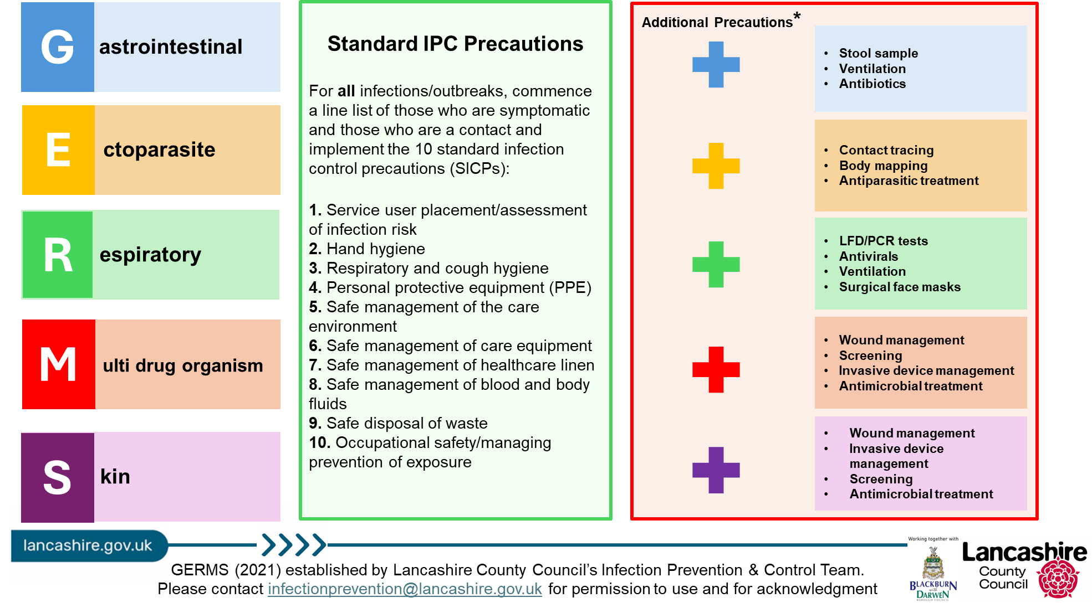

Key Points

Bacteria commonly achieve antibiotic resistance by producing an enzyme, beta-lactamase. This counters the effect of specific antibiotics
The genes that carry antibiotic resistance can spread to other bacteria and control of MDROs requires comprehensive infection control and antibiotic prescribing policies and stewardship
Many MDROs are likely to be passed on via the faecal oral route.
MDROs can cause urinary tract infections, pneumonia and surgical site infections. However, the majority of patients with MDROs are colonised which means bacteria are present, but they do not have symptoms of infection. MDROs are usually identified in stool and urine specimens. If the patient does not have active infection, i.e. they are colonised, antibiotic treatment is not required.
Patients who are colonised with a MDRO do not usually pose a risk to healthy people, but may be a risk to those who are vulnerable.
People at increased risk of being colonised or infected with a MDRO are: Those who in the last 12 months have:
Been an inpatient in any hospital, UK or abroad
Had multiple hospital treatments, e.g. dialysis, or have had cancer chemotherapy
Been previously identified as CPO positive (includes household and care home contacts of known cases)
Been admitted to a hospital augmented care or high-risk unit
Or:
Based on local epidemiology:
Are immunosuppressed

Cleaning

Managers should increase the frequency and intensity of cleaning for all areas, focusing on shared spaces and ensure appropriate linen and waste management systems are in place.
Clean surfaces and high touch areas frequently. Clean shared equipment between residents, e.g. hoists, aids, showers. If suspected or confirmed cases, all areas should be cleaned at least twice daily.
Locations where symptomatic residents have been staff should ensure correct PPE is worn appropriately.
At the end of the outbreak a ‘Terminal Clean’ must be undertaken. This is a thorough clean and disinfection of all areas before normal business resumes.
- All carpeted areas should be steam cleaned.
- All soft furnishings (curtains, cushions, and duvets) should be laundered, or steam cleaned, where fabrics allow.
- Radiator covers removed and behind radiators cleaned.
- Portable fans and extractor air fans cleaned.
- All surfaces including low, mid and high levels e.g., Door frames, picture frames and curtain rails.
- Any furniture that is soiled but cannot be cleaned should be discarded.

Outbreak communication log
To be updated daily and communicated to staff at handover

GERMS (see table below)
First case
Latest case
Total number of service users to date
Total number of staff to date
Units/floors/areas affected
Outbreak measures implemented (select all that apply - line listing, isolation, PPE, hand hygiene, limiting staff movement, notified visitors, testing, coordinating treatment, respiratory etiquette, ventilation, touch point cleaning, infectious laundry and linen processes, risk assessing admissions)
Any concerns? (severe illness, hospitalisation, deaths, delays in review/treatment, further supported/escalation needed)
Expected end date
End of outbreak cleaning arrangements
(estimated completion time, which staff are involved- internal/external)
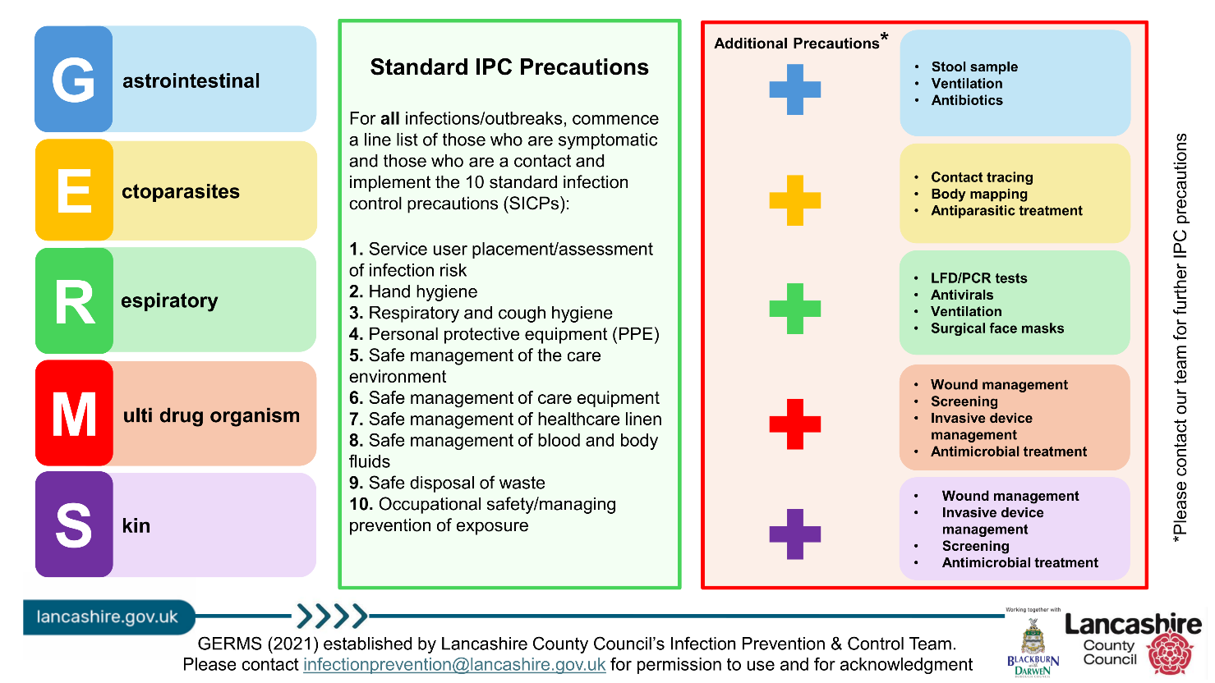

Outbreak reflection sheet

Use this sheet throughout the outbreak to record what went well and what could be improved. Share your findings with staff, service users and visitors.
Some things to consider:
- Was there prompt recognition and reporting of the outbreak?
- Effective communication throughout?
- Were outbreak measures followed by all staff, service users and visitors? (If not, why not? List barriers/solutions)
- Which staff members managed the outbreak? (include at evenings and weekends)
- Are staff confident on the chain of infection? (discussions to be had on return to work for any staff affected in the outbreak)

Post Infection Framework (PIF)

Residential Setting Name:
Date of Outbreak:
Review Date:
Lead of Outbreak Management:

1. Overview of the Outbreak
- Type of Infection:
- Number of Confirmed Cases:
- Affected Areas:
- Duration of Outbreak:
- Outcome:

2. Timeline of Events
Date | Event | Action Taken

3. Contributing Factors
- Environmental:
- Staffing:
- Compliance:
- Communication:

4. What Went Well

5. Areas for Improvement
- Infection prevention & control measures:
- Staff training & education:
- Communication:
- Monitoring & surveillance:

6. Action Plan
Action | Responsible | Deadline | Status

7. Staff & Resident Feedback
- Staff [Insert summary of feedback]:
- Residents/Families [Insert summary of feedback]:

8. Lessons Learned
- Outbreak protocol:
- Infection prevention & control measures:
- Staff training & education:
- Communication:
- Monitoring & surveillance:

9. Next Steps

Example: Post Infection Framework (PIF)

Residential Setting Name: Evergreen Grove
Number of Residents: 56
Number of Staff: 45
Names of Floors/Units: Floor 1, Floor 2, Floor 3
Date of Outbreak: 02/01/2025
Lead of Outbreak Management: Hilary Swane, registered manager

1. Overview of the Outbreak
- Type of Infection: MRSA
- Number of Confirmed Cases: 1
  - Residents: 1
  - Staff: 0
- Affected Areas: Floor 3
- Agency Staff Used: No
- Duration of Incident/Outbreak: 5 days
- Outcome: MRSA incident resolved

2. Timeline of Events
 | Date | Event |  |  | Action Taken
 | 15/04/2025 | First case identified |  |  | Isolation and contact precautions were initiated.  LCC IPC Team notified.

3. Contributing Factors
- Environmental: Shared equipment
- Staffing: Limited MDRO awareness
- Communication: Unclear escalation process

4. What Went Well
- Prompt isolation and implementation of contact precautions
- Effective collaboration with microbiology and IPC teams
- Staff responsiveness and adherence to enhanced cleaning protocols
- Timely communication with families and stakeholders

5. Areas for Improvement
- Staff training: Improved antimicrobial stewardship practices
- Staff training: Refresher training on MDRO management

6. Action Plan
Action | Responsible | Deadline | Status
- MDRO training for staff | Manager | 01/06/2024 | Completed

7. Staff & Resident Feedback
- Staff [Insert summary of feedback]: Felt supported but requested more MDRO-specific training

8. Lessons Learned
- Infection prevention & control measures: Importance of early detection and isolation
- Communication: Value of clear documentation and communication
- Staff training: Reinforcement of antimicrobial stewardship and hygiene protocols
- Staff training: Need for ongoing education on MDRO risks and prevention

9. Next Steps
- Schedule MDRO awareness training
- Conduct audit of antimicrobial usage and IPC practices
- Share findings with all staff and stakeholders
- Update IPC Annual Statement

References

Management of acute respiratory infection outbreaks in care homes guidance - GOV. UK

