



Join the fight against the spread of infection
GET SMART
An Outbreak Guide to G.E.R.M.S: Ectoparasites Post-Infection Framework (PIF)
v1.0





Scan for more
Information

Or find us at:
Lancashire County Council – Infection Prevention & Control

Contents
Version Control Information 3
Chain of Infection 4
Line listing 5
Outbreak flow chart 8
Cleaning 9
Outbreak communication log 11
Outbreak reflection sheet 12
Post Infection Framework (PIF) 13
1. Overview of the Outbreak 13
2. Timeline of Events 13
3. Contributing Factors 13
4. What Went Well 13
5. Areas for Improvement 13
6. Action Plan 14
7. Staff & Resident Feedback 14
8. Lessons Learned 14
9. Next Steps 14
Example: Post Infection Framework (PIF) 15
1. Overview of the Outbreak 15
2. Timeline of Events 15
3. Contributing Factors 15
4. What Went Well 15
5. Areas for Improvement 16
6. Action Plan 16
7. Staff & Resident Feedback 16
8. Lessons Learned 16
9. Next Steps 16

Version Control Information
Title
Version number | v1.0
Document author(s) name and role title | Infection Prevention and Control Team
Document owner name and role title | Emma Dawson
Document approver name and role title | Tanya Shaw

Date of creation | 20/11/2025 | Review cycle | Annual
Last review | - | Next review date | 20/11/2026

Version | Date | Section/Reference | Amendment
1.0 | 20/11/2025 | Whole document | Document created

Chain of Infection

Please use the chain of infection below to help with your post infection framework for Ectoparasite infections.
Have a look at each part of the chain and see what actions can be taken to break the chain to influence the management of future infections.
Chain of Infection: Ectoparasites
Break the Chain of Infection
*Staff education in IPC *Recognising symptoms

*Hand hygiene *Environmental cleaning. *Ensuring service users have their own personal items.

*Social distancing *Environmental and equipment cleaning *Non-sharing of hairbrushes, hats and scarves.
*Washing bedding, communal cushions, towels and clothing. *Increasing hoovering of the setting.
*Notifying visitors of the problem. *Prompt and appropriate treatment.
Social distancing of visitors. Reducing contact of symptomatic residents/visitors.
Notifying visitors of the problem.

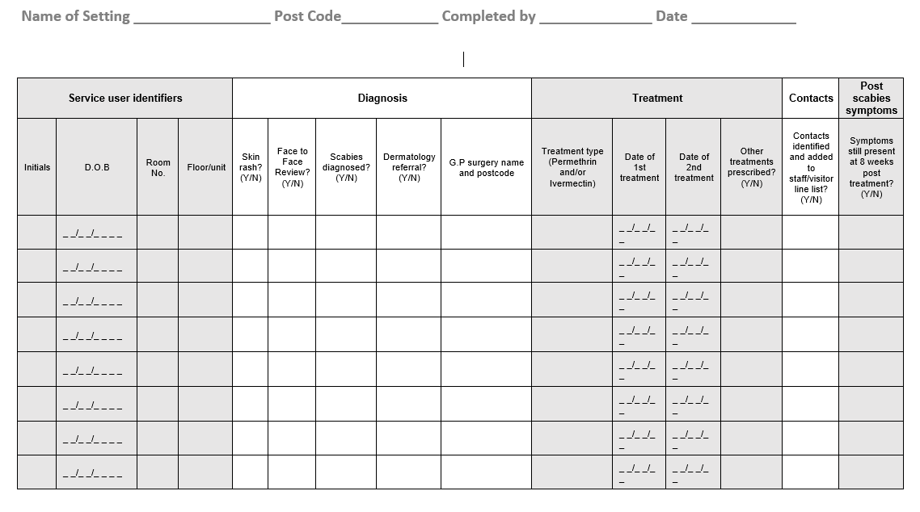
Line listing
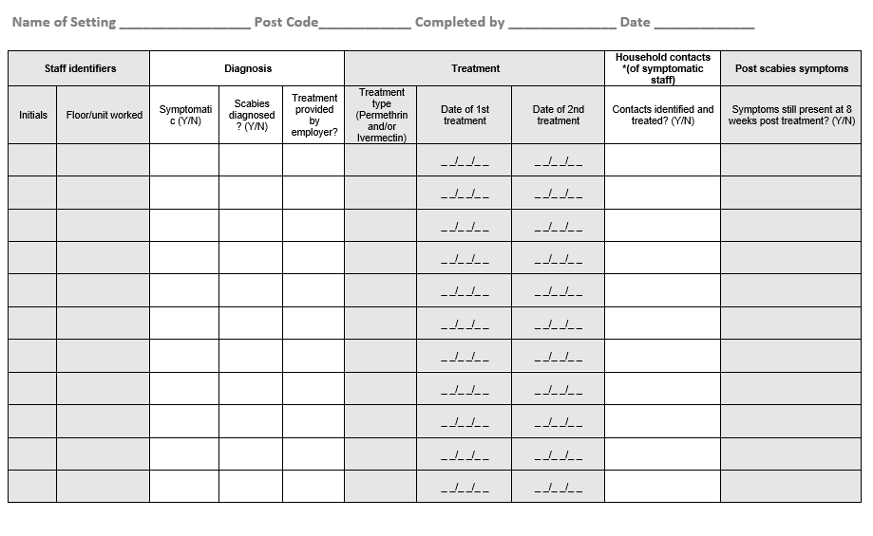
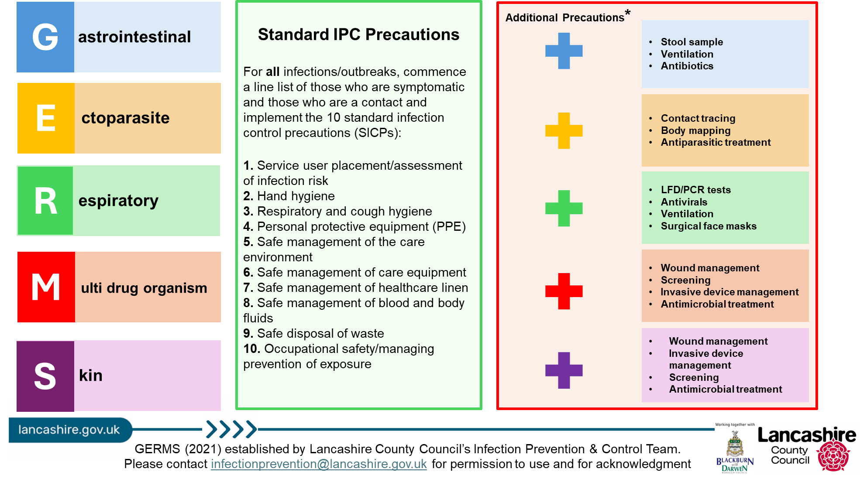

Outbreak flow chart

Diagnosis to be made/confirmed by GP or dermatologist – ideally face to face appointment
Cleaning

Create a line listing of confirmed, suspected, exposed (Contact tracing) and treated cases

Classical

Ensure the service user/staff member has a prescription for treatment (Permethrin, Ivermectin or both)
Normal daily cleaning regimen is sufficient to remove skin scales from the environment, but daily vacuuming is recommended until 3 days after first treatment

If treatment for contacts is taking time to co-ordinate treat diagnosed/symptomatic cases first
Crusted

Ensure contact treatment is co-ordinated
Daily vacuuming until 7 days after treatment.
Deep clean after treatment cycles (for example steam cleaning soft furnishings, cleaning touch points, vacuuming mattresses and so on)

Clothing and personal textiles which have been worn or handled by individuals being treated as cases or contacts in the week before, or at any time up to 24 hours from starting first treatment dose, need to be cleaned

Cleaning

The aim of cleaning in the event of a case or outbreak of scabies is to remove skin scales and dust in the environment. The role of fomites in transmission of scabies is unclear; however, mites are very unlikely to survive without a host long enough to infest a new person. For clinical scabies cases and outbreaks, the normal cleaning regimen (cleaning with warm water and a PH neutral detergent) will be sufficient to remove skin scales from the environment. For crusted scabies, more regular vacuuming and a deep clean after treatment cycles (for example, damp dusting soft furnishings, cleaning touch points, vacuuming mattresses should be considered due to the increased shedding of skin associated with this form of scabies.
- Clinical scabies cases and outbreaks
  - Normal daily cleaning regimen is sufficient to remove skin scales from the environment, but daily vacuuming is recommended until 3 days after first treatment.
- Crusted scabies cases (increased skin shedding)
  - Daily vacuuming until 7 days after treatment.
  - Deep clean after treatment cycles (for example steam cleaning soft furnishings, cleaning touch points, vacuuming mattresses and so on).

Outbreak communication log
To be updated daily and communicated to staff at handover

GERMS (see table below)
First case
Latest case
Total number of service users to date
Total number of staff to date
Units/floors/areas affected
Outbreak measures implemented (select all that apply - line listing, isolation, PPE, hand hygiene, limiting staff movement, notified visitors, testing, coordinating treatment, respiratory etiquette, ventilation, touch point cleaning, infectious laundry and linen processes, risk assessing admissions)
Any concerns? (severe illness, hospitalisation, deaths, delays in review/treatment, further supported/escalation needed)
Expected end date
End of outbreak cleaning arrangements
(estimated completion time, which staff are involved- internal/external)
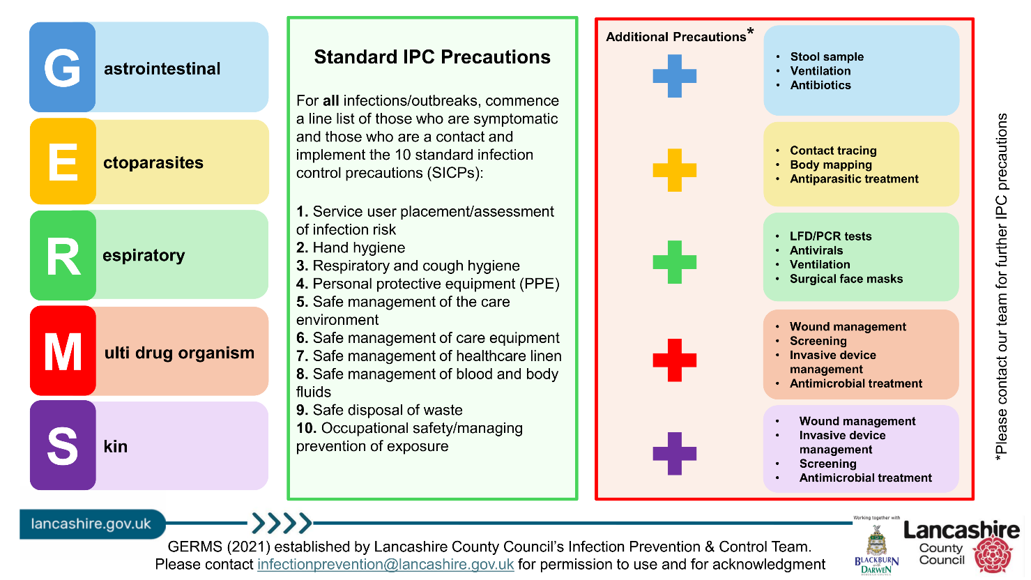

Outbreak reflection sheet

Use this sheet throughout the outbreak to record what went well and what could be improved. Share your findings with staff, service users and visitors.
Some things to consider:
- Was there prompt recognition and reporting of the outbreak?
- Effective communication throughout?
- Were outbreak measures followed by all staff, service users and visitors? (If not, why not? List barriers/solutions)
- Which staff members managed the outbreak? (include at evenings and weekends)
- Are staff confident on the chain of infection? (discussions to be had on return to work for any staff affected in the outbreak)

Post Infection Framework (PIF)

Residential Setting Name:
Date of Outbreak:
Review Date:
Lead of Outbreak Management:

1. Overview of the Outbreak
- Type of Infection:
- Number of Confirmed Cases:
- Affected Areas:
- Duration of Outbreak:
- Outcome:

2. Timeline of Events
Date | Event | Action Taken
 | asdasd

3. Contributing Factors
- Environmental:
- Staffing:
- Compliance:
- Communication:

4. What Went Well

5. Areas for Improvement
- Infection prevention & control measures:
- Staff training & education:
- Communication:
- Monitoring & surveillance:

6. Action Plan
Action | Responsible | Deadline | Status

7. Staff & Resident Feedback
- Staff [Insert summary of feedback]:
- Residents/Families [Insert summary of feedback]:

8. Lessons Learned
- Outbreak protocol:
- Infection prevention & control measures:
- Staff training & education:
- Communication:
- Monitoring & surveillance:

9. Next Steps

Example: Post Infection Framework (PIF)

Residential Setting Name: Evergreen Grove
Number of Residents: 56
Number of Staff: 45
Names of Floors/Units: Floor 1, Floor 2, Floor 3
Date of Outbreak: 10/10/2025
Lead of Outbreak Management: Hilary Swane, registered manager

1. Overview of the Outbreak

Type of Infection: Scabies

Number of Confirmed Cases: 5

Residents: 5

Staff: 0

Affected Areas: Whole home

Agency Staff Used: Not during outbreak but used in the 8 week incubation period

Duration of Outbreak: 17 days

Outcome: Whole home treated with Permethrin

2. Timeline of Events
 | Date | Event |  |  | Action Taken
 | 08/10/2025 | First case diagnosed in a resident on floor 3. |  |  | GP asked to review resident
 | 10/10/2025 | Body mapping commenced for all other residents and 4 other service users had a rash, 2 on floor 3 and 2 on floor 2. |  |  | GP came to review and diagnosed scabies. Asked GP to prescribe treatment for all contacts too.
 | 11/10/2025 | IPC advice received. |  |  | LCC IPC team informed, and advice given on line listing, environmental cleaning, laundry protocols, PPE, cohorting, & treatment application
 | 12/10/2025 | Treatment received for all service users and staff |  |  | Treatment allocated to all service users and staff, including agency staff
 | 14/10/2025 | Whole home treatment carried out on service users. |  |  | Staff asked to treat at home on the same day, and treatment allocated to each staff member
 | 21/10/2025 | Second application of treatment applied to all residents and treatment given to staff to treat at home |  |  | Extra staff rostered on duty to help apply the second treatment to residents

3. Contributing Factors
- Staffing: Agency staff used in the 8 weeks prior to the first case being identified
- Compliance: Second treatment applied 1 day too early

4. What Went Well
- Prompt identification and isolation of affected individuals
- Staff dedication and teamwork
- Effective coordination with external health services

5. Areas for Improvement
- Infection prevention & control measures: Inconsistent laundering of linens and clothing
- Staff training & education: Limited staff training on ectoparasite management
- Communication: Second treatment was given a day too early – should have been 7 full days between the 2 treatment dates

6. Action Plan
Action | Responsible | Deadline | Status
- Staff training on ectoparasites | IPC lead | 01/01/2026 | Pending
- Review scabies treatment guidance | Manager | 01/12/2024 | In progress
- Review laundry protocols | Senior leadership team | 01/12/2024 | Completed

7. Staff & Resident Feedback
- Staff [Insert summary of feedback]: Overwhelmed with extra duties – applying treatment and extra laundry
- Residents/Families [Insert summary of feedback]: Concerned about privacy and comfort during treatment

8. Lessons Learned
- Outbreak protocol: Importance of early symptom recognition
- Infection prevention & control measures: Reinforcement of laundering practices
- Staff training & education: Need for training/education on ectoparasites
- Communication: Clear documentation and communication during outbreaks

9. Next Steps
- Schedule ectoparasite awareness training
- Conduct laundry audits
- Share findings with all staff and stakeholders
- Update IPC Annual Statement

References

UKHSA guidelines for the management of scabies cases and outbreaks in communal residential settings - GOV.UK

