



GET SMART


Join the fight against the spread of infection





An Outbreak Guide to G.E.R.M.S:
Skin Post-Infection Framework (PIF)
v1.0
Scan for more
Information

Or find us at:
Lancashire County Council – Infection Prevention & Control

Contents
Version Control Information 3
Chain of Infection 4
Line listing 5
Outbreak flow chart 7
Cleaning 8
Outbreak communication log 9
Outbreak reflection sheet 10
Post Infection Framework (PIF) 11
1. Overview of the Outbreak 11
2. Timeline of Events 11
3. Contributing Factors 11
4. What Went Well 11
5. Areas for Improvement 11
6. Action Plan 12
7. Staff & Resident Feedback 12
8. Lessons Learned 12
9. Next Steps 12
Example: Post Infection Framework (PIF) 13
1. Overview of the Outbreak 13
2. Timeline of Events 13
3. Contributing Factors 13
4. What Went Well 14
5. Areas for Improvement 14
6. Action Plan 14
7. Staff & Resident Feedback 14
8. Lessons Learned 14
9. Next Steps 14

Version Control Information
Title
Version number | v1.0
Document author(s) name and role title | Infection Prevention and Control Team
Document owner name and role title | Emma Dawson
Document approver name and role title | Tanya Shaw

Date of creation | 20/11/2025 | Review cycle | Annual
Last review | - | Next review date | 20/11/2026

Version | Date | Section/Reference | Amendment
1.0 | 20/11/2025 | Whole document | Document created

Chain of Infection

Please use the chain of infection below to help with your post infection framework for skin infections.
Have a look at each part of the chain and see what actions can be taken to break the chain to influence the management of future infections.
Break the Chain of Infection
*Staff education in IPC *Recognising symptoms

*Hand hygiene *Environmental cleaning *Catch it, bin it, kill it *Personal hygiene *Bare below the elbow

*Environmental and equipment cleaning with appropriate cleaning products *hand hygiene *personal hygiene

*Cover cuts and wounds *Hand hygiene *Catheter care *Aseptic technique *Food hygiene
spores
.
*Prompt and appropriate treatment *Antibiotic stewardship

*Recognition of high-risk service users *Reducing contact of symptomatic residents

Chain of Infection: Skin

Line listing
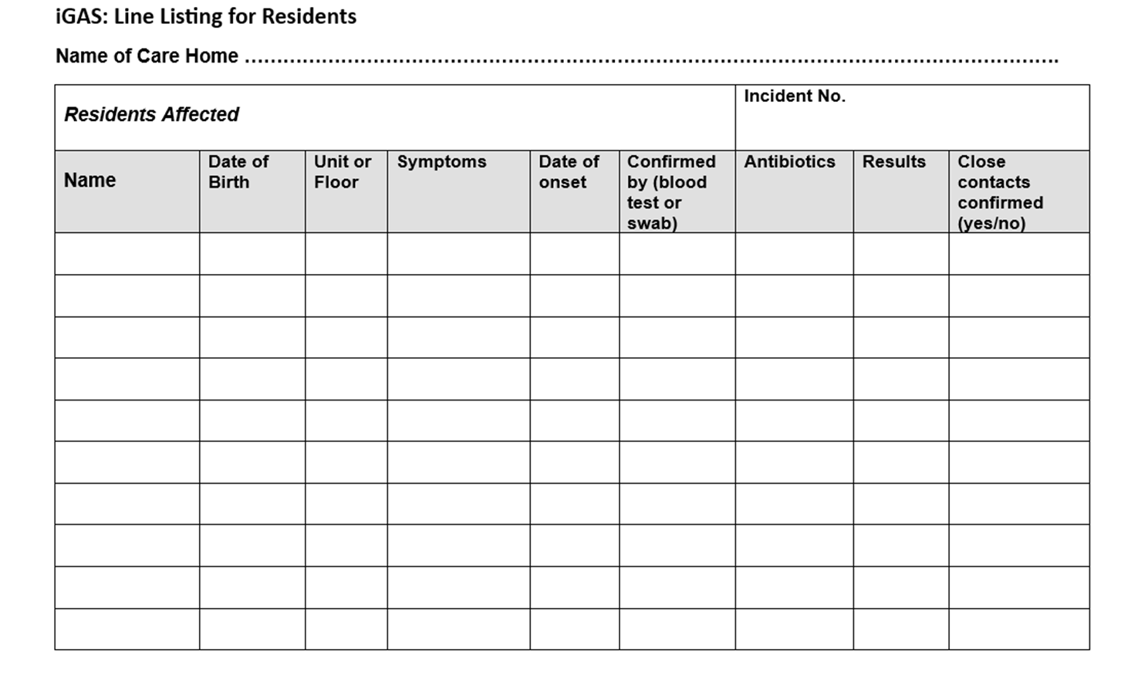
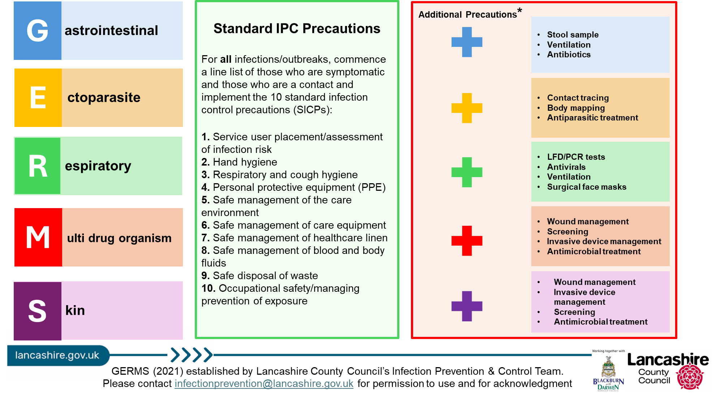

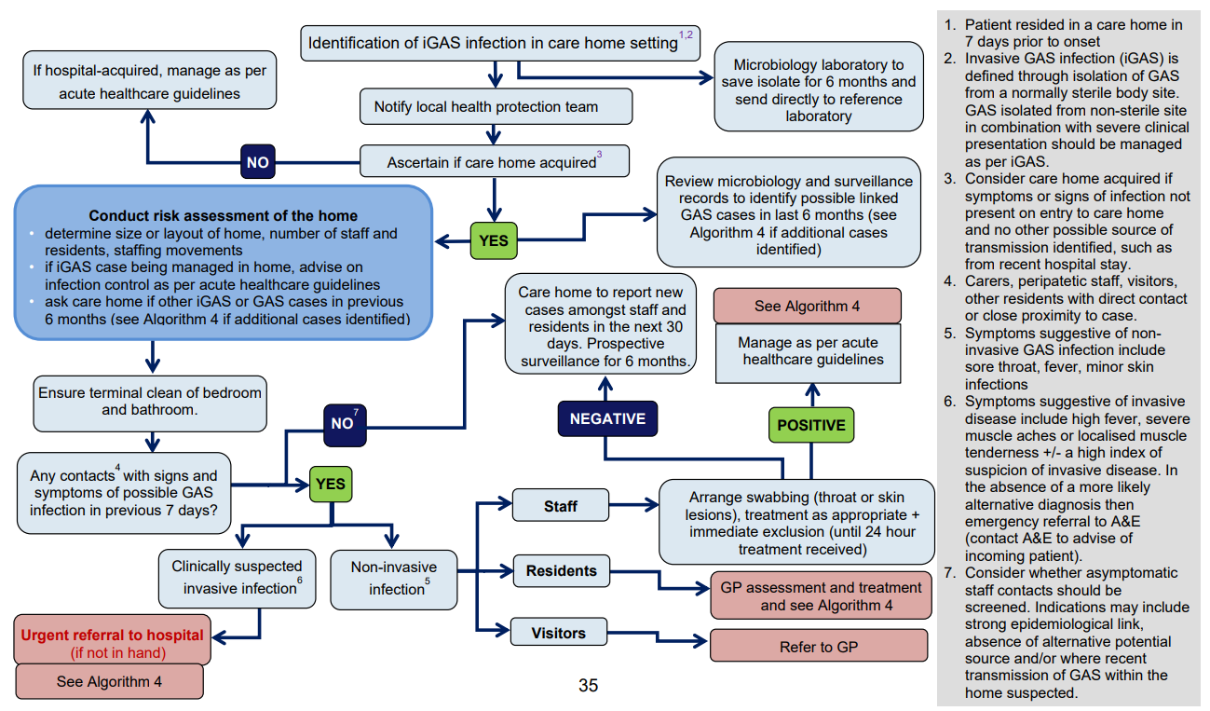
Outbreak flow chart
UKHSA will be leading on iGAS incidents/outbreaks and will support the setting throughout

Cleaning

The environment can play a significant part in transmission as GAS can be found to remain in dust as well as on furniture and equipment.
Keep surfaces clear of unnecessary equipment and ornaments to allow thorough cleaning to occur.
As a minimum recommendation, detergent and water followed by hypochlorite at 1,000 ppm of available chlorine or a combined product, should be used for cleaning and disinfection of equipment and hard surfaces, including commodes and hoists.
Where possible, hoist slings, patient clothing, towels, bed linen, curtains, carpets and rugs should be cleaned and disinfected using a validated laundry process.
Whilst a resident is considered infectious, their clothing, linen and waste must be handled as hazardous. For linen and other laundry items this means they should be sealed in a dissolvable or soluble seam bag, before being removed from the room, avoiding contamination of surfaces by minimising shaking and not putting contaminated linen down on any environmental surface.
Items in dissolvable or soluble seam laundry bags should be loaded directly into a washer-extractor without additional handling or sorting.
A terminal clean will be required if the event of an outbreak.

Outbreak communication log
To be updated daily and communicated to staff at handover

GERMS (see table below)
First case
Latest case
Total number of service users to date
Total number of staff to date
Units/floors/areas affected
Outbreak measures implemented (select all that apply - line listing, isolation, PPE, hand hygiene, limiting staff movement, notified visitors, testing, coordinating treatment, respiratory etiquette, ventilation, touch point cleaning, infectious laundry and linen processes, risk assessing admissions)
Any concerns? (severe illness, hospitalisation, deaths, delays in review/treatment, further supported/escalation needed)
Expected end date
End of outbreak cleaning arrangements
(estimated completion time, which staff are involved- internal/external)
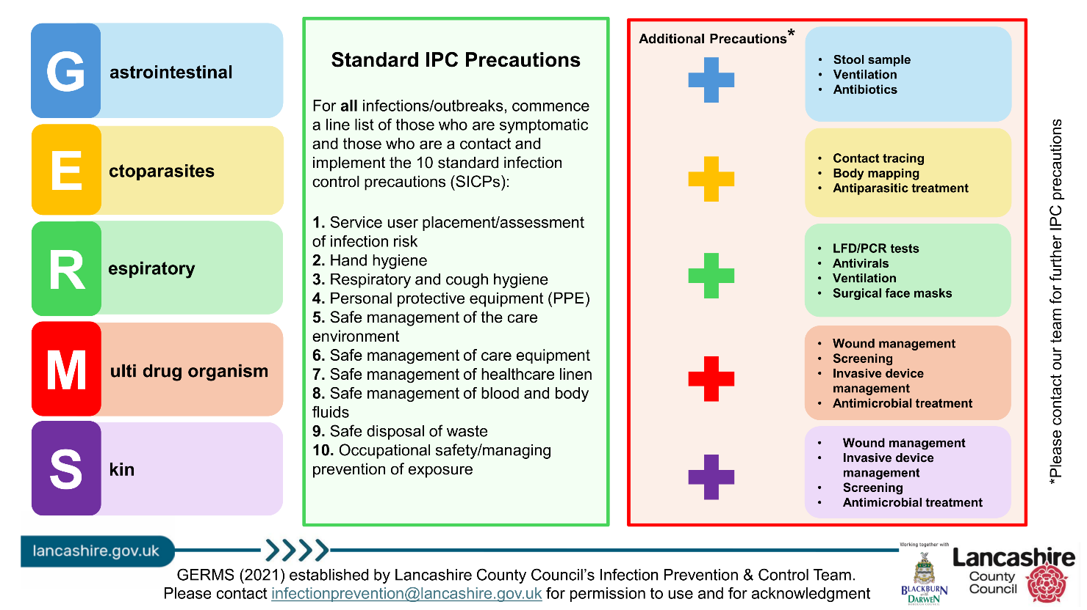

Outbreak reflection sheet

Use this sheet throughout the outbreak to record what went well and what could be improved. Share your findings with staff, service users and visitors.
Some things to consider:
- Was there prompt recognition and reporting of the outbreak?
- Effective communication throughout?
- Were outbreak measures followed by all staff, service users and visitors? (If not, why not? List barriers/solutions)
- Which staff members managed the outbreak? (include at evenings and weekends)
- Are staff confident on the chain of infection? (discussions to be had on return to work for any staff affected in the outbreak)

Post Infection Framework (PIF)

Residential Setting Name:
Date of Outbreak:
Review Date:
Lead of Outbreak Management:

1. Overview of the Outbreak
- Type of Infection:
- Number of Confirmed Cases:
- Affected Areas:
- Duration of Outbreak:
- Outcome:

2. Timeline of Events
Date | Event | Action Taken

3. Contributing Factors
- Environmental:
- Staffing:
- Compliance:
- Communication:

4. What Went Well

5. Areas for Improvement
- Infection prevention & control measures:
- Staff training & education:
- Communication:
- Monitoring & surveillance:

6. Action Plan
Action | Responsible | Deadline | Status

7. Staff & Resident Feedback
- Staff [Insert summary of feedback]:
- Residents/Families [Insert summary of feedback]:

8. Lessons Learned
- Outbreak protocol:
- Infection prevention & control measures:
- Staff training & education:
- Communication:
- Monitoring & surveillance:

9. Next Steps

Example: Post Infection Framework (PIF)

Residential Setting Name: Evergreen Grove
Number of Residents: 56
Number of Staff: 45
Names of Floors/Units: Floor 1, Floor 2, Floor 3
Date of Outbreak: 02/01/2025
Lead of Outbreak Management: Hilary Swane, registered manager

1. . Overview of the Outbreak
- Type of Infection: Cellulitis
- Number of Confirmed Cases: 2
  - Residents: 2
  - Staff: 0
- Affected Areas: Floor 2
- Agency Staff Used: No
- Duration of Outbreak: 13 days
- Outcome: 1 resident hospitalised with sepsis

2. Timeline of Events
 | Date | Event |  |  | Action Taken
 | 23/07/2024 | First case identified |  |  | Wound assessment and isolation
 | 25/07/2024 | Second case identified |  |  | Wound assessment and isolation. LCC IPC Team informed
 | 26/07/2024 | IPC measures escalated |  |  | Barrier nursing, enhanced cleaning, wound management and invasive device management
 | 28/07/2024 | One resident was admitted to hospital with sepsis |  |  | Updated LCC IPC Team
 | 08/08/2024 | Outbreak declared over |  |  | Deep clean of setting completed

3. Contributing Factors
- Environmental: Shared hygiene facilities, poor wound care documentation
- Staffing: Limited wound care training
- Compliance: Inconsistent use of gloves and aprons
- Communication: Delayed reporting of skin changes

4. What Went Well
- Prompt identification and isolation of affected individuals

5. Areas for Improvement
- Infection prevention & control measures: Consistent use of PPE during wound care
- Staff training: Improved documentation of wound assessments
- Staff training: Refresher training on skin infection management
- Staff training: Refresher training on RESTORE 2 and sepsis

6. Action Plan
Action | Responsible | Deadline | Status
- Staff wound care training | Manager | 01/10/2024 | Completed
- Review wound care protocols | Senior leadership team | 01/10/2024 | Completed
- Staff RESTORE 2 and sepsis training | Manager | 01/12/2024 | In progress

7. Staff & Resident Feedback
- Staff [Insert summary of feedback]: Felt supported but requested more wound care training

8. Lessons Learned
- Infection prevention & control measures: Reinforcement of PPE and hygiene protocols
- Communication: Value of clear documentation and communication
- Staff training: Importance of early detection and wound monitoring
- Staff training: Importance of recognising signs of deterioration and escalation

9. Next Steps
- Schedule skin infection awareness training
- Conduct audit of wound care practices
- Conduct audit of RESTORE 2 monitoring and recording
- Share findings with all staff and stakeholders
- Update IPC Annual Statement

References

UK guidelines for the management of contacts of invasive group A streptococcus (iGAS) infection in community settings

