Key Points | - The purpose of the audit tool is to undertake regular audits to assess the standard of cleanliness of commodes, commode pans, shower chairs, bath seats and toilet seat raisers.  - All columns should be completed  - In the event of non-compliance, action plans should be produced and reviewed regularly  - Completed audit tools should be kept locally for good practice assurance and as evidence for CQC inspections  Appropriate PPE must be worn.  Use appropriate cleaning and disinfection methods. Adhere to COSHH standards.  Equipment should be replaced when scratched, stained or if any metal work is rusted.  - Add the total number of pass answers in each standard  - Divide by the total number of pass and fail answers,  - Multiply by 100 to get the percentage.  - Follow the formula below to work out your percentage:
  Total number of pass answers | X 100 = |  | %
  Total number of pass and fail answers | X 100 = |  | %
  Audit Scoring Key:
  Green Rating | 95 - 100%
  Amber Rating | 80 - 94%
  Red Rating | 79% and below*

Equipment Audit Tool
Equipment and location | Equipment is rust free with no signs of damage | Equipment is visibly clean, including underneath surfaces, legs and feet | Appropriate PPE is available when decontaminating equipment | Staff can explain the correct procedure for manually cleaning and disinfecting equipment | Comments/Action taken |  | Pass or fail
Commode room 5 | ☐ Yes ☒ No | ☐ Yes ☒ No | ☒ Yes ☐ No | ☐ Yes ☐ No | Commode rusted on legs and faeces observed on underneath of commode. Communicated cleanliness findings and expectations with staff team. New commode ordered 27/08/2026 |  | Fail
 | ☐ Yes ☐ No | ☐ Yes ☐ No | ☐ Yes ☐ No | ☐ Yes ☐ No
 | ☐ Yes ☐ No | ☐ Yes ☐ No | ☐ Yes ☐ No | ☐ Yes ☐ No
 | ☐ Yes ☐ No | ☐ Yes ☐ No | ☐ Yes ☐ No | ☐ Yes ☐ No
 | ☐ Yes ☐ No | ☐ Yes ☐ No | ☐ Yes ☐ No | ☐ Yes ☐ No
 | ☐ Yes ☐ No | ☐ Yes ☐ No | ☐ Yes ☐ No | ☐ Yes ☐ No
 | ☐ Yes ☐ No | ☐ Yes ☐ No | ☐ Yes ☐ No | ☐ Yes ☐ No
 | ☐ Yes ☐ No | ☐ Yes ☐ No | ☐ Yes ☐ No | ☐ Yes ☐ No
 |  |  |  |  |  | Percentage total
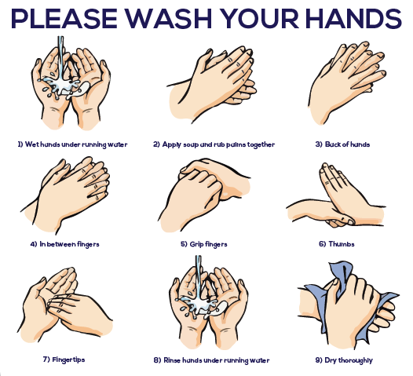
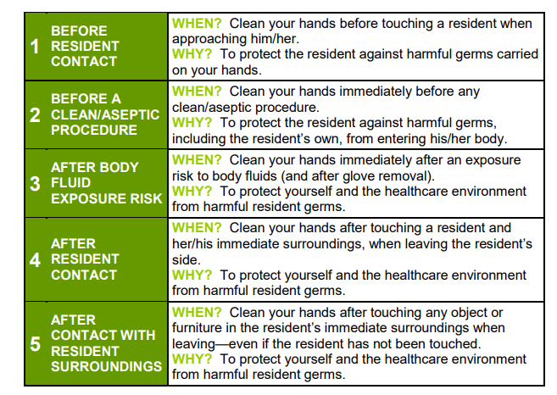
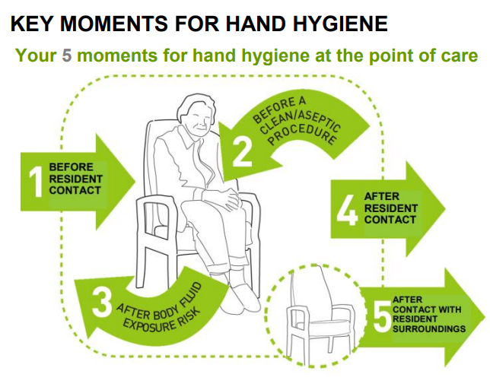

Manual decontamination of commodes and commode pans
- Staff must perform hand hygiene before donning PPE
- Wear eye protection if there is a risk of splashing to the eyes
- Cover commodes pan with lid and carefully remove from the commode to avoid spillages, empty contents into en-suite toilet in the resident's room or transfer the covered commode pan to the sluice room and discard the contents into the waste disposal
- Rinse the pan with cold water, clean with detergent and then followed by chlorine- use disposable cloths. If using sporicidal wipes, then detergent clean first is not required
- Wipe the outside of the pan first, then the inside, do not dry with paper towels but leave inverted to dry naturally
- Dispose of the cloth into clinical waste bin
- Doff PPE appropriately and perform hand hygiene
For other equipment
Follow the above precautions around hand hygiene and PPE and remember to clean from:
- top to bottom
- clean to dirty areas
- the furthest point to nearest point
- low risk to high-risk pathways
- Staff need to be trained in manual cleaning processes to prevent recontamination of surfaces e.g., clean large and flat surfaces using an ‘S’ shape motion

