


Join the fight against the spread of infection
GET SMART


An Outbreak Guide to G.E.R.M.S: Respiratory Post-Infection Framework (PIF)
v1.0





Scan for more
Information

Or find us at:
Lancashire County Council – Infection Prevention & Control

Contents
Version Control Information 3
Chain of Infection 4
Line listing 5
Outbreak flow chart 7
Cleaning 8
Outbreak communication log 9
Outbreak reflection sheet 10
Post Infection Framework (PIF) 11
1. Overview of the Outbreak 11
2. Timeline of Events 11
3. Contributing Factors 11
4. What Went Well 11
5. Areas for Improvement 11
6. Action Plan 12
7. Staff & Resident Feedback 12
8. Lessons Learned 12
9. Next Steps 12
Example: Post Infection Framework (PIF) 13
1. Overview of the Outbreak 13
2. Timeline of Events 13
3. Contributing Factors 13
4. What Went Well 14
5. Areas for Improvement 14
6. Action Plan 14
7. Staff & Resident Feedback 14
8. Lessons Learned 14
9. Next Steps 14

Version Control Information
Title
Version number | v1.0
Document author(s) name and role title | Infection Prevention and Control Team
Document owner name and role title | Emma Dawson
Document approver name and role title | Tanya Shaw

Date of creation | 20/11/2025 | Review cycle | Annual
Last review | - | Next review date | 20/11/2026

Version | Date | Section/Reference | Amendment
1.0 | 20/11/2025 | Whole document | Document created

Chain of Infection

Please use the chain of infection below to help with your post infection framework for respiratory infections.
Have a look at each part of the chain and see what actions can be taken to break the chain to influence the management of future infections.
Break the Chain of Infection
*Staff education in IPC *Recognising symptoms

*Hand hygiene *bare below the elbow *Environmental cleaning *IPC audits

*PPE including masks *Isolation *Hand hygiene *Catch it, bin it, kill it *Environmental and equipment cleaning
*Hand hygiene of staff and service users *Environmental and equipment cleaning
spores
.
*Seasonal influenza vaccination *Pneumococcal vaccination *COVID-19 vaccination/booster *Nutrition and hydration

*Recognition of high-risk service users

Chain of Infection: Respiratory

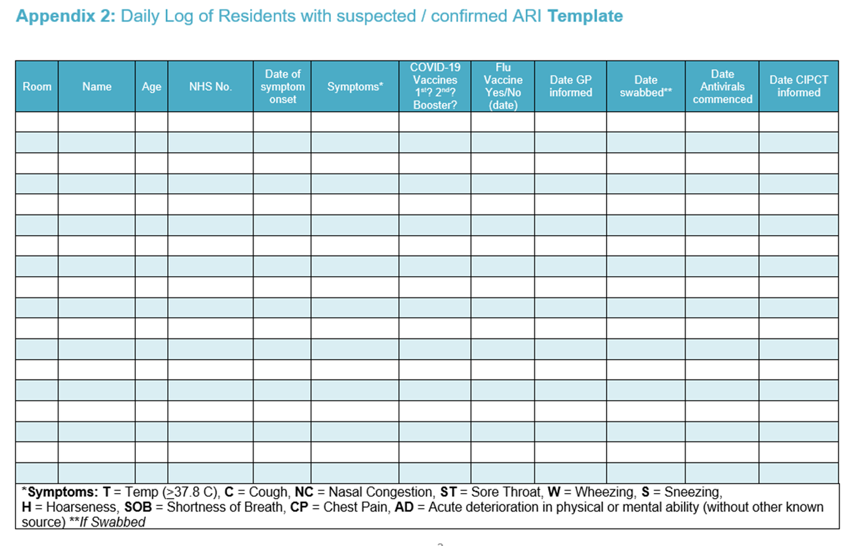
Line listing

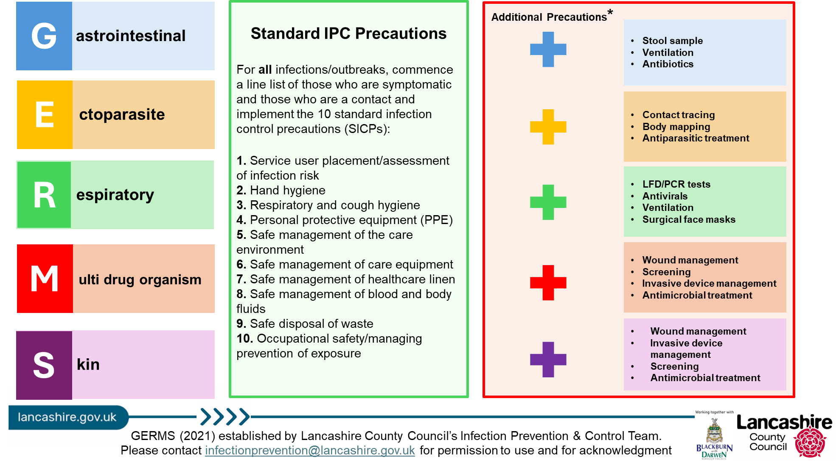

Outbreak flow chart
If an outbreak of ARI is suspected inform UKHSA and IPC team as they can offer support and advice

Create a line listing of symptomatic residents and staff

If flu is clinically suspected/detected, antivirals may need to be arranged within 48 hours of symptom onset for the case, but this is a clinical decision.
Should a case of flu be reported and it’s within 48 hours of exposure antivirals may be considered for resident contacts and any staff in at risk groups who are unvaccinated against flu, but this will be discussed with CIPCT /UKHSA HPT

Commence covid 19 testing as per guidance for clinically vulnerable only

If COVID-19, isolate resident cases for 5 days from date of test and until feeling well
If ARI (non COVID-19), isolate resident cases for a minimum 5 days after the onset of symptoms and until feeling well.

Management of staff cases
Exclude symptomatic staff from work. If COVID-19 positive isolate and follow staying at home guidance. Staff should not attend work until 5 days after date of test and until feeling well.

If negative for COVID-19 and have symptoms of or are confirmed as having influenza, they should remain off work for a minimum of 5 days after the onset of symptoms and until feeling well.

Hand and respiratory hygiene for staff, residents and visitors.

Ensure clear communication regarding effective handwashing and use of PPE is covered in handovers/safety huddles

Enhanced cleaning
Clean surfaces and high touch areas frequently. Clean shared equipment between residents, e.g. hoists, aids, showers. If suspected or confirmed cases, all areas should be cleaned at least twice daily.

Personal Protective Equipment (PPE) for staff and visitors.
Adequate PPE worn as per national guidance

Segregate Linen and Waste appropriately Ensure linen management and clinical waste disposal systems are in place. No specific COVID laundry requirements any more, see general guidance for managing waste and laundry

Cleaning

Managers should increase the frequency and intensity of cleaning for all areas, focusing on shared spaces and ensure appropriate linen and waste management systems are in place.
Clean surfaces and high touch areas frequently. Clean shared equipment between residents, e.g. hoists, aids, showers. If suspected or confirmed cases, all areas should be cleaned at least twice daily.
Locations where symptomatic residents have been staff should ensure correct PPE is worn appropriately.
At the end of the outbreak a ‘Terminal Clean’ must be undertaken. This is a thorough clean and disinfection of all areas before normal business resumes.
- All carpeted areas should be steam cleaned.
- All soft furnishings (curtains, cushions, and duvets) should be laundered, or steam cleaned, where fabrics allow.
- Radiator covers removed and behind radiators cleaned.
- Portable fans and extractor air fans cleaned.
- All surfaces including low, mid and high levels e.g., Door frames, picture frames and curtain rails.
- Any furniture that is soiled but cannot be cleaned should be discarded.

Outbreak communication log
To be updated daily and communicated to staff at handover

GERMS (see table below)
First case
Latest case
Total number of service users to date
Total number of staff to date
Units/floors/areas affected
Outbreak measures implemented (select all that apply - line listing, isolation, PPE, hand hygiene, limiting staff movement, notified visitors, testing, coordinating treatment, respiratory etiquette, ventilation, touch point cleaning, infectious laundry and linen processes, risk assessing admissions)
Any concerns? (severe illness, hospitalisation, deaths, delays in review/treatment, further supported/escalation needed)
Expected end date
End of outbreak cleaning arrangements
(estimated completion time, which staff are involved- internal/external)
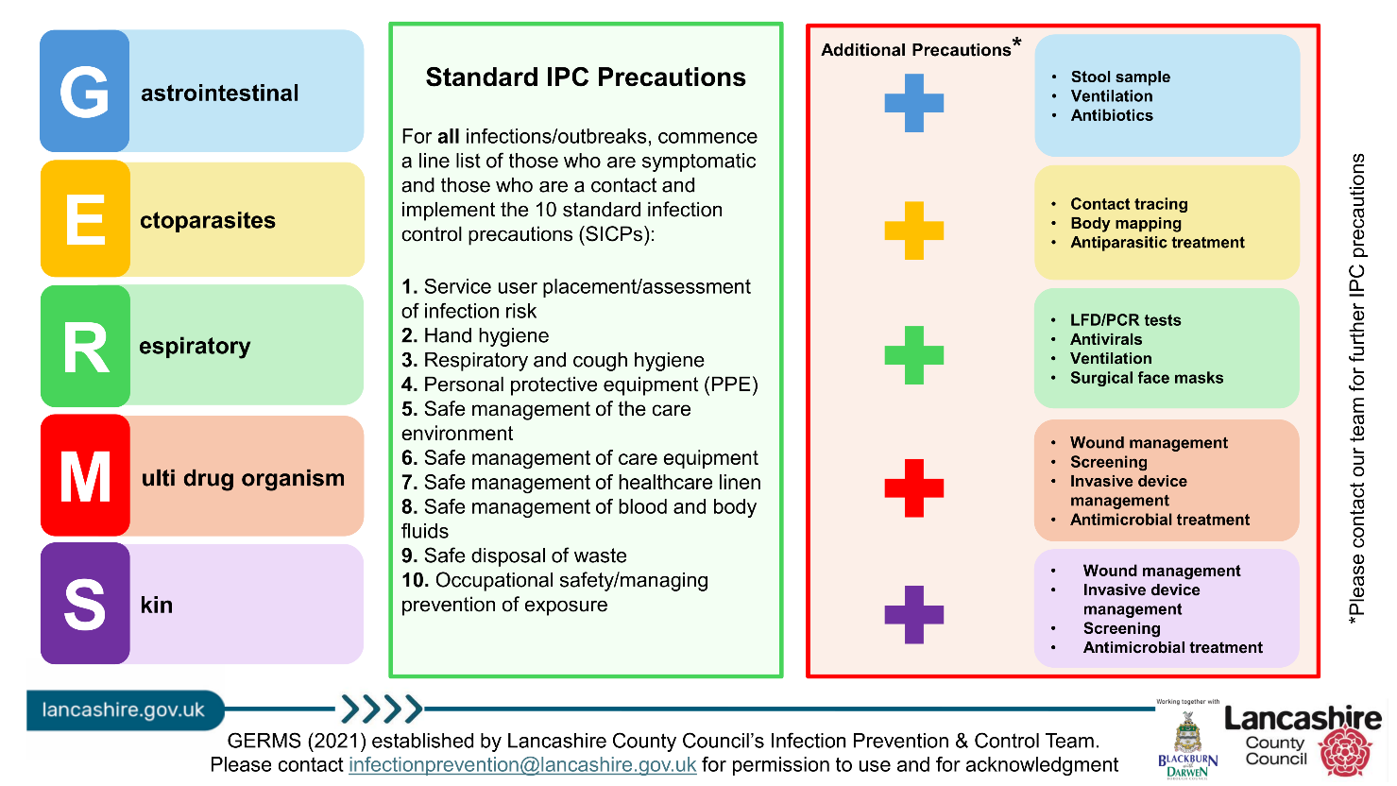

Outbreak reflection sheet

Use this sheet throughout the outbreak to record what went well and what could be improved. Share your findings with staff, service users and visitors.
Some things to consider:
- Was there prompt recognition and reporting of the outbreak?
- Effective communication throughout?
- Were outbreak measures followed by all staff, service users and visitors? (If not, why not? List barriers/solutions)
- Which staff members managed the outbreak? (include at evenings and weekends)
- Are staff confident on the chain of infection? (discussions to be had on return to work for any staff affected in the outbreak)

Post Infection Framework (PIF)

Residential Setting Name:
Date of Outbreak:
Review Date:
Lead of Outbreak Management:

1. Overview of the Outbreak
- Type of Infection:
- Number of Confirmed Cases:
- Affected Areas:
- Duration of Outbreak:
- Outcome:

2. Timeline of Events
Date | Event | Action Taken

3. Contributing Factors
- Environmental:
- Staffing:
- Compliance:
- Communication:

4. What Went Well

5. Areas for Improvement
- Infection prevention & control measures:
- Staff training & education:
- Communication:
- Monitoring & surveillance:

6. Action Plan
Action | Responsible | Deadline | Status

7. Staff & Resident Feedback
- Staff [Insert summary of feedback]:
- Residents/Families [Insert summary of feedback]:

8. Lessons Learned
- Outbreak protocol:
- Infection prevention & control measures:
- Staff training & education:
- Communication:
- Monitoring & surveillance:

9. Next Steps

Example: Post Infection Framework (PIF)

Residential Setting Name: Evergreen Grove
Number of Residents: 56
Number of Staff: 45
Names of Floors/Units: Floor 1, Floor 2, Floor 3
Date of Outbreak: 08/11/2024
Lead of Outbreak Management: Hilary Swane, registered manager

1. Overview of the Outbreak
- Type of Infection: Flu A
- Number of Confirmed Cases: 3
  - Residents: 3
  - Staff: 0
- Affected Areas: Floor 1
- Agency Staff Used: No
- Duration of Outbreak: 7 days
- Outcome: Influenza A outbreak – antivirals given

2. Timeline of Events
 | Date | Event |  |  | Action Taken
 | 08/11/2024 | 6 service users with acute respiratory symptoms on Floor 1 |  |  | Tested the symptomatic service users with COVID-19 LFD tests. Negative. Reported to UKHSA and LCC IPC Team.  Cohorted the symptomatic residents to the same lounge and kept away from other service users.
 | 10/11/2024 | Flu tests arrived at setting |  |  | The first 5 service users that presented with respiratory symptoms were tested and sent by courier to UKHSA
 | 11/11/2024 | Flu test results received |  |  | 3 out of 5 flu tests were positive.  Antivirals given to the 3 service users
 | 15/11/2024 | Outbreak declared over |  |  | Deep clean of setting completed

3. Contributing Factors
- Environmental: poor ventilation, shared airspace
- Compliance: low staff flu vaccination uptake

4. What Went Well
- Prompt identification and isolation of affected individuals
- Staff dedication and teamwork
- Effective coordination with external health services

5. Areas for Improvement
- Infection prevention & control measures: Inconsistent mask usage across shifts
- Infection prevention & control measures: Poor ventilation

6. Action Plan
Action | Responsible | Deadline | Status
- Review ventilation strategy | Manager | 01/01/2026 | Completed
- Update respiratory outbreak protocol | Senior leadership team | 01/12/2024 | Completed
- Increase flu vaccination uptake | Manager | 01/09/2025 | In progress

7. Staff & Resident Feedback
- Staff [Insert summary of feedback]: Needed PPE refresher as they haven't needed to don and doff since the COVID-19 pandemic
- Residents/Families [Insert summary of feedback]: Happy that the outbreak appeared to be controlled

8. Lessons Learned
- Infection prevention & control measures: Importance of flu and COVID-19 vaccination
- Infection prevention & control measures: Importance of respiratory etiquette and hand hygiene

9. Next Steps
- PPE donning and doffing training for staff
- Incentives for staff influenza vaccination
- Air filter implementation for better ventilation
- Share findings with all staff and stakeholders
- Update IPC Annual Statement

References

Management of acute respiratory infection outbreaks in care homes guidance - GOV. UK

