Job Description

Directorate: | Growth, Environment, Transport, and Health
Service: | Trading Standards
Location: | Preston (Hybrid Working)
Salary range: | £53,888 – £58,282 | Grade: | 12
Reports to: | Head of Trading Standards Service | Staff responsible for: | 5

Job purpose and scope
One of the Council’s senior professionals in the Trading Standards Service, heavily involved and integrated into the service, influencing, shaping and challenging at senior levels to inform service planning, development and associated budgets within their own area and Service.

Requires a high level of professional expertise and experience, exercising a large degree of independent professional responsibility and discretion. Role holders will lead, support or direct a team of professionals or be an individual contributor providing a technical reference to a professional team, but a major part of their role will be to work collaboratively and closely with senior management and stakeholders to ensure a range of service development, improvement and on-going compliance.

Performance Indicators
- Quality of advice/service against legal, safety and best practice standards
- Achievement of relevant service targets
- Adherence to internal/external quality standards if applicable
- Adherence to policies and procedures
- Accuracy and timeliness of information recording and processing
- Customer and stakeholder feedback
- Leading Lancashire Framework

Leading Lancashire – Our Leadership Framework
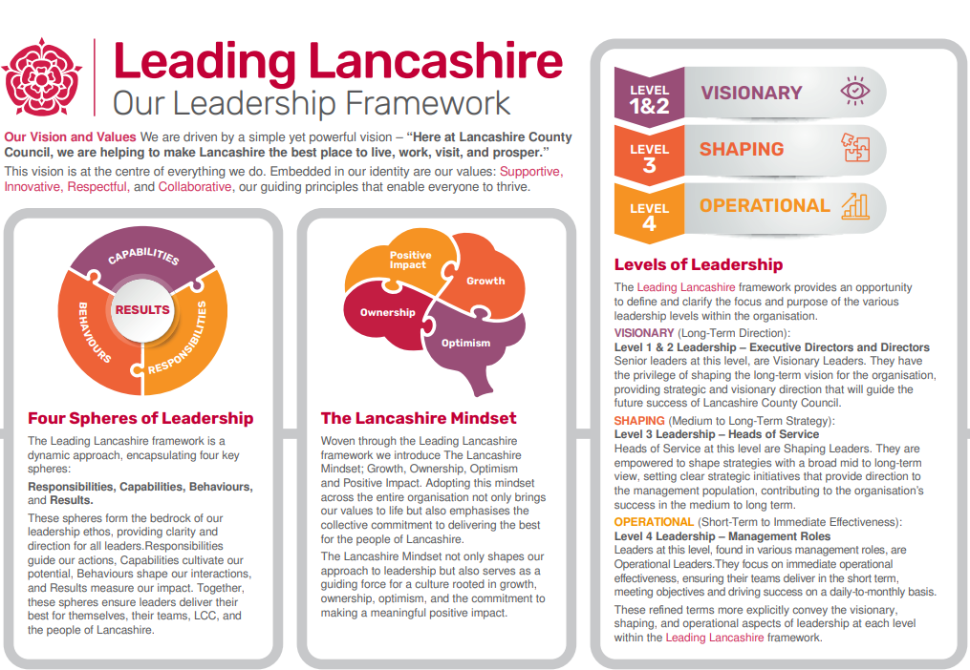

Accountabilities/Responsibilities
The following are a range of duties that are appropriate to this grade:
- Lead on the interpretation and communication of policy, legislation, regulations and codes of practice relevant to a wider service area, scanning the horizon for relevant changes that may impact the Trading Standards Service.
- Proactively provide expert advice to meet internal/external customers’ needs, to inform multi-agency initiatives, and to facilitate management decision-making which will have medium to long term effects on the business
- Evaluate existing provision and monitor service developments to recommend large scale service improvements for decision by senior management e.g. reviewing service delivery models.
- Review management information requirements and identify improvements to ensure information gathered meets requirements for service planning or legal/security requirements.
- Represent the Council at external forums, conferences and meetings to build professional networks and influence wider policy agendas.
- Lead on the design and delivery of medium to large projects to resolve service issues or to achieve service improvements. This includes initiating and scoping improvement projects and leading on the design of objectives.
- Lead, develop and promote a culture of continual professional development of all staff at each level.

Other
- Equal Opportunities
We are committed to achieving equal opportunities in the way we deliver services to the community and in our employment arrangements. We expect all employees to understand and promote this policy in their work.

- Health and safety
All employees have a responsibility for their own health and safety and that of others when carrying out their duties and must help us to apply our general statement of health and safety policy.

- Customer Focused
We put our customers' needs and expectations at the heart of all that we do. We expect our employees to have a full understanding of those needs and expectations so that we can provide high quality, appropriate services at all times.

- Safeguarding Commitment
We are committed to protecting and promoting the welfare of children, young people and vulnerable adults.

- Skills Pledge
We are committed to developing the skills of our workforce. All employees will be supported to work towards a level 2 qualification in literacy and numeracy if they do not have one already.

Our Values
We expect all our employees to demonstrate and promote our values:

- Supportive
We are supportive of our customers and colleagues, recognising their contributions and making the best of their strengths to enable our communities to flourish.

- Innovative
We deliver the best services we possibly can, always looking for creative ways to do things better, putting the customer at the heart of our thinking, and being ambitious and focused on how we can deliver the best services now and in the future.

- Respectful
We treat colleagues, customers and partners with respect, listening to their views, empathising and valuing their diverse needs and perspectives, to be fair, open and honest in all that we do.

- Collaborative
We listen to, engage with, learn from and work with colleagues, partners and customers to help achieve the best outcomes for everyone.

Person Specification

All the following requirements are essential unless otherwise indicated by *

Your ability to meet the job requirements will initially be assessed by the information provided on your application but further assessment will be undertaken at interview and, in some cases, by using other types of assessment(s).

Qualifications
- Professional qualification and substantial vocational experience in a relevant technical, scientific, specialised or operational field
Experience
- Significant experience in a senior technical/specialist advisory role within a large and/or complex operation/function/service
- Significant experience of working across services within multidisciplinary teams; managing projects and teams outside of direct line management
- Developing initial service plans and managing services in
- line with agreed budgets, targets and plans
- Initial strategy, policy and procedural development and implementation across the area of responsibility
- Innovative and creative management of services within a changing and challenging financial environment

Essential knowledge, skills & abilities
- Ability to build relationships and influence, develop and motivate at senior levels, internally and externally
- Significant knowledge of the application, principles, theory and practice of the specialist area of responsibility
- Comprehensive understanding of Corporate and service strategy and objectives and translation and implementation at local level
- Ability to apply managerial judgement to ensure service area objectives are achieved
- Strong analytical and problem-solving skills and the ability to look ahead and understand implications of future initiatives within the area of responsibility
- Strong project and change management skills
Other essential requirements
- Commitment to equality and diversity.
- Commitment to health and safety.
- Display the LCC values and behaviours at all times and actively promote them in others.
- This is an essential car user post
You will be required to provide a car for use in connection with the duties of this post and must be insured for business use. In certain circumstances consideration may be given to applicants who, as a consequence of a disability, are unable to drive

