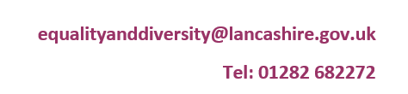

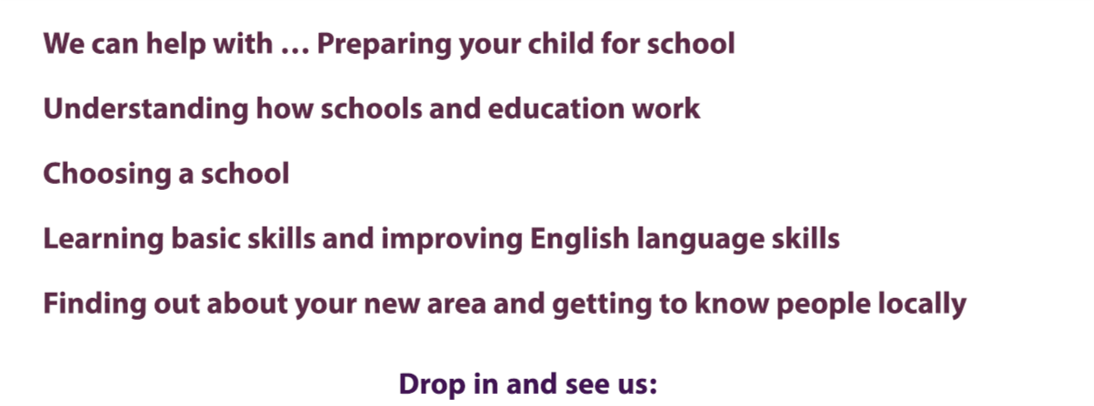

**Visit us at our drop-in (Term time only):**

Tuesday's 9-1pm

Tuesday's 2-4pm (Appointment only)

For afternoon appointments please email: 

**ELLIE at The Zone Nelson**

**Leeds Road**

**Nelson**

**BB9 8EL**

**Closed during the following dates-**

|  |  |  |
| --- | --- | --- |
| **17th February** | **-** | **21st February 2025** |
| **7th April** | **-** | **22nd April 2025** |
| **26th May** | **-** | **30th May 2025** |
| **21st July** | **-** | **29th August 2025** |
| **27th October** | **-** | **31st October 2025** |
| **22nd December** | **-** | **2nd January 2026** |
| **16th February** | **-** | **20th February 2026** |
| **30th March 2026** | **-** | **10th April 2026** |
| **25th May** | **-** | **29th May 2026** |

**(Lancashire School holidays)**

**We are also closed on Bank Holidays:**

**Monday 5th May 2025**

Please bring **any relevant ID documents** (Passport, UK Identity card, National Insurance Number, E-VISA **for each child and parent/Guardian**.

**Monday 4th May 2026**