**LANCASHIRE COUNTY COUNCIL**

(ABBOTT BROW, MELLOR, RIBBLE VALLEY)

(TEMPORARY PROHIBITION OF THROUGH TRAFFIC) ORDER 2025

**NOTICE IS HEREBY GIVEN** that Lancashire County Council have made an Order under **Section 14(1) (a) of the Road Traffic Regulation Act 1984**, as amended, the effect of which will be to temporarily prohibit traffic on the roads set out in this notice.

1. No person shall cause any motor vehicle to proceed over that length of Abbott Brow, Mellor from a point outside Lower Abbott House Farm travelling in either direction for approximately 20 metres.
2. Nothing in this order shall apply to persons engaged in the carrying out of the works.
3. The prohibition will be operative from 0800 hours on 17th February 2025 until 1700 hours on 21st February 2025 or until completion of the works within this period. Access will be maintained whenever and wherever possible.
4. Vehicular access for residents will be maintained whenever and wherever possible. Pedestrian access to properties will always be maintained.
5. An alternative route for vehicular traffic affected by the closure is via:-

Mellor Brook Bypass – Mellor brow – Mellor Lane

The temporary prohibition is necessary to allow Network Plus on behalf of Electricity North West to install a new customer connection.

Authority given for this Order to be made:

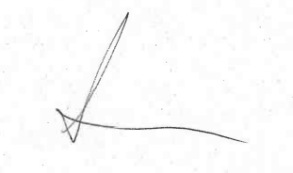

Amanda Meldrum,

Streetworks Team Leader

Highways and Transport

03001236780

[Ref: HRiT/55793/KF]