Religious Education (RE) at Park Primary school

*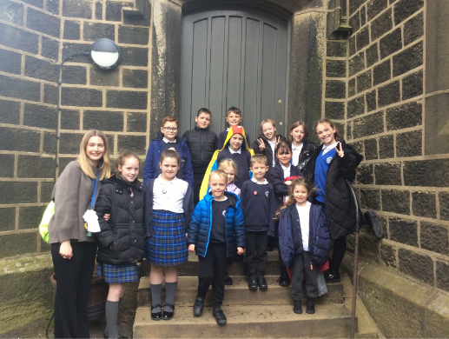*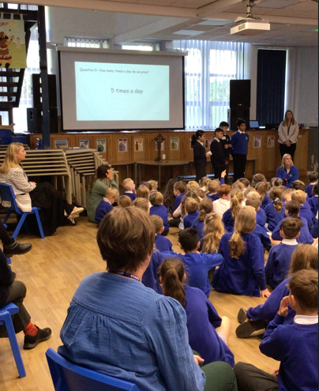

*Miss Richardson (RE Lead) and the RE Champions*

*4 of our pupils delivering an assembly on Islam at a nearby school*

At Park Primary School, we are committed to raising the profile of Religious Education (RE) and highlighting the importance of teaching our children about differences, encouraging them to be open-minded, respectful, and achieve greater self-awareness. We really value our RE lessons and dedicate a week each half term as our ‘RE Week’, this allows children to embed their learning and engage fully with the topic throughout the week.

As part of raising the profile of RE, we have established a group of ‘RE Champions’ at Park. This is a team of 12 children, ranging from EYFS to Year 6, who visit different places of worship throughout the year. They share their experiences with their peers during assemblies, creating a sense of excitement around religion, culture, and traditions. We are especially excited about our upcoming visit to a Hindu Mandir temple at the end of October!

Last year, some of our Muslim pupils enjoyed visiting two local schools to deliver an assembly on Islam. This was very well received, and we hope that continuing similar projects will further develop community cohesion in our town.

We also enjoy inviting a variety of speakers into our school to discuss their religion. Our relationship with our local church, St. Bartholomew’s, is particularly strong. Recently, the whole school visited the church to deliver our Harvest donations, and we are very proud of the work we do at Park to foster respect and understanding across different faiths.