Supplier Submissions

Supplier Portal

Submissions to Negotiations

Schools Cleaning

This Guide

1. Supplier Home Screen
2. Supplier Portal Tile
3. View Active Negotiations
4. Create Response: Overview
5. Create Response Requirements
6. Review Response
7. Manage Responses: Revise Response

Quick Step Guide

Additional Information

Blue boxes offer explanations, options and other useful information.

Green boxes indicate a step that must be completed to make a submission against the negotiation

# Supplier Home Screen

Shortcuts to the watchlist

Access the Supplier portal to view negotiations, invoices and orders

Home button, press anytime to return to this screen.

Shortcuts to notifications and actions.



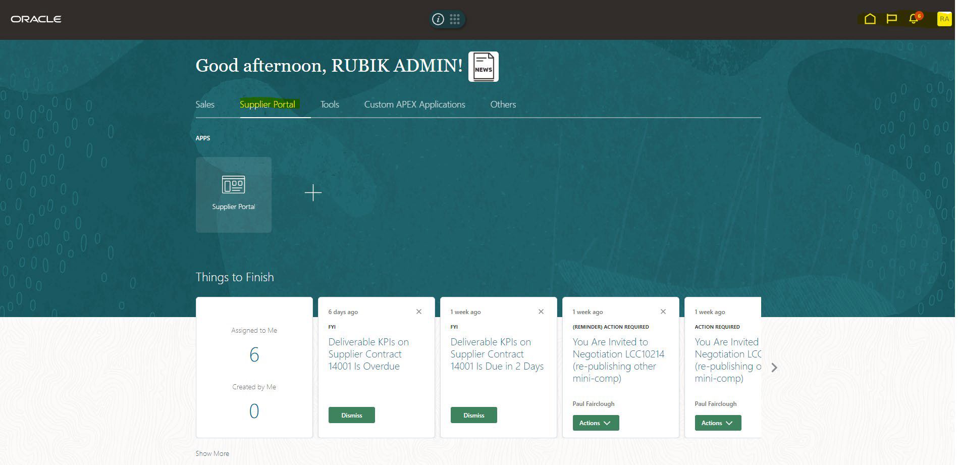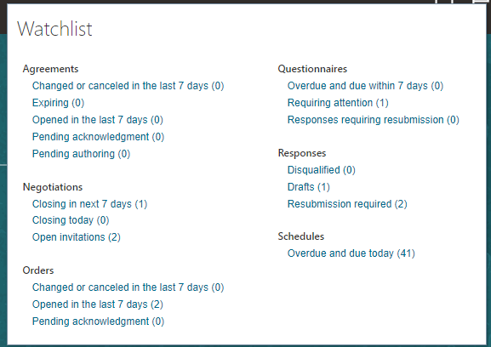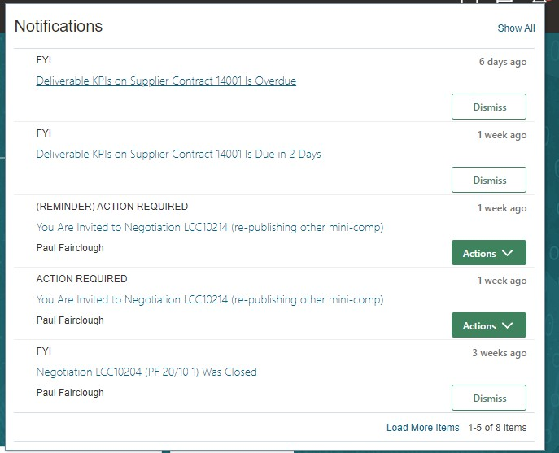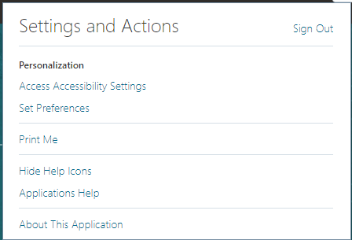

Shortcut to sign out or change preferences.

# Supplier Portal Tile

‘Negotiation’ is the new term used to refer to a procurement process in Fusion. We will no longer use the terms ‘RFI’ and ‘RFQ’ that were synonymous with the old sourcing software.

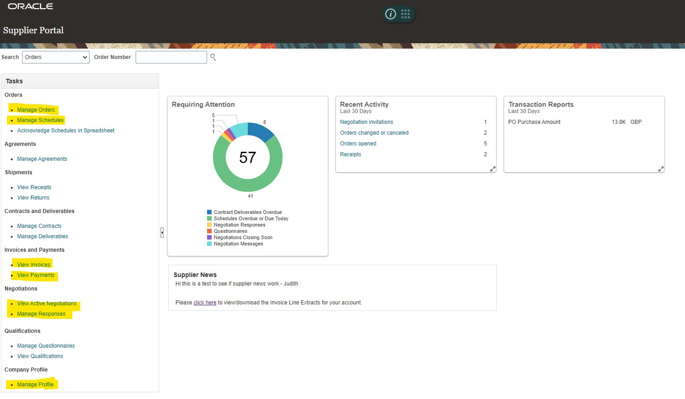

Access purchase order header information

Access purchase order Line Information

View invoice detail, paid/hold status etc

Access payment detail

View live negotiations

Manage submitted responses

Download Invoice Line Extracts

Manage supplier record

# View Active Negotiations

Use the search criteria to search for specific negotiations.

* + Wildcard searches can use %

sign.

Change ‘Response Submitted’

* (YES) displays active negotiations that the supplier has already

Change ‘Invitation Received’

Active negotiations that meet the search criteria are listed in the table.

[Select the Negotiation Number hyperlink to view the negotiation]

* + For example, all negotiation numbers start ‘LCC’ searching ‘LCC%’ will return all active negotiations

submitted a response to.

* + (No) displays active negotiations that the supplier has not yet submitted a response to.
  + (YES) displays active negotiations

that the supplier has been invited to.

* + (No) displays active negotiations that the supplier has not been invited to (including open tenders).

Switch between saved searches.

Note the time remaining to provide a response

Customise searches and save them.

Start to create a response for the highlighted negotiation

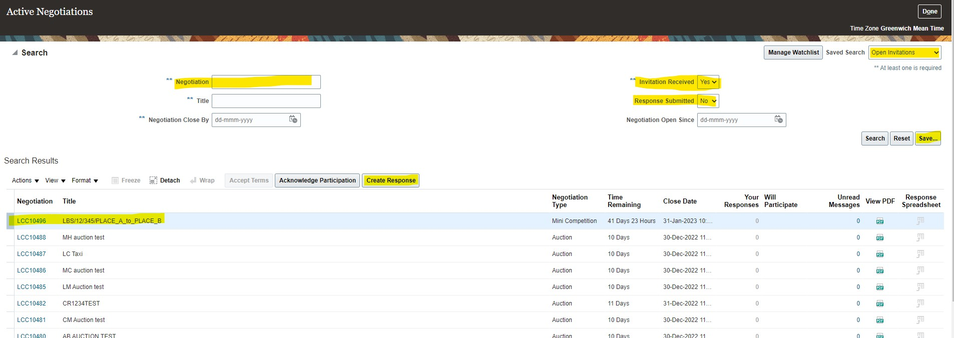

A previous response would show as ‘1’ here

# Create Response: Overview

Use the ‘train track’ to navigate the parts of the submission that need completing

To ask question or view messages from LCC you can click on messages

Click next to move to the next ‘station’ on the ‘train track’.

Save your response as you progress to protect against data loss should your internet connection be interrupted.

You can also save part way through and return later to complete your draft response.

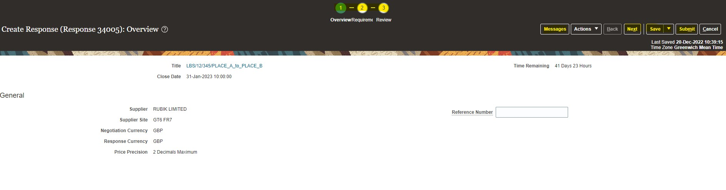



The negotiation I am responding to

My company name

Enter a reference relevant to your response if needed. This is not mandatory

# Create Response: Requirements

You have now moved on to ‘Requirements’

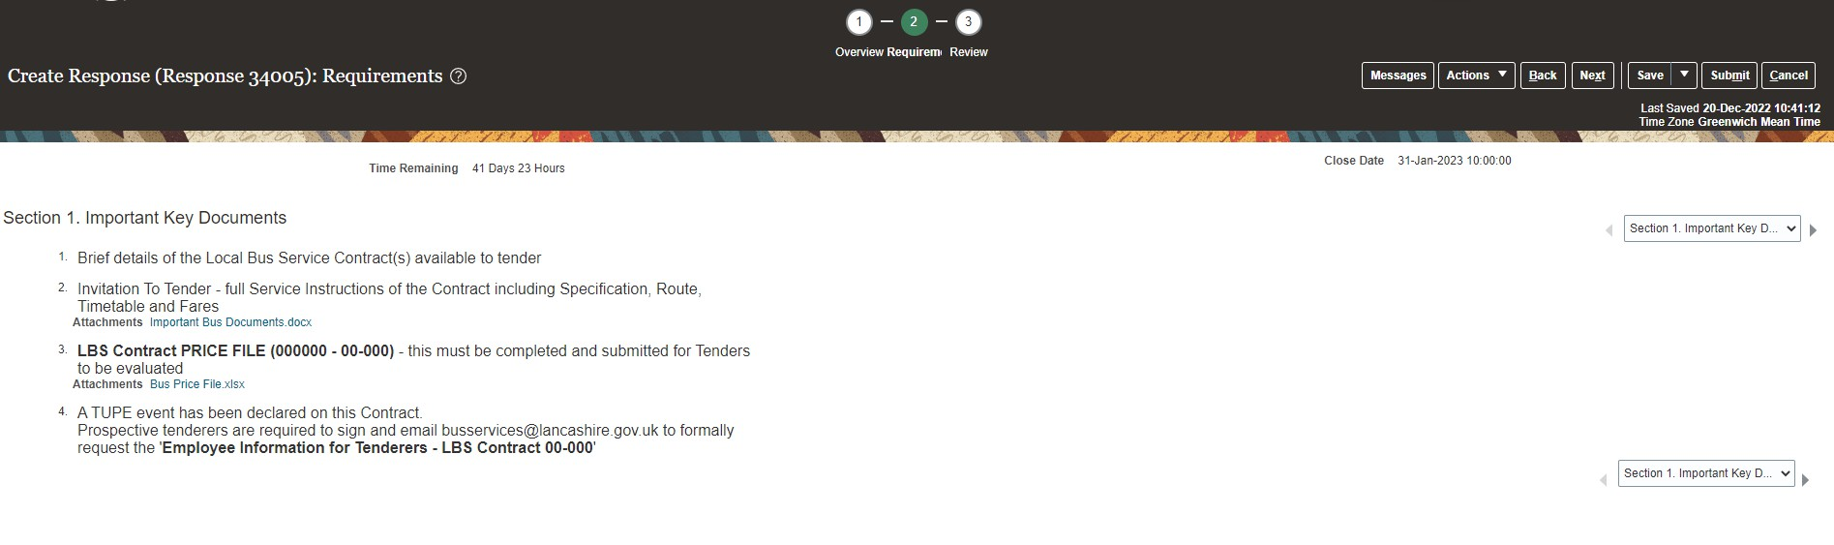

Access attachments

This example negotiation has multiple sections, navigate between the sections using the backward and forward arrows.



This is an information only Requirement that is displaying a document for the supplier to review

# Create Response: Requirements continued…

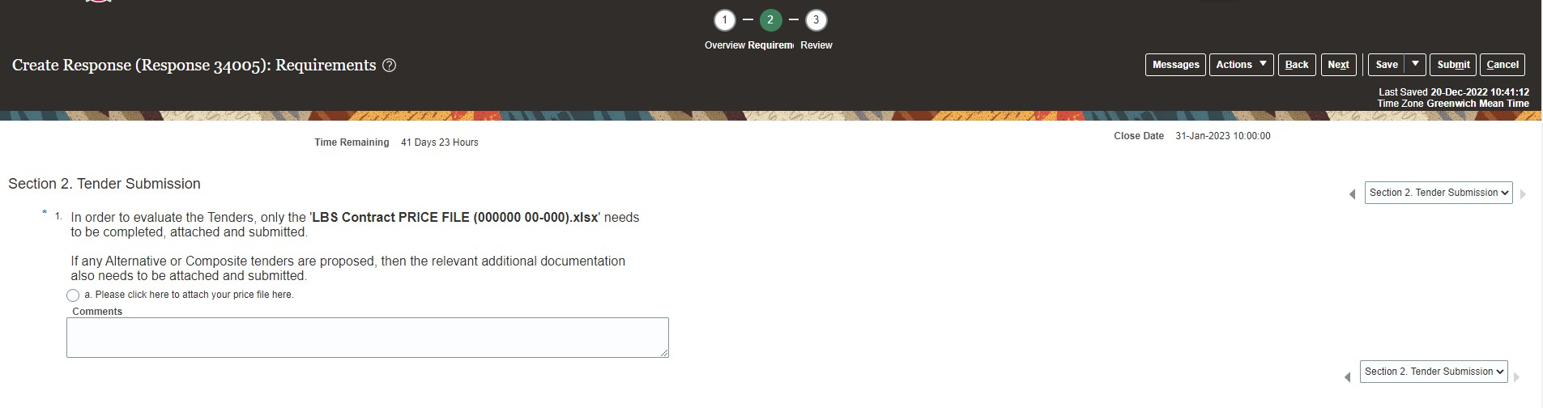

Complete all mandatory requirements in each available section.

Save your responses as you progress.

1. **Review Response**

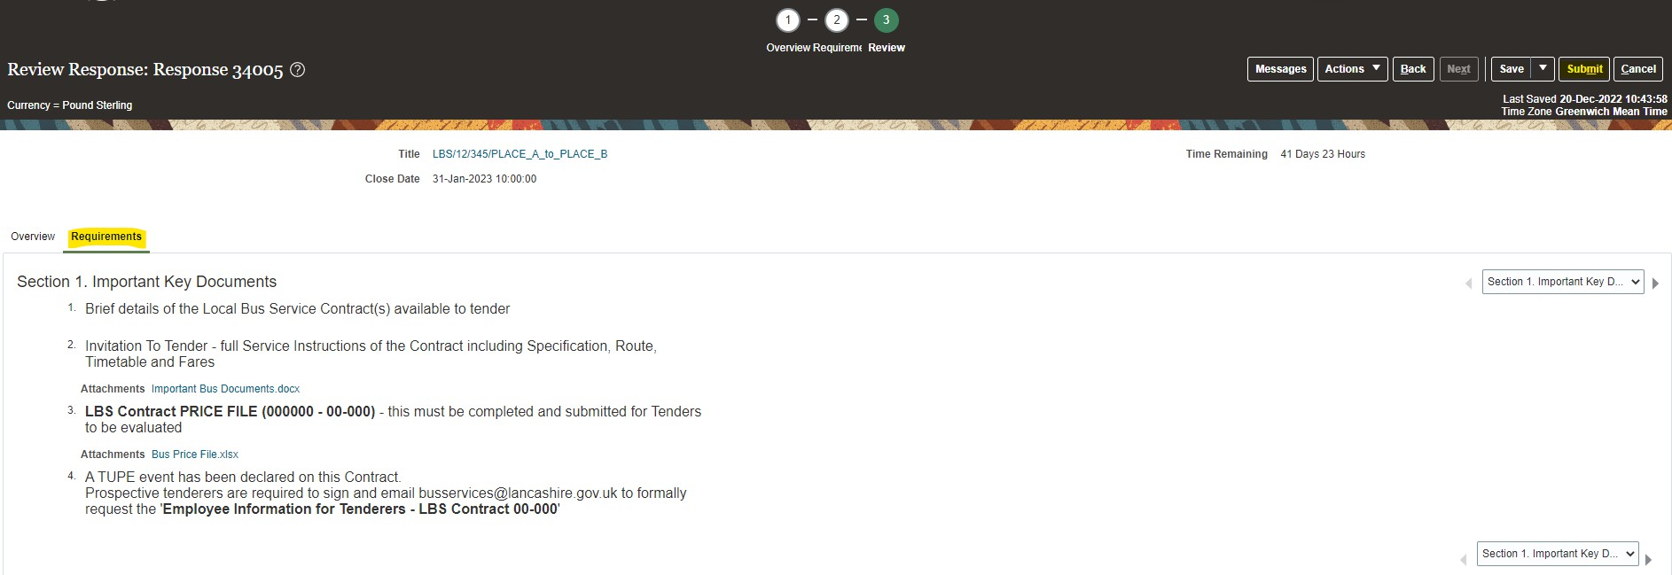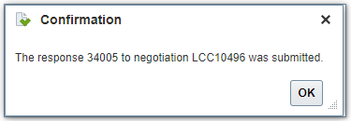

Review your responses, click on requirements and cycle through sections as before.

If you wish to amend your submission, click on requirements to return.

If you are satisfied with your responses and wish to submit, click submit



Once you have submitted your response you will receive this confirmation.

# Manage Responses: Revise Response

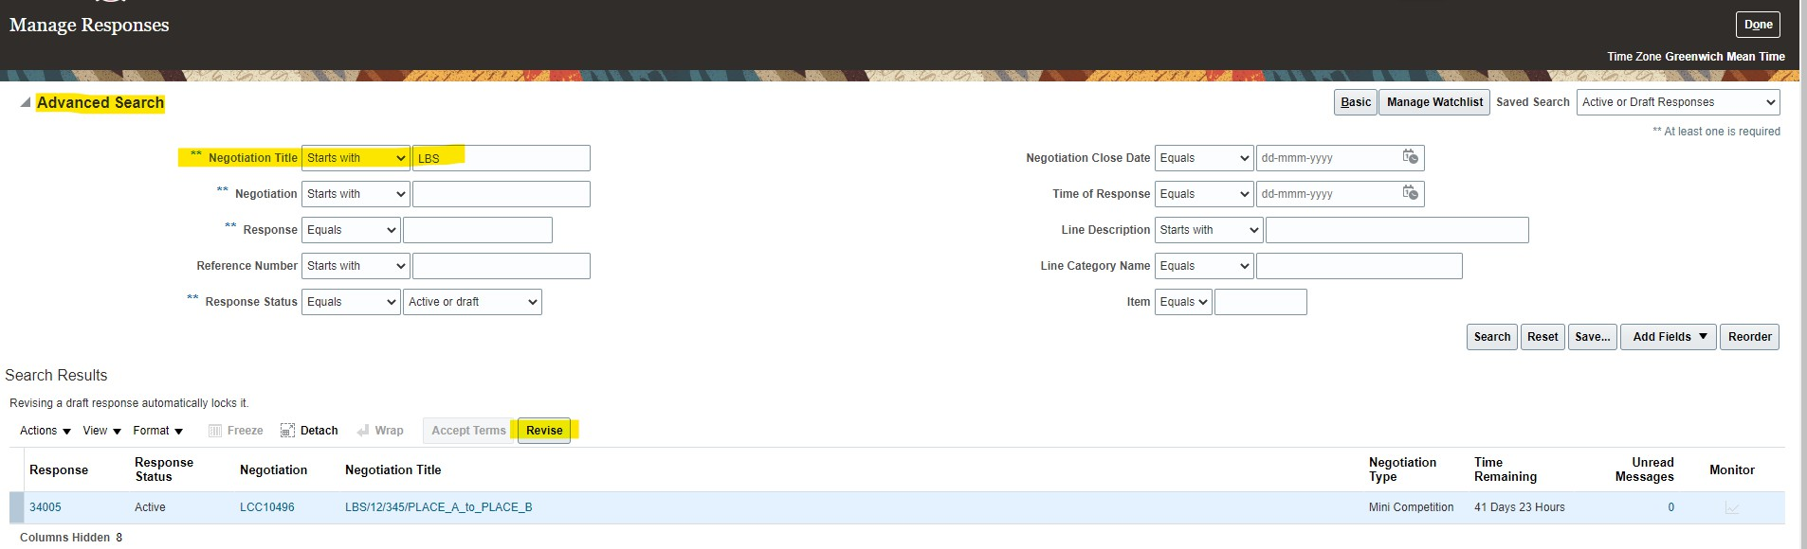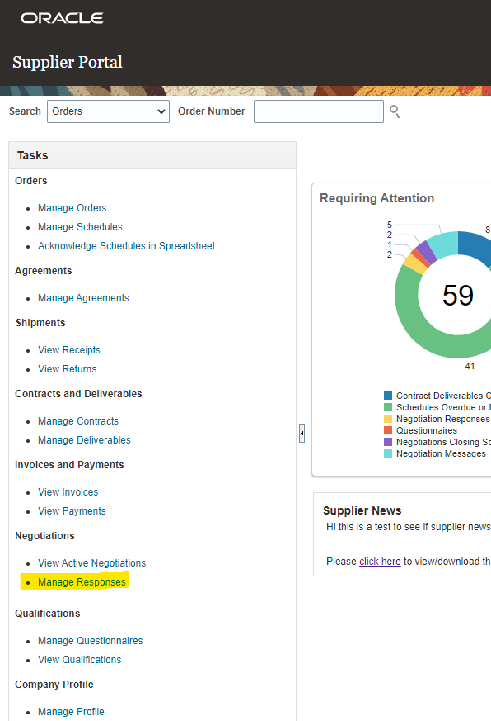

Once you have submitted you can go to the ‘Manage Responses’ screen from the Supplier Portal homepage

Search for the process or pick from the list

‘Manage Responses’ is

directly accessible from the Supplier Portal homepage



To change a submission before the negotiation deadline passes, click revise.