Is your setting a vocabulary rich environment? What does that look like?

* Stories are read daily
* In all CP areas key vocabulary is displayed and where possible with pictures to enable children to use these words independently.
* Vocabulary underpins all new learning - planned but also incidental new words.
* Lots of opportunities to use spoken language to adults and peers
* Children are listened to read on a one to one and in this new vocabulary is explored
* Guided reading sessions - new vocabulary explored.

What resources do you use?

* NELI is used as an intervention programme.  The TA leading this shares the key vocabulary they have been focussed on so we can then continue this learning.
* Other resources we use are: stories with puppets and resources for children to retell them, curioisty box/case for children to explore and learn new vocabulary, lots of open ended resources such as blocks, loose parts, problem solving tasks.
* Cosy reading area with ever changing selection of books and puppets.

How do you plan for explicit vocabulary in your setting? How does that look on your planning?

* Key vocabulary is explicit on our planning - these words are taught directly in sessions and then displayed in the classroom.  For example as shown in the screenshot of a snippet of our planning:
* 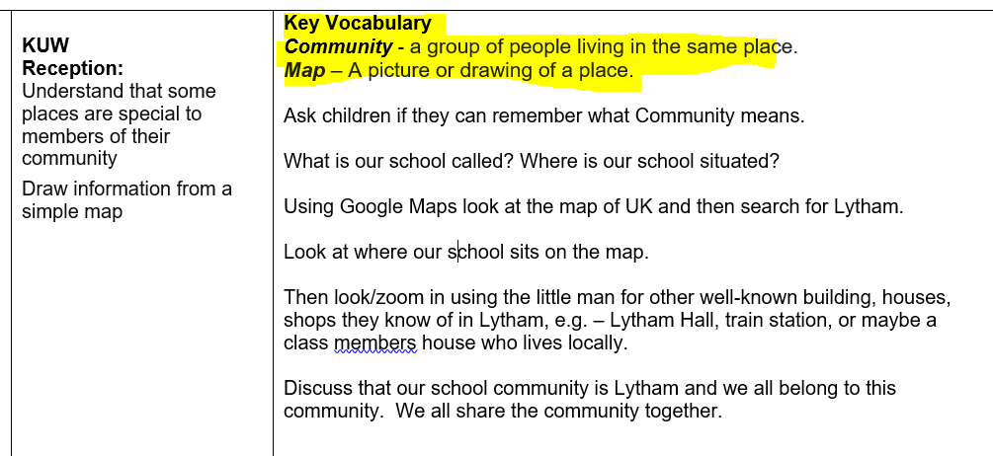
* These words are revisited at the beginning of each session in that area of learning.
* Throughout the week new vocabulary is explored in sessions where we might use microphones, story maps, puppets, Mr Potato head etc

How do you capture and live new vocabulary?

* Through stories new vocabulary is explained, explored and acted out where possible.  These words are then written down and displayed for adults to encourage children to use.  These words are also revisited.
* New words are said repeatedly, in different voices (high pitched, silly voice, deep voice etc) and syllables clapped.

- The meaning of these words are explored in different ways, scenarios and sentences.

- In CP areas clipboards are displayed for those unplanned words which come up during the week, for example from a story or a discussion with a child.

How do you share vocabulary for the adults in your setting?

* Through displaying the words in the classroom.
* Through discussions with adults daily.

How do you plan for children to remember and apply vocabulary that you have taught?

- At the beginning of focussed teaching sessions previous key words are revisited and games played.

How do you engage parents in the teaching of vocabulary in your setting?

- Through our BLOG which is updated several times a week

- Each Friday we send a Home School Book and key words will often be shared in there.

What CPD have your staff had for developing CLL/vocabulary?

- Nothing recently

