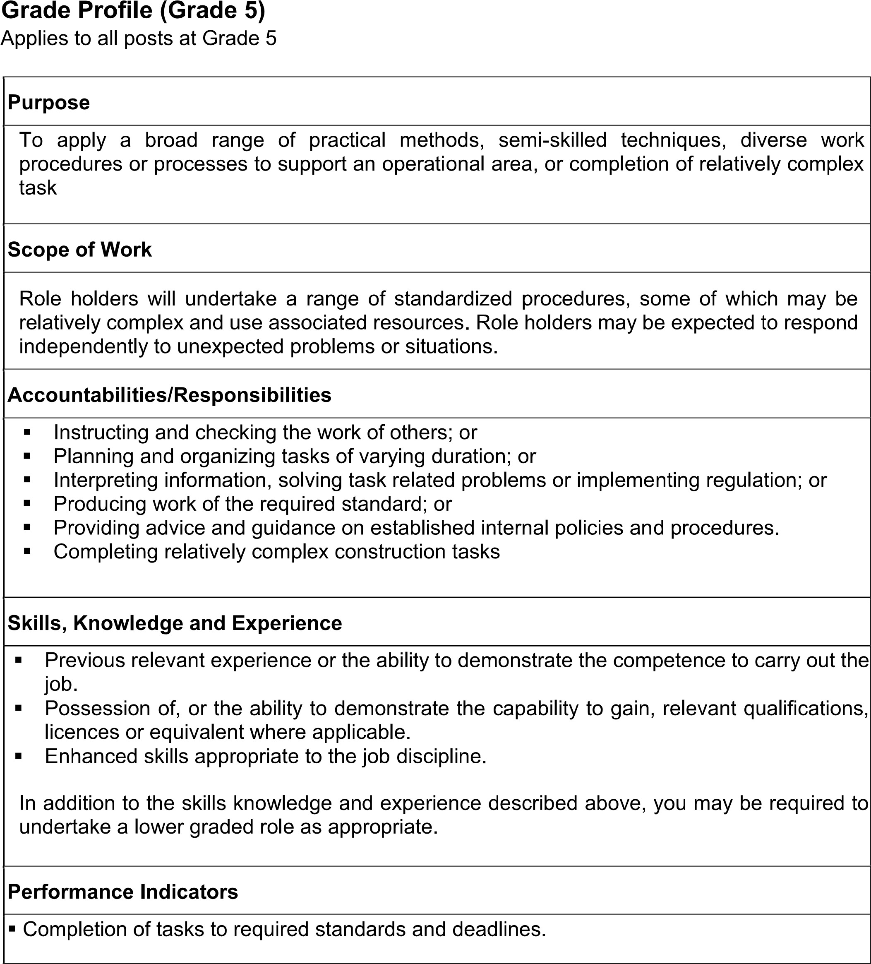

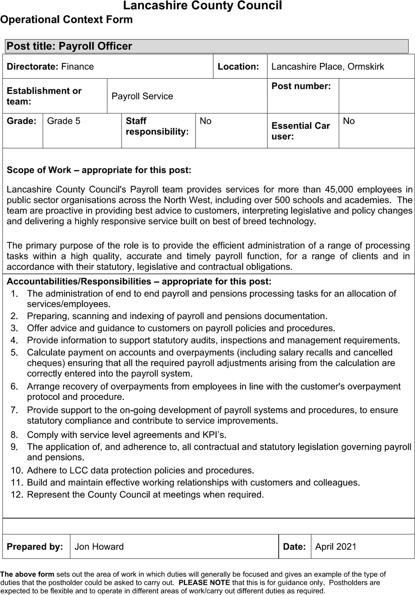

**County Hall, Preston**





        
        
        
        
        
        
        
        

