W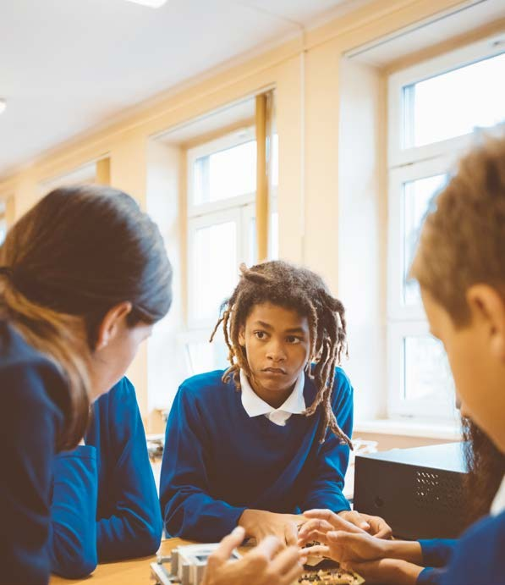
Lancashire Virtual School Guidance on Transition to High School
Looked After Children & Previously Looked After Children
With huge gratitude from Ealing Virtual school for sharing this resource.

Contents

Introduction Page 4

Transition for Looked After Children (LAC) and Previously Page 6 Looked After Children (PLAC): Lessons from research

What children worry about at transition to high school Page 9 Transition Planning Page 10
Assessing readiness for transition and providing support Page 11 Transition time lines Page 12
Appendices Page 18

This pack has been created by Irene Tymkiw, Senior Educational Psychologist & Alison O’Connor Virtual School teacher on behalf of Ealing Virtual School

3

Introduction
Transition to High School can be a particularly difficult time for children who are, or have been, Looked After. Transition means change and change can be uncomfortable and difficult for us all. However, change is especially stressful for Children Looked-After (CLA) and Previously Looked After Children (PLAC) because it can trigger deep rooted feelings of insecurity, instability, loss and separation, which can be experienced as devastating.
Transition also means saying goodbye to the old; endings must therefore be viewed as an integral part of the transition process. Before tackling transition, we must acknowledge the central role and importance of saying goodbye. It is important for all our children to help them manage the ending of their primary school experience and to help them say goodbye to key adults and peers. This should include explicitly acknowledging and celebrating the child’s primary school achievements and success. It is important for LAC and PLAC to know that they can come back and visit their primary school and that their teacher at primary will still be thinking about them and
wondering how they are getting on. This is because the experience of some looked after or previously looked after children is that people in their lives ‘disappear’ without reason. It is important for our children that they know they are being held in mind and that their key primary school adults have not similarly ‘disappeared’.

For helpful suggestions on how to manage endings see the PAC UK resources: Appendix 1 Appendix 2
At times of transition, in the mind of the LAC and PLAC, parallels may unconsciously be drawn with previous loss of caregivers and relationships; this can give rise to feelings of anxiety, vulnerability and abandonment. These feelings, that might so far have been managed well in the safe, familiar, environment of primary school, can be so
strong and overwhelming when that familiarity and security have been removed, that they trigger maladaptive, primitive patterns of behaviour related to survival. They may send the body’s stress regulation system into overdrive, giving rise to toxic levels of stress, that, so far, have
not been displayed in primary school, or displayed only minimally or infrequently. It is often noted that the vulnerability of some LAC and PLAC increases over time in High School with difficulties being
exacerbated by the onset of adolescence. Often by the time the child reaches Year 9 a crisis point has been reached and everyone involved is finding it hard to manage.
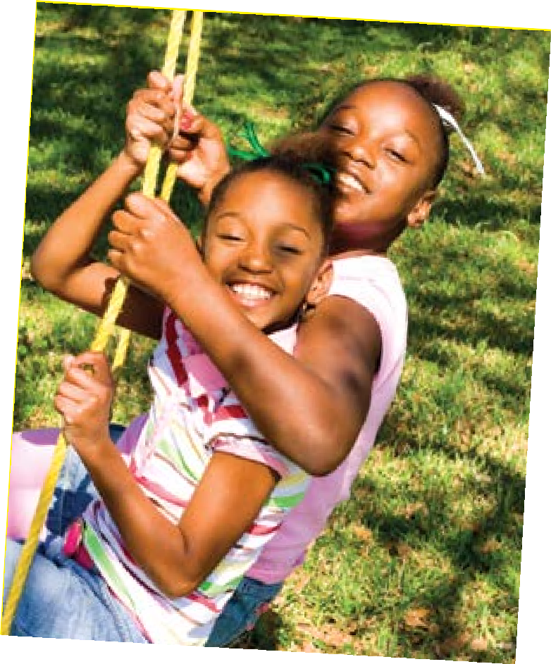For this reason, transitions with LAC and PLAC need to be managed very carefully even in those children who seem, on the face of it, to be taking things in their stride,
in order that children can make a success of the next phase of their education.

5

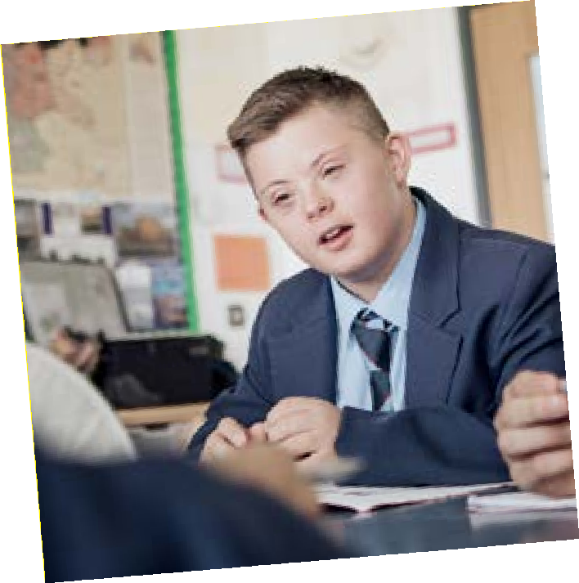Transition for LAC and PLAC: Lessons from research Research has shown us that no single transition ‘package’ is relevant to all children
A holistic approach is required which is tailored to the needs of the individual child. Despite the vulnerability of LAC
and PLAC, studies have also shown that the transition needs of these children are in many ways much the same as those of all children. We also know that LAC and PLAC want to be treated
in the same way as other children (Brewin & Statham¹); however, for LAC and PLAC, we know there are additional
factors at play, relating to the looked after child’s unique experiences of developmental trauma, separation and loss, which make them especially vulnerable at these times.
In practical terms this means they should benefit from the same transition preparation as all Year 6 children, but account must be taken of these additional factors, which will need to be responded to in a sensitive and considered manner and incorporated into their transition programme.

Transition for LAC and PLAC: Lessons from research (continued)

Relationships: Continuity of relationships is important for LAC and PLAC and other vulnerable children. The work of Bomber and Hughes consistently refers to the importance of relationships to undo or repair some of the damage that may have previously been done. They note that developing safe and meaningful relationships with a few key adults is important for emotional growth. Bomber (2007) points out that ‘Every relationship has the power to confirm or challenge what’s gone before’. Relationships (old and new) should be a key component of the LAC and PLAC transition programme. Frederikson and Bloyce (2012)2 demonstrated the importance of Transition Support Assistants (TSAs) working with vulnerable children in the final term of Year 6 and continuing this
work in the first term of Year 7. A significant part of the role of the
TSA was to facilitate key relationships in High School.
Studies have also shown that self-efficacy is a significant protective factor in increasing wellbeing and reducing mental health problems in a child’s transition year. Self-efficacy is defined by Bandura (1995) ‘as the belief in one’s capabilities to organise and execute the course of action required to manage prospective situations’. In other words, how confident a person feels about his or her ability to succeed in a specific situation or with a specific task. Self-efficacy is a key component of resilience; building resilience will in turn build self-efficacy. There is widespread evidence that self-efficacy is negatively impacted by maltreatment and neglect. Improving a LAC or PLAC’s self – efficacy is therefore recommended. For suggestions see Appendix 3: Helping Children feel they can Succeed.

Transition for LAC and PLAC: Lessons from research (continued)
Resilience too has a positive impact on an individual’s capacity to cope with change. We should therefore be looking at how to develop vulnerable children’s resilience well ahead of their transition date. The Friends for Life programme is a social skills
and resilience building group programme that has been recognised by the World Health Organisation as an effective way to prevent anxiety in children. It can be run in schools and has a very good evidence base. Ideally it is designed to be run with small groups
of children but can also benefit children who need an individual approach. (See Appendix 4)
Executive functioning: We also know that children who have experienced developmental trauma often have poorer executive functioning skills (Wretham, AE & Woolgar, M. 2017; Lansdown, R., Burnell, A., Allen, M: Family Futures 20073). These are the skills that help us to control our impulses, to plan ahead with a clear aim in mind, to organise ourselves, to work out what we need to do next and to be able to shift from one thing to another as the situation requires. It is easy to see how relevant these skills are
to the increased level of independent behaviour that we require of our children as they move to high school. It is also easy to see how many LAC and PLAC will struggle with this through no fault of their own. Programmes and activities to improve executive functioning skills will be helpful. (See Appendix 5)
(See Appendix 6)

What children worry about at transition to high school
Various studies have consistently shown that children worry about:
- Bullying
- Peer relationships
- Routines/environments
- Social issues
- Workload
- Homework
- Getting lost.
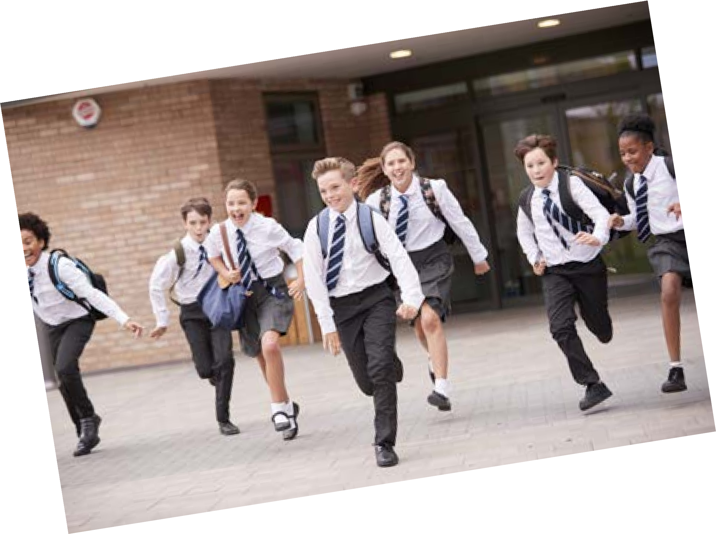It therefore makes sense that school transition programmes should work on these areas, some of which are very practical, as well as on the more emotional aspects of transitions relating to relationships, losses, separations and endings. See Virtual School Transition workbook Appendix 7

Transition planning
Research by Brewin & Statham 2011 identified certain key principles (at an individual and whole school level) that need to be taken into account when planning transition for LAC and PLAC.
These principles underpin the Lancashire Virtual School Guidance and are as follows:
- Early planning and good information sharing (both prior to and after transition) which should involve all stakeholders, including carers
- Transition support needs to be holistic
- LAC and PLAC’s differences should be minimised whenever possible
- Support should be individualised – there is no ‘one size fits all’ transition package.
Additionally, Designated Teachers from some of our own schools told us that good transition is:
- Individualised
- Shared
- Not rushed
- Involves a key person
- Understand that the young person needs to feel loved (importance of relationships emphasised here)
- 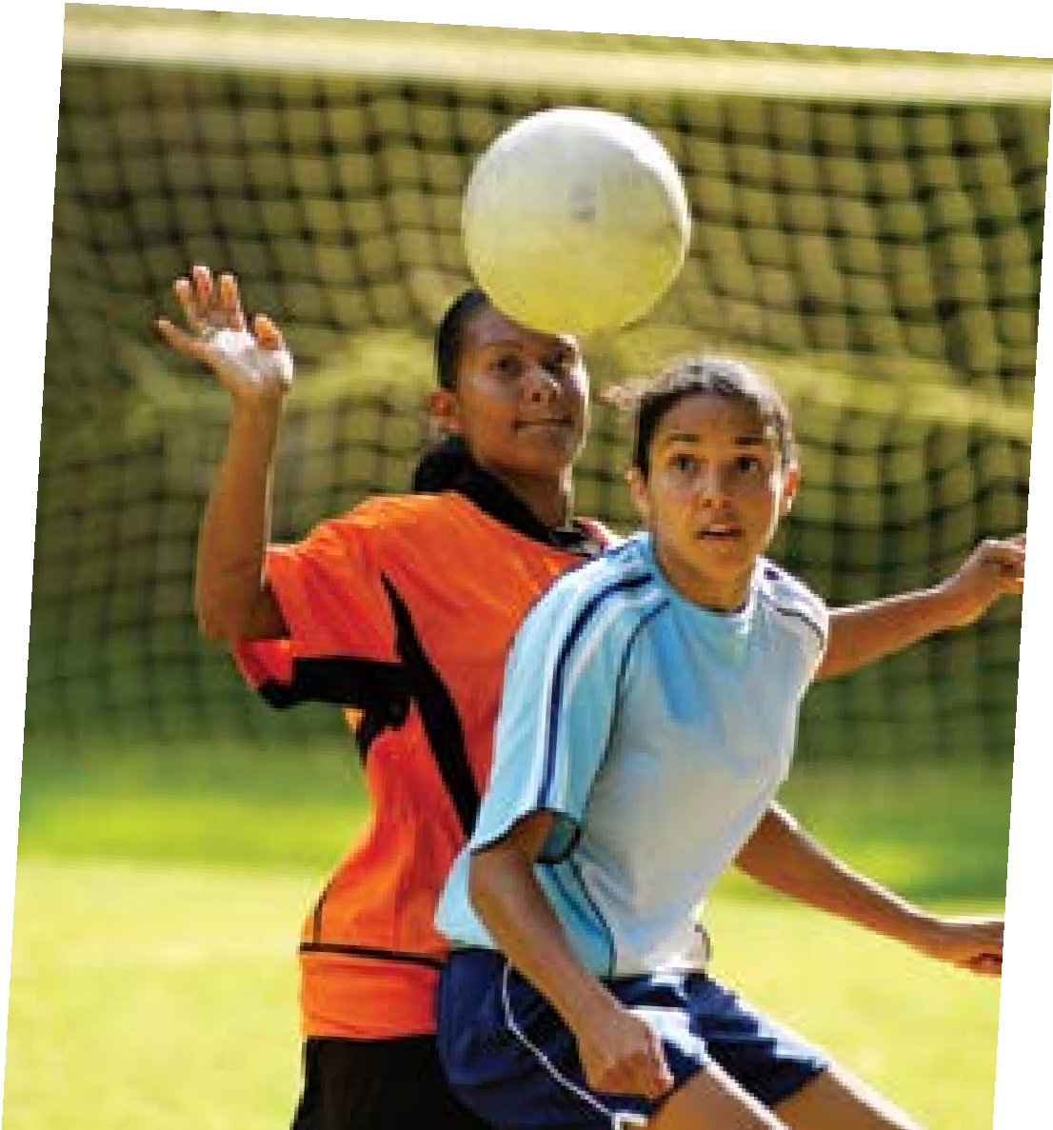Record and evidence based.

Assessing readiness for transition and providing support
It is useful to establish how ready the individual child is for transition to High School and to identify any areas that need to be developed so that a plan can be put in LAC and PLAC to support these. Lancashire Virtual School are using the ‘Readiness Scale for Transition to High School’ Appendix 8 (developed by Ealing VS) which is an assessment tool (based on materials developed by Rebecca Doyle (2001) and Jane McSherry, 1999) which might be used to explore the child’s ‘transition readiness’. It’s use enables a Transition Profile to be produced for each child. This tool was initially devised to examine readiness to return to mainstream provision in children with Social, Emotional and
Behavioural difficulties, but can be put to good use by schools working with the transition needs of LAC and PLAC.

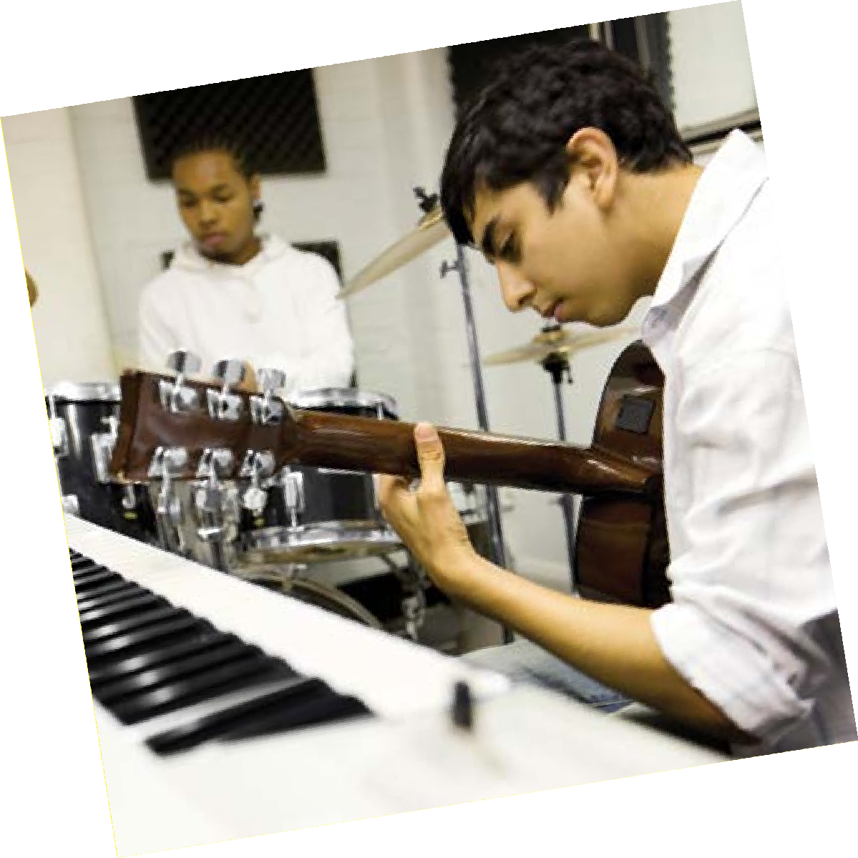

11

Transition time line
On the following pages is a suggested time-line of activities which may be useful to carry out when planning transition for LAC and PLAC in your school. The time-line starts in the final term of Year 5 and ends
in Spring of Year 7, though it is acknowledged that work may still be required beyond this in some individual cases. The time-line references certain resources/programmes that might be used to support the work of education staff. Additional information is given on these in the appendices at the end of this document.
Key people to involve:
- Child’s carer
- Child’s social worker
- Designated Teachers (DT) for LAC and PLAC (from High school and Primary). Primary school DT has responsibility for liaison with all concerned and coordination of activities and support; this responsibility will be handed over to High School DT
- Year 7 lead in High School
- Pastoral Head in High School
- Child’s Key Transition Person from Primary School
- Virtual School teacher.

Transition time line

All Looked After Children (LAC) and Previously Looked After Children (PLAC)
Carry out assessment of child’s transition readiness and create profile of need -see website
Summer term PEP starts the planning for what needs to happen in Autumn term year 6 regarding an individual’s transition needs
Inform High School (HS) of any LAC or PLAC intention to apply before HS open evenings begin Inform HS Designated Teacher (DT) when LAC or PLAC decides to apply
Encourage carers to start visiting local schools
Start to create a memory box for the children to take with them.

Looked After Children (LAC) with Education Health and Care Plan (EHCP) Year 5 Annual Review (AR) is an important time for planning and thinking about HS. If possible, hold the AR early in the year

Request updated Education Psychologist (EP) advice and advice from other relevant professionals as appropriate
Include social worker and VST in AR
Invite EHC Co-ordinator to review if concerns are felt about high school transfer or if it is felt that different provision may be required
Involve EHC Co-ordinator in admissions processes and PEPs
Schools need to know the local offer. Familiarise parents/carers with local offer especially for those with EHCPs

All
Teachers/key people (KP) from local high schools visit and children become familiar with them. Continues throughout year 6
Year 5 Summer term

Transition time line

Autumn Term Year 6

School’s transition programme in place for all year 6 children

Looked After Children (LAC) and Previously Looked After Children (PLAC)
Autumn PEP: To focus on HS transition needs. At this PEP:
Where there are significant concerns about an individual, Primary school to consider identifying a key person (transition support assistant/transition mentor) for Looked After Children transition support. PPG may need to be used to fund this
This person will be available to work closely with the child and with HS to support the transition plan and to carry out any necessary individual transition work with the child. This person will also need to be available once the child has moved on to visit the HS in Autumn term Y7
Key person to start sessions with child using VS Transition workbook – see website
Consideration should also be given to whether the child might benefit from any of the following: Resiliency training programme e.g Friends for Life (to continue through the year) (Appendix number 4)
Work on executive functioning – how to plan, think ahead, make lists, organise self (to continue through the year) (Appendix number 6)
Think about developing self-efficacy skills. Focus on experiences of success and attribution to oneself rather than to external factors (see appendix for suggestions) (Appendix number 3)

ALL
Children doing preliminary research on local High Schools and communicating findings to parents and carers. Discussions begin
Primary schools to be aware of HS open days and share info with parents and carers Information share evening for parents/carers relating to HS transfer plans
Primary school to use school’s PSED programme. Key person follows up with Looked After Children in individual sessions
PSHE Changes/transition programme. CLA/PLAC may need individual additional sessions.
High schools come in to talk to children. Key person follows up with LAC and PLAC in individual sessions Consider: Y7 to visit primary and have regular sessions talking to future pupils about life at the school
Regular Q&A sessions with pupils to provide them with opportunities to obtain information in a safe space – with support of KP
Whole class circle time / teaching on high school
Primary school: Teaching of strategies to help support independence – Looked After Children with support of KP when necessary
High school induction day

Transition time line

Spring Term Year 6

Looked After Children and Previously Looked After Children (PLAC)
Face to face PEP to be held after HS place confirmed for LAC or PLAC
Primary school to invite key person/people from HS (usually DT, Year 7 Head & SENCo if appropriate). Transition meeting / plans made
Year 7 Head and DT/SENCo to attend Looked After Children reviews, to meet child, carers and social worker (social worker to try to arrange 6 monthly Looked After Children review to coincide with this term or the Summer term)
Bespoke enhanced transition visits to HS commence. Try to arrange these so they occur at a time that will minimise the singling out of the Looked After Children and where other children may also be included
Possibly include Key transition support person Introduction to curriculum/lessons
Facilities
Introduction to teachers
High school try to include time in Y7 classroom/nurture base/Y7 base and include in activities e.g. craft activities. Invite some current Year 7s to meet the children
High school to arrange for Y7s to talk about positive experiences at the school. Possibly arrange ‘buddy’ system
Prioritise for EP assessment if necessary to ensure Y7 support is appropriate

ALL
Transition group work may be provided for certain children; for example:

Induction/taster days for all – these may also be in the summer term

Transition time line

Looked After Children and Previously Looked After Children (PLAC)
PEP to be held to include same key person/people from HS
All children including Looked After Children various transition activities
Child researching high school they will be attending
MY New School Booklet with photos of teachers/DT and other key people School’s own transition project may be run after SATS
Child passport/one-page profile prepared for HS
Work on independence training if necessary (may be carried out by child’s key person (transition support worker)

Some children may benefit from use of social stories to address anxieties
Primary and High schools work on ‘curriculum continuity’ perhaps by inviting Y7 teacher to primary Consider the child’s HS transport arrangements, including
SEND transport application procedures for parents/carers

High School:
Carefully plan tutor groups
Consult DT and key person re who vulnerable child needs to be placed
Explore Summer holiday programmes arranged by high school which may be accessed by some children
Induction/taster days for all
Summer Term Year 6

Transition time line

High school / form tutor communicates primary school information about Looked After Children to subject teachers
HS to set up a Buddy System if felt this would be helpful
Where appropriate Looked After Children Key transition person from primary makes regular visits to create bridge between primary and HS. PPG may need to be used to facilitate this
Autumn PEP to include Key transition person from primary
Carers should be provided with a contact in high school, so they have a good understanding of how the high school works and what the challenges are
Consider staff training for all those who will be teaching/ supporting Looked After Children. The VS should support with this.
DT in school hold focus group for all staff working with the pupil
DT/key person to meet with the pupil weekly for first half term. Bring ‘news’ from primary school; for example: postcard/phone call
Autumn Term Year 7

PEP meeting to be held and to ensure transition support remains appropriate. Ensuring PPG continues to reflect child’s transition needs

Spring Term Year 7

Appendices
Appendix 1
Example Transition Plan and Strategies: PAC-UK Education Service
https://www.pac-uk.org/wp-content/uploads/2018/05/Example-Transition-Plan-and-Strategies- V1.0.pdf
Appendix 2
PAC-UK Saying Goodbye to Primary School:
https://www.pac-uk.org/wp-content/uploads/2016/04/Goodbyes-and-Transitions-V1.1-1.pdf
Appendix 3
Self-Efficacy ideas: Helping children believe they can succeed, Fishful thinking https://www.forsyth. k12.ga.us/cms/lib3/ga01000373/centricity/domain/31/self-efficacy_helping_children_believe_they_ can_suceed.pdf
Appendix 4
Resilience: Friends for Life Programme. https://friendsresilience.org/friendsforlife
Appendix 5
National Centre for Learning Disabilities NCLD: Executive Function Factsheet http://www.ldonline.org/article/24880/
Appendix 6
Executive Function 101: National Centre for Learning Disabilities https://www.understood.org/en/learning-attention-issues/child-learning-disabilities/executive- functioning-issues/ebook-executive-function-101

References
Brewin, M., Statham, J. (2011) Supporting the transition from primary school to secondary school for children who are looked after
Bloyce, J., Frederikson, N., Intervening to improve the transfer to secondary school: Educational Psychology in Practice Vol.28. No. 1, March 2012, 1 - 18
Wretham, AE & Woolgar, M 2017, ‘Do children adopted from British foster care show difficulties in executive functioning and social communication?’ Adoption and Fostering, vol. 41, no. 4,
pp. 331-345
Family Futures (Richard Lansdown, Alan Burnell and Marion Allen): Is it that they won’t do it, or is it that they can’t? Executive functioning and children who have been fostered and adopted
Social and Emotional Aspects of Learning (SEAL): Improving behaviour, improving learning https://webarchive.nationalarchives.gov.uk/20110812101214/http://nsonline.org.uk/ node/66432?uc=force_uj
Social and Emotional Aspects of Learning (SEAL): Theme 7: Changes https://webarchive.nationalarchives.gov.uk/20110812101214/http://nsonline.org.uk/ node/66432?uc=force_uj

Additional useful resournces
Let’s learn together Sheila Lavery: Adoption UK and Health and Social Care The Day the Sea Went Out and Never Came Back by Margot Sunderland The Huge Bag of Worries by Virginia Ironside.

EC8943-1 PrintOut Design & Production January 2021

