Answers and Mark Scheme

Holiday Revision

10-4-10
Ten minutes a day for ten days

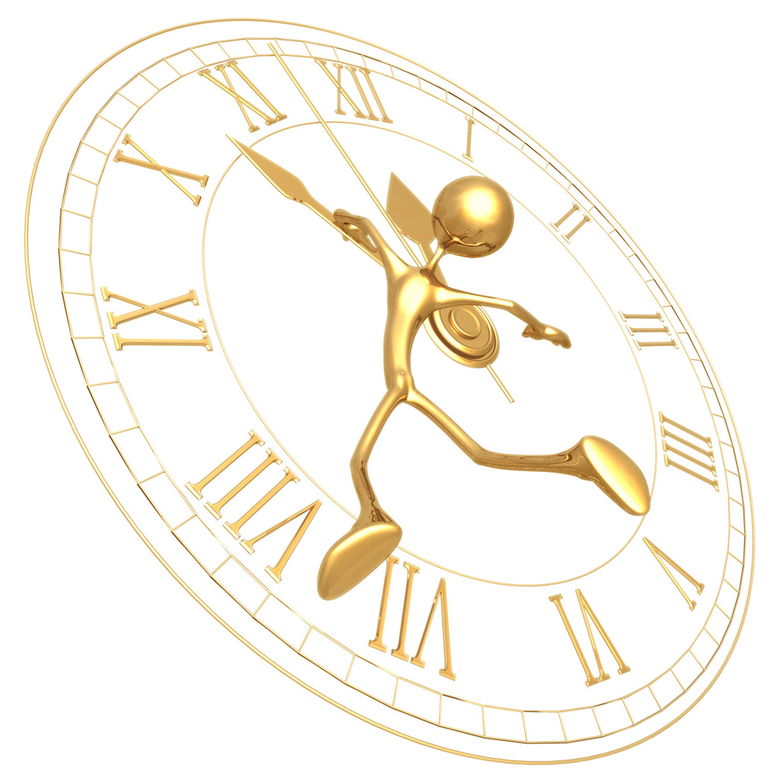

10-4-10 | Year 11 mathematics: holiday revision  Non-Calculator Answers | DAY 1
1. One night at a school concert the audience is made up as follows:
1
4
a
r
e
m
e
n
,
a
r
e
w
o
m
e
n
,
a
n
d
t
h
e
r
e
s
t
a
r
e
c
h
i
l
d
r
e
n
.
3
5
(a) (i) What percentage of the audience are children?
Remember percentage means ‘out of 100’
 = 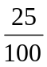 = 25% (This one you should know)
x 20
= 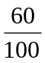 = 60%
x 20
25% are men, 60 % are women so 100% - 25% - 60% = 15 %
So 15% are children.
(2)

- What fraction of the audience are children?
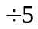
15% is the same as 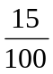 = 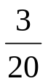

(3)
(b) The next night the audience is made up in the following ratio:
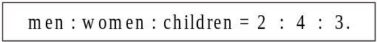
There are 270 people in the audience. Calculate the number of men.
Total number of parts = 2 + 4 + 3 = 9 parts
270 people shared between 9 parts
= 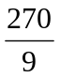 = 30 people per part, So 1 part represents 30 people
Men represent 2 parts 2 parts ⇨ 2 x 30 people = 60 people (2)
10-4-10 | Year 11 mathematics: holiday revision  Calculator answers | DAY 1
2. (a) Miss Evans earns £240 per week. She is awarded a pay rise of 3.5%.
Mr Dale earns £220 per week. He is awarded a pay rise of 4%.
Whose weekly pay increases by the greater amount of money?
You must show all your working.
Both pay increases are found by calculating a % of an amount
Remember percentage means ‘out of 100’
3.5% means 3.5 out of 100 = 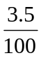= 3.5 100 = 0.035
4% means 4 out of 100 = 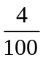= 4 100 = 0.04
So 3.5% of £240 So 4% of £220
= 0.035 x 240 = 0.04 x 220
= 8.4 = £8.40 (Not £8.04) = 8.8 = £8.80 (Not £8.08)
Mr Dale gets a greater pay increase of £8.80 compared to £8.40
(4)
(b) In 2003 the State Pension was increased by 2% to £78.03.
What was the State Pension before this increase?
This is quite a difficult percentage question!
100% represents the total state pension before the increase.
We know that 100% + 2% increase = 102% = £78.03
Use the diagram to calculate 100%, by first finding 1%

£0.765 x 100
= 76.5
=£76.50
102% 100% = £76.50
= £78.03
1% = 78.03 102
= £0.765
(Do not round here) (3)

10-4-10 | Year 11 mathematics: holiday revision  Non-Calculator Answers | DAY 2
3. In the year 1900, estimates were made of the numbers of three types of whales.
The estimates were made again in 1993.
The information for the Sei Whales is not shown on the diagram.
(a) Find the following fraction, giving your answer in its simplest form.
1900
in

Whales
Blue

of
Number
in

Whales
Blue

of
Number
1993
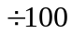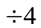
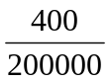= 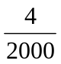= 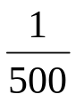

(1)
(b) Calculate the percentage decrease in the number of Fin Whales between the years 1900 and 1993.
The amount of whales decreased = 500 000 – 140 000 = 360 000
Percentage decrease = 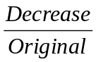 x 100% = 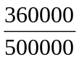 x 100%
= 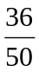 x 100% = 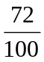 x 100% = 72% (3)
(c) The ratio of Sei Whales for 1900 to Sei Whales for 1993 is 5 : 1.
The combined total of these whales for the two years was 300 000.
How many Sei Whales were estimated in 1900?
Total number of parts = 5 + 1 = 6 parts
300 000 whales shared between 6 parts
= 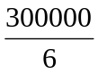 = 50 000 whales per part, so 1 part represents 50 000
1900 represents 5 parts 5 parts = 5 x 50 000 = 250 000 whales (2)

10-4-10 | Year 11 mathematics: holiday revision  Calculator Answers | DAY 2

4. James invests £730 for 2 years at 12% per year compound interest.
How much interest does he earn?
There are two ways you can tackle this. First you must understand that
compound interest means that interest compounds – builds up
The long way of doing this!
Find 12% of £730 = 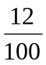 x 730
= 0.12 x 730 = 87.6 = £87.60 (Not £87.06)
So after 1 year there is £87.60 interest + £730 in the bank = £817.60
So for the second year we need to find the interest accrued on £817.60
Next Find 12% of £817.60 = x 817.6
= 0.12 x 817.6 = 98.112 = £98.11
So after 2nd year there is £98.11 interest + £817.60 in the bank
Total interest = £87.60 + £98.11 = £185.71
The hard to understand but easy way to calculate
If you increase an amount by £730 by 12%
£730 is 100% of the money, 12% is the interest added on to the 100%
We need to find 100% +12% = 112%
112% = 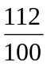 = 1.12 So 112% of £730 = 1.12 x 730
If we do this for two years we find 1.12 x 1.12 x £730 or 1.12² x 730
= £915.71 (Amount in bank)
Therefore the interest = £915.71 - £730 = £185.71
(2)

10-4-10 | Year 11 mathematics: holiday revision  Non-Calculator Answers | DAY 3

5. Yogurt is sold in small pots and large pots.
(a) A small pot costs 20 pence.
A large pot costs 150% more.
How much does a large pot cost?
Need to find what 150% of 20 pence is
100% of 20 pence is 20 pence
50% of 20 pence is 10 pence
So 150% of 20 pence is 30 pence
Answer 30 pence
(2)

(b) The ratio of the weight of a small pot to the weight of a large pot is 3 : 11.
The weight of a small pot is 120 g.
What is the weight of a large pot?
Information we have is that 3 parts of small pot : 11 parts of large pot
120 g is weight of small pot = 3 parts
= 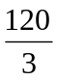 = 40 g per part, so 1 part represents 40 g
Large pot represents 11 parts
11 parts = 11 x 40 g = 440 g
Answer is 440 g
(3)
(c) The weight of a small pot is correct to the nearest gram.
What is the minimum weight of a small pot?
Weight of small pot = 120g
119.5 120 120.5
Help – Because the weight has been calculated to the nearest gram then there needs to be 1 gram difference between then minimum and maximum values
This means that there needs to be 0.5 g either side of the 120 g
119.5 g minimum, 120.5 g maximum Answer 119.5 g (1)

10-4-10 | Year 11 mathematics: holiday revision  Calculator Answers | DAY 3

6. Work out:

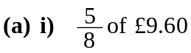

= 5 8 ‘of’ means ‘’ £9.60 = 9.6
Remember to include the correct units in your answers e.g. £, metres etc

Calculator sequence (58) 9.6 = 6 = £6.00

- 24% of 35 metres.

Remember percentage means ‘out of 100’

24% = 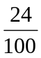 = 24 100 = 0.24 ‘of’ means ‘’

Calculator sequence (24100) 35 = 8.4 metres

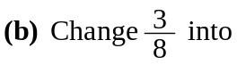

- a decimal fraction,

= 3 8 = 0.375 (a decimal fraction is a decimal number)

- a percentage.
Remember percentage means ‘out of 100’

= 3 8 = 0.375

To convert a decimal fraction to a percentage simply 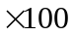 or

using place value know that 0.375 = 375 thousandths = 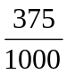 = 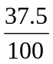 = 37.5%

(4 marks)

10-4-10 | Year 11 mathematics: holiday revision  Non-Calculator Answers | DAY 4

7.
The longest side is opposite the right-angle and is labelled
c = hypotenuse

The diagram shows a right-angled triangle ABC and a circle.
A, B and C are points on the circumference of the circle.

AC is a diameter of the circle.
Using Pythagoras find the length of the diameter AC.

Pythagoras’ Rule states that a² + b² = c²
Remember that c is the longest side (hypotenuse) and is opposite the right-angle; in this example c must equal the diameter AC. It does not matter how you label the other two sides
Let AB = a so a² = 16² = 16 16 =?
16 10 = 160
16 6 = (10 6) + (6 6) = 96
16 16 = 160 + 96 = 256

Let BC = b so b² = 12² = 12 12 =144

Using Pythagoras’ Rule a² + b² = c² 256 + 144 = 400 = c² c = 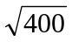= 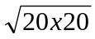=20
Therefore Diameter AC = 20 cm, so radius = 10 cm
Given is approximately 3.14, Calculate the area of the shaded part of the circle.

Area of circle = r² = 3.14 x 10 x 10 = 3.14 x 100 = 314 cm²
Area of triangle = 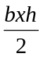= 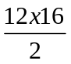= 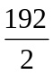= 96 cm²

Shaded Area = Area of circle – Area of triangle = 314 cm² - 96 cm² = 218 cm2
(6 marks)
10-4-10 | Year 11 mathematics: holiday revision  Calculator answers | DAY 4

8. Sidney places the foot of his ladder on horizontal ground and the top against a vertical wall. The ladder is 16 feet long.
The foot of the ladder is 4 feet from the base of the wall.
The longest side is opposite the right-angle and is labelled
c = hypotenuse
= 16 feet

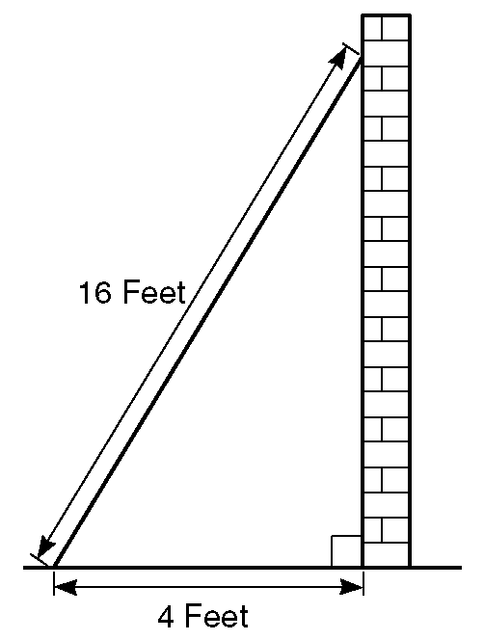
(a) Work out how high up the wall the ladder reaches.
Give your answer to 3 significant figures.

Pythagoras’ Rule states that a² + b² = c²
Remember that c is the longest side (hypotenuse) and is opposite the right-angle; in this example c must equal the length of the ladder 16 feet. It does not matter how you label the other two shorter sides

c = 16 feet so c² = 16 x 16 = 256 ft²
a = 4 feet so a² = 4 x 4 = 16 ft²

Pythagoras’ Rule states that a² + b² = c²
So 16 + b² = 256
16 + ? = 256
16 + 240 = 256
So b² = 240
b = 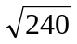 = 15.491933 (write down all the calculator display here)
b = 15.5 feet (3 significant figures)
This is the angle we need to find
(b) Work out the angle the base of the ladder makes with the ground.
Give your answer to 3 significant figures.

You will need to remember your trigonometric identities

Sin x = 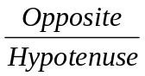 Cos x = 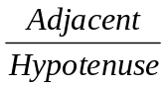 Tan x = 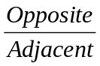

Label your right-angled triangle O = Opposite, A = Adjacent, H = Hypotenuse
In this example A = 4 feet, H = 16 feet and we have just found O = 15.5 feet.
It is always best to use the values given in the question i.e. A and H
A = 4 feet
Adjacent is between the right-angle and angle

Cos x == 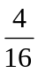 = 0.25
x = Cos ⁻¹
(Use inverse Cos function on your calculator)

x = 75.5224878
x = 75.5 degrees (3 significant figures)

(6 marks)
10-4-10 | Year 11 mathematics: holiday revision  Non-Calculator answers | DAY 5

9. The diagram is a drawing of a triangular prism.
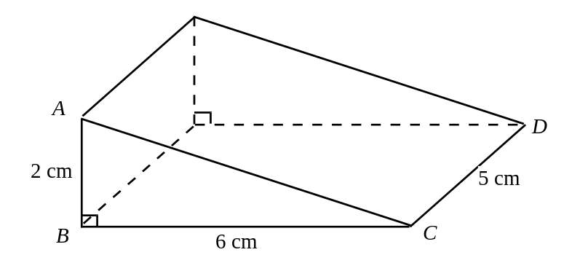
- Calculate the area of triangle ABC.
Area of triangle ABC is easy to calculate, it is simply half the area of a rectangle measuring 6 cm by 2 cm

Area of triangle = = 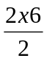= 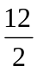= 6 cm²

(2)
(b) Calculate the volume of the prism.
Volume of a prism = Area of the cross-section x length

Area of cross section = 6 cm²

Length = 5 cm
Volume of a prism = 6 cm² x 5 cm = 30 cm³

(2)
Units of volume =cm³
Area x length
= cm²
cm
= cm
cm
cm = cm³

cm

10-4-10 | Year 11 mathematics: holiday revision  Calculator answers | DAY 5

10. The diagram shows a cylinder.

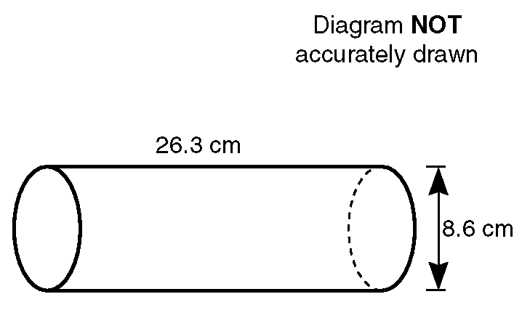

The height of the cylinder is 26.3 cm.

The diameter of the base of the cylinder is 8.6 cm.

Calculate the volume of the cylinder.
Give your answer correct to 3 significant figures.
Area of cross section
= Area of circle
=
r²

Length (Height)
= 26.3 cm
A cylinder is a prism and the two end faces (cross section) are circles
Volume of a prism = Area of the cross-section x length
= r² 26.3
= 4.3 4.3 26.3 = 1527.716
diameter = 8.6 cm
radius = 4.3 cm

= 1530 cm³ (3 sig. figs)

(4 marks)

10-4-10 | Year 11 mathematics: holiday revision  Non-Calculator answers | DAY 6
8
4
°
x
°
2
°
x
N
o
t

d
r
a
w
n
a
c
c
u
r
a
t
e
l
y
11. (a) The triangle has angles x°, 2x° and 84° as shown.
Find the value of x.

Angle fact: The sum of the interior angles in a TRIANGLE is 180°

x° + 2x° + 84° = 180°
Subtract 84° from both sides to eliminate 84° from RHS
84° - 84° = 0
3 x° + 84° = 180°
Divide both sides by 3

3x° = 180° - 84°
3x° = 96 °
x° = 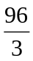
x = 32 degrees
(3)
(b) 5(2x – 1) = 35,
5(2x – 1) means 5 lots of (2x – 1) = 10x – 5
or (2x – 1)+(2x – 1)+(2x – 1)+(2x – 1)+(2x – 1) = 10x – 5
Add 5 to both sides to eliminate -5 from LHS
-5 + 5 = 0
10x – 5 = 35
Divide both sides by 10

10x = 35 + 5
10x = 40
x = 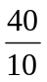
First chose the side with least number of x’s (RHS)
We need to eliminate
-2x from RHS so we will add 2x to both sides
-2x + 2x = 0
x = 4
(2)
(c) 4x + 3 = 18 – 2x.
4x + 3 + 2x = 18
6x + 3 = 18
Subtract 3 from both sides to eliminate 3 from LHS
3 - 3 = 0

Divide both sides by 6

6x = 18 – 3
6x = 15
x = 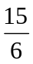 (You can leave your answer like this) 0r x = 2.5 (2)
10-4-10 | Year 11 mathematics: holiday revision  Calculator answers | DAY 6
12. The angles of a quadrilateral are 73°, 2x°, 3x° and 102°.
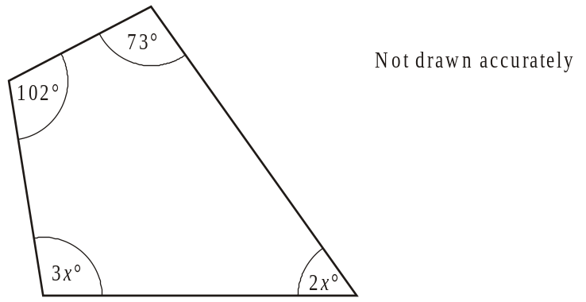
To remember this angle fact, think of a square, another 4 sided polygon. The sum of its interior angles is
4 x 90° = 360°
- Write down an equation in x.
Angle fact: The sum of the interior angles in a QUADRILATERAL is 360° (A quadrilateral is a 4 sided polygon)

3x° + 2x° +102°+ 73°= 360°
5 x° + 175° = 360°
Subtract 175° from both sides to eliminate 175° from LHS
175° - 175° = 0
Divide both sides by 5

5x° = 360° - 175°
5x° = 185 °
x° = 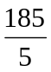
x = 37 degrees

(2)
(b) Use your equation to find the largest angle in the quadrilateral.
Largest angle = 3x° = 3 37° = 111°
Answer 111 degrees
(3)
(c) Solve
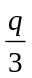 = − 7.4
Multiply both sides by 3
-7.4 x 3 = -22.2

Rules for multiplying and dividing negative and positive numbers

/ | + | -
+ | + | -
- | - | +

Answer q = -22.2
(2)

10-4-10 | Year 11 mathematics: holiday revision  Non-Calculator answers | DAY 7
13. (a) Simplify 10d + 3e – 2d – 7e
Collect together like terms. What have we got?
+3e -7e +10d -2d
(Remember the sign of the term is in front of the term)
Answer is 8d - 4e or -4e + 8d
(2)
(b) (i) Expand and simplify (2x − 3)(3x + 5)
Use the method you are most comfortable with such as FOIL, Smiley face etc. The method shown here is the grid method
Remember rules for multiplying and dividing negative and positive numbers

 | 2x | -3
3x | 6x² | -9x
+5 | +10x | -15

Collect together like terms: 6x² -9x + 10x -15
Answer 6x² + x - 15 (3)
(ii) Multiply out and simplify (n + 3)2
If 3² = 3 3 then (n + 3)² = (n + 3) (n + 3)
 | n | +3
n | n² | +3 n
+3 | +3 n | +9

Collect together like terms n ² +3 n +3 n+9
Answer n ² + 6 n + 9
When multiplying – ADD powers
When dividing – SUBRACT powers
(3)
(c) Simplify
(i) y⁴ y⁻³ = y¹ = y (ii) y⁴ y⁵ = y-1 (=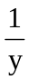)
10-4-10 | Year 11 mathematics: holiday revision  Calculator answers | DAY 7
14. (a) Expand and simplify
x(2x – 3) + 4(x2 + 1)
x(2x – 3) = 2 x² - 3 x 4(x2 + 1) = 4 x² + 4
Collect together like terms
Answer 6 x²- 3 x + 4
(3)
4 is common to both terms and is the highest common factor (HCF), so this can be taken outside the bracket
(b) Factorise 4c + 64
4c = 4 c 64 = 4 16
4c
4 = c
64
4 = 16
So c + 16 goes inside the bracket
Double check by expanding the bracket in your answer

Answer 4(c + 16)
(1)

(c) Factorise x2 + 5x
x is common to both terms and is the HCF, so this can be taken outside the bracket
x² = x x 5x = 5 x

Answer x(x + 5)
(2)
4xy² is common to both terms, and is the HCF, so this can be taken outside the bracket
(d) Factorise
8x3y2 – 4xy3
8 x³y² = 4 2 x x x y y
4xy³ = 4 x y y y
What is common to both terms? 4 x y y
Answer 4xy2 (2x2 - y)
(2)

10-4-10 | Year 11 mathematics: holiday revision  Non-Calculator answers | DAY 8
15. James plants some sunflower seeds.
He plants two seeds in each pot. The probability that a seed grows is
The probability tree diagram shows the outcomes for the two seeds in a pot.
(a) Complete the probability tree diagram.
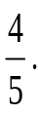
Probabilities sum up to 1, so each pair of branches add up to 1

G
r
o
w
N
o
t

g
r
o
w
G
r
o
w
N
o
t

g
r
o
w
G
r
o
w
N
o
t

g
r
o
w
4
5
.
.
.
.
.
.
.
.
.
.
.
.
.
.
.
.
.
.
.
.
.
.
.
.
.
.
F
i
r
s
t

s
e
e
d
S
e
c
o
n
d

s
e
e
d
(2)
(b) (i) What is the probability that both seeds grow?
In words: First seed grows AND second seed grows
Using probability
Remember
AND means
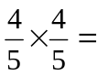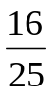
(2)
(ii) What is the probability that at least one seed grows?
In words; First seed grows AND second seed does not grow
OR First seed does not grow AND the second seed grows OR Both seeds grow
Using probability
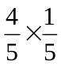 ₊ 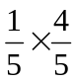₊ 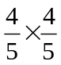 = 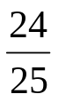
Remember
AND means
OR means +
(2)
10-4-10 | Year 11 mathematics: holiday revision  Calculator answers | DAY 8
16(i). Ruth made a spinner with three colours, green, blue and red.
She tested it by spinning it 500 times.
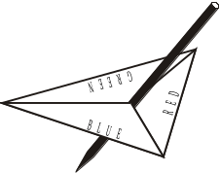
Her results were
227 landed on green
176 landed on blue
97 landed on red.
(a) Estimate the probability of the spinner landing on blue.
176 out of 500 is written as a fraction 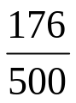 (2)
(b) In a game, the spinner is used 100 times.
How many times would you expect the spinner to land on blue?
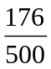 = 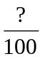 176 5 = 35.2 which is roughly 35 times
5
(2)
16(ii). (a) Three cards are numbered 1, 3 and 4.Three discs are numbered 2, 4 and 5.
1
3
4
2
4
5
A game consists of picking one card at random and one disc at random. The numbers on the card and disc are added together.
Complete the table to show all the possible totals.
1 + 5 = 6
Etc
 |  | Disc
 |  | 2 | 4 | 5
Card | 1 | 3 | 5 | 6
 | 3 | 5 | 7 | 8
 | 4 | 6 | 8 | 9
(b) What is the probability of getting a total which is an even number?.
Even numbers in grid are 6, 6, 8 and 8 so there are 4 even numbers out of 9 possible numbers. As a fraction this is 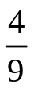
(4)

10-4-10 | Year 11 mathematics: holiday revision  Non-Calculator answers | DAY 9

17. Write down the nth term for each of the following sequences.
(a) 3, 6, 9, 12 ....…..
This is a linear sequence because the first difference is constant. Term to Term rule is +3

+3
+3
+3

Try 3n 3 6 9 12

The nth term is 3n
(1)
(b) 1, 4, 7, 10 ....……
+3
+3
+3

Try 3n 3 6 9 12

Try 3n-2 1 4 7 10

The nth term is 3n - 2
(1)
(c) 1, 4, 9, 16, ………
This is a not a linear sequence because the first difference is not constant.

The second difference is constant +2 this means that the sequence is quadratic
So we need to consider square numbers i.e. n²

+3
+5
+7
+2
+2
+2

Try n² 1 4 9 16

The nth term is n²
(1)
This is a quadratic sequence again so we need to use square numbers i.e. n²but because the second difference is +8 we need to use 4n² (8
2 = 4)
(d) 4, 16, 36, 64, ………
+122
+20
+28
+8
+8
+8

Try n² 1 4 9 16

Try 4 n² 4 16 36 64
The nth term is 4n² (2)
10-4-10 | Year 11 mathematics: holiday revision  Calculator answers | DAY 9

18. A sequence of numbers is shown below.
The first two terms are 3 and 4.
The remaining terms are found by adding together the two previous terms.
3, 4, 7, 11, 18, 29, . . .
(a) Write down the next two terms in the sequence.
18 + 29 = 47 47 + 29 = 76 47, 76

(1)

(b) The numbers from the first sequence are used to find the terms of a second sequence as shown below.
The terms are given to 2 decimal places.
4 ÷ 3 = 1.33
7 ÷ 4 = 1.75
11 ÷ 7 = 1.57
(i) Calculate the next three terms of this second sequence.
18 ÷ 11 = 1.64
29 ÷ 18 = 1.61
47 ÷ 29 = 1.62

(ii) Write down what you notice about the terms in the second sequence.
Terms are decimal numbers and are 1.something. The difference between the terms is decreasing and getting closer to 1.6

(3)

10-4-10 | Year 11 mathematics: holiday revision  Non-Calculator answers | DAY 10
19. Ten pupils took two examination papers in Mathematics.
Their marks out of 50 were as follows.
P
a
p
e
r
1
P
a
p
e
r
2
4
4
4
3
2
4
2
8
4
0
3
8
4
8
4
2
3
0
3
2
2
5
3
0
1
0
2
5
3
7
3
5
3
8
4
0
3
4
3
7
(a) On the grid below draw a scatter diagram of these marks.
35 marks on paper 1 corresponds to 35 marks on paper 2
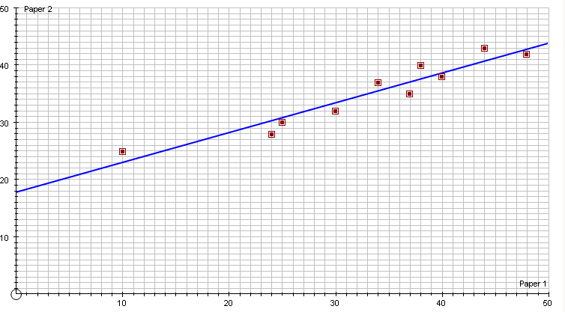
(2)
Find 32 marks on paper 1

b) Draw a line of best fit for the points you have plotted. (1)

10-4-10 | Year 11 mathematics: holiday revision  Non-Calculator answers | DAY 10

(c) Omar was absent for Paper 2. He scored 32 marks on Paper 1.
(i) What mark do you think it fair to give him for Paper 2?
35 (this answer will depend on how you have determined your line of best fit)

(ii) State how you got your answer.
Find 32 on the x-axis (paper 1 mark) draw a vertical line from 32 on the x-axis up to the line of best fit and then a horizontal line from the line of best fit to the y-axis and read off the paper 2 mark from the y-axis.
(2)
(d) These pupils also took an examination paper in Art and one in Chemistry.
A scatter diagram of these marks is drawn.
How might it be different from the one drawn for the two Mathematics papers?
There is a strong correlation between the two papers in mathematics; if a child performs well in paper 1 then they generally perform well in paper 2. A scatter diagram showing the marks in Art and Chemistry will show little or no correlation, as pupils performing well in Art might not necessarily perform well in Chemistry and vice versa
(1)

10-4-10 | Year 11 mathematics: holiday revision  Calculator | DAY 10
20. The countries of the world are divided into ‘developed’ and ‘under-developed’ countries.
The frequency table shows the distribution of ages for the population in the developed countries.
The figures are percentages and were estimated for the year 1985.

Age  (y years) | Percentage of  population | Cumulative  Percentage
0 < y ≤ 15 | 19 | 19
15 < y ≤ 30 | 22 | 41
30 < y ≤ 45 | 20 | 61
45 < y ≤ 60 | 17 | 78
60 < y ≤ 75 | 11 | 89
75 < y ≤ 90 | 9 | 98
90 < y ≤ 105 | 2 | 100
Cumulative percentage is like a ‘running total’
19 = 19 + 0
41 = 19 + 22
61 = 41 + 20
78 = 61 + 17
89 = 78 +11
98 = 89 + 9
100 = 98 + 2

10-4-10 | Year 11 mathematics: holiday revision  Calculator answers | DAY 10

- Construct a cumulative frequency diagram to show this information.
In this example the total cumulative percentage = 100%
The median ‘middle’ cumulative percentage is at 50% (100%
2) which corresponds to a median age of 37 on x-axis
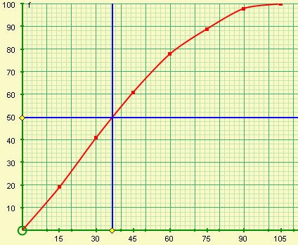
(3)
(b) (i) What was the median age for the population in developed countries in 1985?
37
(1)

(ii) The median age for the population in the under-developed countries in 1985 was 21.
What do the medians tell you about the difference between the population in the developed countries and the population in the underdeveloped countries?
People live longer in developed countries compared to those in underdeveloped countries as the median age is greater in developed countries
(2)

