Year 7 Golden Number Project

Introduction

The Mathematics National Curriculum states:

Learning and undertaking activities in mathematics contribute to achievement of the curriculum aims for all young people to become: successful learners, who enjoy learning, make progress and achieve.

It also says that mathematics is important because

Mathematics equips pupils with uniquely powerful ways to describe, analyse and change the world. It can stimulate moments of pleasure and wonder for all pupils when they solve a problem for the first time, discover a more elegant solution, or notice hidden connections. …

Mathematics is a creative discipline. The language of mathematics is international. The subject transcends cultural boundaries and its importance is universally recognised. Mathematics has developed over time as a means of solving problems and also for its own sake.

This project is intended to reflect this and to encourage pupils to

- Appreciate and be inspired by the beauty of mathematics.
- Enjoy working on mathematical activities
- Look for mathematics in the world in which they live.
- Discuss and apply different aspects of mathematics and develop the use of mathematical vocabulary in the context of the golden ratio.

The project follows on from the Year 6 Spirals project but is not dependant on it. It is primarily concerned with consolidation of mathematical knowledge and applying this knowledge to new situations. It is intended that pupils of all abilities will be able to complete the activities, though the amount of support needed and the outcomes will vary. There is the opportunity to develop this into a cross–curricular project by developing the theme of the golden ratio in art, and technology and using a range of ICT tools. The cross-curriculum dimensions of cultural diversity, creativity and critical thinking are important aspects of this project.

The project is presented as a whole project using different activities rather than a series of individual lessons. It is intended that teachers will make their own decisions about how they wish to divide up the activities. Teachers may choose to use the activities as presented in the project, but they are encouraged to develop this project using their own ideas in order to provide an interesting and worthwhile learning experience for the pupils they teach. Modification of some tasks may be needed to enable pupils of all abilities to complete the activities.

The activities could be completed by individuals working independently, but there is plenty of opportunity to encourage pupils to work in pairs and discuss what they are doing.

Key Concepts of Mathematics

The project aims to support the developments of the key concepts of mathematics.

1.1 Competence
a. Applying suitable mathematics accurately within the classroom and beyond.
b. Communicating mathematics effectively.
c. Selecting appropriate mathematical tools and methods, including ICT.

1.2 Creativity
a. Combining understanding, experiences, imagination and reasoning to construct new knowledge.
b. Using existing mathematical knowledge to create solutions to unfamiliar problems.
c. Posing questions and developing convincing arguments.

1.3 Applications and implications of mathematics
a. Knowing that mathematics is a rigorous, coherent discipline.
b. Understanding that mathematics is used as a tool in a wide range of contexts.
c. Recognising the rich historical and cultural roots of mathematics.
d. Engaging in mathematics as an interesting and worthwhile activity.

1.4 Critical understanding
a. Knowing that mathematics is essentially abstract and can be used to model, interpret or represent situations.
b. Recognising the limitations and scope of a model or representation.

Key Processes of Mathematics

A range of key processes will be used in completing the activities.

2.1 Representing
Pupils should be able to:
a. identify the mathematical aspects of a situation or problem
b. choose between representations
c. simplify the situation or problem in order to represent it mathematically, using appropriate variables, symbols, diagrams and models
d. select mathematical information, methods and tools to use.

2.2 Analysing

Use mathematical reasoning
Pupils should be able to:
a. make connections within mathematics
b. use knowledge of related problems
c. visualise and work with dynamic images
d. identify and classify patterns
e. make and begin to justify conjectures and generalizations, considering special cases and counter-examples
f. explore the effects of varying values and look for invariance and covariance
g. take account of feedback and learn from mistakes
h. work logically towards results and solutions, recognising the impact of constraints and assumptions
I appreciate that there are a number of different techniques that can be used to analyse a situation
J reason inductively and deduce.

Use appropriate mathematical procedures
Pupils should be able to:
a. make accurate mathematical diagrams, graphs and constructions on paper and on screen
b. calculate accurately, selecting mental methods or calculating devices as appropriate
c. manipulate numbers, algebraic expressions and equations and apply routine algorithms
d. use accurate notation, including correct syntax when using ICT
e. record methods, solutions and conclusions
f. estimate, approximate and check working.

2.3 Interpreting and evaluating
Pupils should be able to:
a. form convincing arguments based on findings and make general statements
b. consider the assumptions made and the appropriateness and accuracy of results and conclusions
c. be aware of the strength of empirical evidence and appreciate the difference between evidence and proof
d. look at data to find patterns and exceptions
e. relate findings to the original context, identifying whether they support or f. refute conjectures
f. engage with someone else’s mathematical reasoning in the context of a problem or particular situation
g. consider the effectiveness of alternative strategies.

2.4 Communicating and reflecting
Pupils should be able to:
a. communicate findings effectively
b. engage in mathematical discussion of results
c. consider the elegance and efficiency of alternative solutions
d. look for equivalence in relation to both the different approaches to the problem and different problems with similar structures
e. make connections between the current situation and outcomes, and situations and outcomes they have already encountered.

Mathematical processes and Applications

A range of mathematical processes and applications are included in all of the activities.

1.1 Representing
- identify the necessary information to understand or simplify a context or problem;
- represent problems, making correct use of symbols, words, diagrams, tables and graphs;
- use appropriate procedures and tools, including ICT

1.2 Analysing – use mathematical reasoning
- classify and visualise properties and patterns;
- generalise in simple cases by working logically;
- draw simple conclusions and explain reasoning
- understand the significance of a counter-example;
- take account of feedback and learn from mistakes

1.3 Analysing – use appropriate mathematical procedures
Within the appropriate range and content:
- make accurate mathematical diagrams, graphs and constructions on paper;
- make accurate mathematical diagrams, graphs and constructions on screen;
- calculate accurately, selecting mental methods or calculating devices as appropriate;
- manipulate numbers, algebraic expressions and equations,
- apply routine algorithms;
- use accurate notation, including correct syntax when using ICT
- record methods, solutions and conclusions;
- estimate, approximate and check working

1.4 Interpreting and evaluating
- interpret information from a mathematical representation or context;
- relate findings to the original context;
- check the accuracy of the solution;
- explain and justify methods and conclusions
- compare and evaluate approaches

1.5 Communicating and reflecting
- communicate own findings effectively, orally and in writing,
- discuss and compare approaches and results with others;
- recognise equivalent approaches
Activity 1 Calculating the Golden Number

Key words
Phi (Φ), Fibonacci sequence, divide, golden number, column, row, calculator, irrational number, recurring, decimal, decimal places

Resources
- PowerPoint slides 1 - 12
- Fibonacci and the Golden Number worksheet for each pupil.
- Calculator for each pupil
- Access to computers if the pupils are to produce a spreadsheet and a graph

Mathematics Learning Objectives | Mathematics Assessment Criteria
2.1 Place value, ordering and rounding
- understand and use decimal notation and place value;
- compare decimals in different contexts; | - order decimals to three decimal places (L4)
2.5 Mental calculation methods
- solve simple problems mentally accompanied where appropriate by suitable jottings; | - use a range of mental methods of computation with all operations (L4)
2.7 Calculator methods
- enter numbers and interpret the display in different contexts | - solve problems with or without a calculator (L4)
2.8 Checking results
- check results by considering whether they are of the right order of magnitude and by working problems backwards | - apply inverse operations and approximate to check answers to problems are of the correct magnitude (L5)
3.2 Sequences, functions and graphs
- describe integer sequences; | - recognise and describe number patterns (L4)
- generate terms of a simple sequence, given a rule (e.g. finding a term from the previous term, finding a term given its position in the sequence) | - recognise and use number patterns and relationships (L5)  - generate terms of a sequence using term-to-term definitions of the sequence, on paper and using ICT; (L6)
- plot the graphs of simple linear functions, where y is given explicitly in terms of x using ICT | - construct functions arising from real-life problems and plot their corresponding graphs;  - interpret graphs arising from real situations (L6)

Slide 1 Title – The Golden Number Φ (phi)

Slides 2 – 4 are taken from the Year 6 Spirals project presentation. The pupils should already have met the Fibonacci sequence. The slides are included here to remind pupils of the Fibonacci sequence or introduce the sequence to pupils who have not completed the Year 6 project.

Slide 2 Leonardo of Pisa (1170 – 1250 AD) was an Italian mathematician. He is sometimes called Fibonacci.

Fibonacci is famous for helping to spread the use of Hindu Arabic numbers in Europe. These numbers replaced the Roman number system.

Slide 3 Map of Italy.

Slide 4 This slide gives the first five numbers of the Fibonacci sequence. The next four numbers will appear on a mouse click. The teacher can make use of this to introduce or remind pupils about the Fibonacci sequence of numbers. There is an opportunity here to find out by questioning pupils what they know about the Fibonacci sequence.

Explain to the pupils that they are going to investigate the Fibonacci sequence further. Using the Fibonacci and the Golden Number worksheet (Appendix), get the pupils to continue the Fibonacci sequence and to calculate the quotients of each number and the previous number in the sequence. This activity can be completed by individuals or by pupils working in pairs. Pupils will need calculators to complete this task. Writing down all of the numbers on the calculator in the golden number column will allow the pupils to see how the number changes. This task can be modified by asking pupils who might find this task too demanding to complete fewer rows in the table.

Slide 5 This slide shows the completed Fibonacci and the Golden Number table.

When the pupils have completed the table, ask them to comment on what they notice about the numbers in the Golden Number column. They should notice that as they move down the golden number column the difference between one number and the next is getting less so that the numbers are getting nearer to the same number.

Slide 6 The Fibonacci numbers can be used to calculate the value of a special number called the golden number.

The golden number can not be written down exactly because it is a decimal number that goes on for ever without any recurring pattern.

Because the golden number cannot be written down exactly we use the 21st letter of the Greek alphabet, Φ or phi to represent the golden number.

Teachers may decide to explain the concept of rational and irrational numbers to pupils who are able to understand it.

Slide 7 Greek alphabet with Φ marked

Slide 8 Φ to 20 decimal places – the number appears on a mouse click.

Slide 9 Φ to 1000 decimal places – the number appears on a mouse click.

A spreadsheet with formulae that allow the Fibonacci and Golden Number columns to be extended is provided. If computer facilities are available, the pupils could create spreadsheets which would produce these results. This could then be used to draw a graph showing Φ tending to approximately 1.618

Slide 10 Graph showing Φ tending to approximately 1.62

Since it is not practical to produce this graph by hand due to the accuracy needed to plot the points the teacher could explain how the points have been plotted so that the pupils understand what the graph represents. If computers are available pupils could produce this graph from a spreadsheet.

Slide 11 Map of Egypt - It is thought that the Egyptians may have known about Φ over 2500 years ago

Slide 11 Picture of the great pyramid of Giza. Some people think that the Egyptians used Φ in the design of the Great pyramid of Giza which was completed about 2500 years ago.

Slide 12 Some people think that the Egyptians used Φ in the design of the Great pyramid of Giza which was completed about 2500 years ago.

Activity 2 The Golden Rectangle

Key words
Phi (Φ), centimetre, multiply, approximately, rectangle, width, length, golden rectangle, rounding, decimal places

Resources
- PowerPoint slides 13 - 25
- Golden Rectangles 1 worksheet for each pupil
- Golden Rectangles 2 sheet for each pupil.
- The great Golden Rectangle Hunt sheet for each pupil.
- Ruler and pencil for each pupil
- Tape measures
- Calculator for each pupil

Mathematics Learning Objectives | Mathematics Assessment Criteria
2.1 Place value, ordering and rounding
understand and use decimal notation and place value
compare decimals in different contexts | order decimals to three decimal places (L4)
2.7 Calculator methods
enter numbers and interpret the display in different contexts | solve problems with a calculator (L4)
2.8 Checking results
check results by considering whether they are of the right order of magnitude and by working problems backwards | apply inverse operations and approximate to check answers to problems are of the correct magnitude (L5)
3.1 Equations, formulae, expressions and identities
use letter symbols to represent unknown numbers or variables;
use simple formulae from mathematics and other subjects | begin to use simple formulae expressed in words (L4)  use simple formulae involving one or two operations (L5)
4.1 Geometrical reasoning
explore geometrical problems involving properties of quadrilaterals, explaining reasoning orally, using step-by-step deduction supported by diagrams | use a wider range of properties of 2-D shapes (L5)
4.3 Construction and loci
use a ruler to measure lines to the nearest millimetre | choose and use appropriate units and instruments (L4)  interpret, with appropriate accuracy, numbers on a range of measuring instruments (L4)
use a ruler to draw lines to the nearest millimetre

Slide 13 Golden Rectangles title slide

Slide 14 This slide explains that a rectangle is a golden rectangle if the length is Φ times the width.

The Golden Rectangles 1 worksheet (Appendix) can be completed by individuals or pairs of pupils working together. Explain to the pupils that they are going to measure some rectangles and find out which golden rectangles and which are not. For this activity the pupils will need to measure the lengths of the sides of the rectangles to the nearest millimetre. It may be helpful to check that they are able to do this correctly before they begin the activity on the Golden Rectangles 1 worksheet. Calculators will be needed for this activity. Some discussion about how close the numbers need to be before the rectangle can be considered to be golden would be useful, though there is no precise answer to this. It is a good opportunity to compare decimal number. There is also an opportunity to talk about rounding to a specified number of decimal places for pupils who are able to understand this concept.

Slide 15 This slide shows the completed table for the Golden Rectangles 1 activity.

The Great Golden Rectangles Hunt (Appendix) could be used as a homework activity though pupils will need to have rulers and or tape measures.. The pupils need to measure rectangles and determine how near they are to being golden rectangles. It will need to be pointed out that it is unlikely that they will find a rectangle that gives a result of exactly 1.618 when the length is divided by the width. A class competition to see who can get a rectangle that is nearest to a golden rectangle might encourage enthusiasm for the task.

The Golden Rectangles 2 activity provides one side of a rectangle that is either the length or the width and requires the pupils to complete the golden rectangle.

Slide 16 World map showing Greece - People in Greece knew about golden rectangles about 2500 years ago.

Slide 17 The Parthenon is a temple that was built about 2500 years ago on the Acropolis in Athens, Greece.

Slide 18 Many golden rectangles can be found in the design of the Parthenon.

Slide 19 The Parthenon with golden rectangles drawn in.

Slide 20 World map showing France. The west face of the cathedral of Notre Dame in Paris which was completed in the 13th century contains many golden rectangles.

Slide 21 The Cathedral of Notre Dame

Slide 22 The Cathedral of Notre Dame with golden rectangles

Slide 23 World map showing India The Taj Mahal In Agra in India was completed in around 1648 AD. Many golden rectangles can be found in the Taj Mahal.

Slide 24 The Taj Mahal

Slide 25 The Taj Mahal with golden rectangles

Activity 3 Constructing Golden Rectangles

Key words
Phi (Φ), centimetre, multiply, approximately, rectangle, width, length, golden rectangle, line, rounding, decimal places, square, midpoint, extend, corner, vertex, arc.

Resources
- PowerPoint slides 26 - 32
- Exercise books or paper
- Ruler, pencil and compasses for each pupil.
- Calculator for each pupil

Mathematics Learning Objectives | Mathematics Assessment Criteria
4.1 Geometrical reasoning
- identify and use angle, side and symmetry properties of quadrilaterals; | - use a wider range of properties of 2-D shapes (L5)
- explore geometrical problems involving angle side and symmetry properties of quadrilaterals, explaining reasoning orally, using step-by-step deduction supported by diagrams
4.3 Construction and loci
- use a ruler to draw and measure lines to the nearest millimetre | - choose and use appropriate units and instruments (L4)  - interpret, with appropriate accuracy, numbers on a range of measuring instruments (L4)
- use straight edge and compasses to construct: (Y8) | - use straight edge and compasses to do standard constructions (L6)
- use ICT to explore constructions | - devise instructions for a computer to generate shapes (L6)

Slide 26 Constructing golden rectangles title slide.

Slides 27–30 Golden rectangle construction instructions.

When pupils have completed the drawing they can check that the rectangle is golden by measuring the length and the width and dividing. They can draw other golden rectangles by starting with squares of different sizes.

The archaeologist Christopher Powell believes that the Mayan people have used the golden rectangle in their buildings. He says that the fundamental shape of Mayan geometry is the golden section, and that the Maya constructed golden rectangles using a piece of rope. The rope was used to mark out a square. If the rope is doubled back on itself it becomes half the length, and that halved rope can be used to find the midpoint of one of the sides of the square. The rope is placed on the midpoint and extended to one of the opposite corners, and then swung like compasses in an arc that will define the length of the longer side of the golden rectangle. Christopher Powell observed modern Yucatec Maya using this technique. Red marks remain on some ancient structures at Copan and Tikal that suggest sizing using the rope method.

Slide 31 Map showing Mexico, Honduras and Guatemala - The Mayan people have lived in the countries that are now Mexico, Guatemala and Honduras for thousands of years.

Slide 32 It is thought that the Mayan people used golden rectangles in their architecture. This is part of the Maya ruins of Copan in Honduras.

A dynamic geometry program such as Geogebra, Cabre or Geometers Sketch Pad could be introduced to produce golden rectangles using the similar techniques.
Activity 4 Golden Triangles

Key words
Phi (Φ) Triangle, isosceles, degrees, obtuse angle, acute angles, arc, round, decimal places

Resources

- PowerPoint slides 33 - 50
- Ruler, pencil, compasses and protractor for each pupil
- Exercise books or paper
- Calculator for each pupil

Mathematics Learning Objectives | Mathematics Assessment Criteria
2.1 Place value, ordering and rounding
- round decimals to the nearest whole number or one decimal place | - round decimals to the nearest decimal place and order negative numbers in context (L6)
- round decimals to the nearest whole number or to one or two decimal places (Y8)
4.1 Geometrical reasoning
- know the sum of the angles in a triangle; | - know and use the angle sum of a triangle (L5)
- identify and use angle, side and symmetry properties of triangles | - use language associated with angle(L5)
4.3 Construction and loci
- use a ruler to measure lines to the nearest millimetre | - choose and use appropriate units and instruments (L4)  - interpret, with appropriate accuracy, numbers on a range of measuring instruments (L4)
- Use a protractor to measure angles to the nearest degree | - measure and draw angles to the nearest degree, (L5)
- Construct a triangle given three sites (Y8) | - use straight edge and compasses to do standard constructions (L6)
- Use ICT to construct a triangle given three sites (Y8) | - devise instructions for a computer to generate shapes (L6)
4.4 Measures and mensuration
- distinguish between and estimate the size of acute, obtuse and reflex angles | - use language associated with angle(L5)  measure and draw angles to the nearest degree, (L5)

Slide 33 Golden triangles title slide

Slide 34 This slide shows a right angle an acute angle and obtuse angle and is intended to support whole class discussion to ensure that pupils can distinguish between obtuse angled and acute angled triangles.

Slide 35 Similarly, this slide shows equilateral, isosceles, right angled and scalene triangles and is provided to allow some initial assessment of understanding of terminology and properties with explanations where necessary.

Slide 36 There are two special isosceles triangles known as golden triangles. In both the length of the longer side is Φ times the length of the shorter side.

An example of each triangle is shown.

Slide 37 An example of an obtuse angled and an acute angled golden triangle

Slide 38 Constructing Golden Triangles title slide

Slide 39-43 It will be necessary to ensure that pupils are able to round numbers to one decimal place in order to be able to convert he measurement found after multiplying by Φ to a practical length to draw. These slides give instructions for construction of a golden triangle with the two equal sides longer than the third side. When the triangle has been constructed, pupils are asked to estimate then measure the size of each angle. It is advisable to check that pupils are able to use a protractor to measure angles before beginning the task.

Slide 44. Acute angled triangle showing sizes of angles. Some discussion about the angle sum of a triangle would be appropriate here.

Slide 45-49 Instructions for construction of a golden triangle with two equal sides shorter than the third size.

Slide 50 Obtuse angled triangle showing sizes of angles.

Dynamic geometry can be used to construct triangles in a similar way.
Activity 5 Golden Triangles Investigation

Key words
Phi (Φ) Triangle, isosceles, equilateral, scalene, quadrilateral, rectangle, square, parallelogram, rhombus, trapezium, kite, arrow head kite, degrees, parallel, right angle, obtuse angle, acute angles, congruent, similar

Resources
- PowerPoint slides 51 - 62
- Golden Triangles investigation sheet for each pupil
- Similar Triangles sheet fro each pupil
- Ruler and pencil for each pupil
- 4 card acute angled golden triangles and 4 card obtuse angled golden triangles for each pair of pupils
- Pair of scissors for each pupil or cut out triangles

Mathematics Learning Objectives | Mathematics Assessment Criteria
4.1 Geometrical reasoning
- identify and use angle, side and symmetry properties of triangles and quadrilaterals; | - use the properties of 2-D shapes. (L4)  - use a wider range of properties of 2-D shapes (L5)
- explore geometrical problems involving angle side and symmetry properties of triangles and quadrilaterals, explaining reasoning orally, using step-by-step deduction supported by diagrams | - use language associated with angle and know and use the angle sum of a triangle (L5)
- solve geometrical problems using side and angle properties of isosceles triangles and special quadrilaterals, explaining reasoning with diagrams and text; classify quadrilaterals by their geometrical properties (Y8)

Slide 51 Investigating Golden Triangles title slide.

Slide 52 Quadrilaterals. This slide is intended to provide an opportunity to discuss quadrilaterals and their properties to ensure that the pupils have a good understanding of this before beginning the activity.

Although a worksheet is provided for Golden Triangles Investigation, most pupils will need some further explanation of what is required. Whilst at least the first part of the task is relatively straight forward the level of reading required could make the task inaccessible to some pupils. Pupils will need to cut out card copies of the golden triangles. Four of each type of triangle between two pupils will be sufficient for the task. Templates are provided (Appendix). It might be helpful to copy the two types of triangle onto different colours of card to avoid confusion. Pupils should be advised to make the required shapes out of the card triangles and then to use the triangles to draw the shapes. This will be done most effectively by putting a small dot at the corner of each triangle and then joining the dots with a ruler.

These next two slides show the solutions to the first part of the Golden Triangles Investigation.

Slide 53 Quadrilaterals made from obtuse angled triangles.

Slide 54 Quadrilaterals made from acute angled triangles

Slide 55 Similar Golden Triangles title slide.

Slide 56 Congruent shapes are exactly the same shape and the same size. The slide is provided to support an explanation of the term congruent.

Slide 57 Similar shapes are the same shape but the sizes are different. The slide is provided to support an explanation of the term similar.

Slide 58 Slide showing shapes that are neither similar nor congruent.

There is an opportunity to relate this to how shapes are enlarged using ICT. When the corner of a rectangle is dragged the shape is enlarged and is similar to the original shape. When one of the sides is dragged the shape is stretched and is not similar.

The similar triangles activity is a continuation of the Golden Triangles Investigation.

Slide 59 Solution to similar triangles investigation

Activity 6 A Golden Knot

Key words
Phi (Φ) quadrilateral, parallel, .parallelogram, trapezium, kite, pentagon.

Resources
- PowerPoint slides 63 - 68
- One long strip of paper for each pupil. A long strip about 3cm wide cut from A4 paper will be suitable.
- Ruler and pencil for each pupil
- Calculator for each pupil

Mathematics Learning Objectives | Mathematics Assessment Criteria
2.7 Calculator methods
- enter numbers and interpret the display in different contexts | - solve problems with a calculator (L4)
4.1 Geometrical reasoning
- identify and use angle, side and symmetry properties of quadrilaterals; | - use a wider range of properties of 2-D shapes (L5)
- explore geometrical problems involving angle side and symmetry properties of quadrilaterals, explaining reasoning orally, using step-by-step deduction supported by diagrams
4.3 Construction and loci
- use a ruler to measure lines to the nearest millimetre | - choose and use appropriate units and instruments (L4)  - interpret, with appropriate accuracy, numbers on a range of measuring instruments (L4)

Slide 60 A Golden Knot title slide

Slide 61 This explains how to make the knot. It is more appropriate for the teacher to demonstrate the tying of the knot rather that depending on the written explanation on the slide. It is important that the knot is made as tight as possible without making unnecessary creases in the paper.

Slide 62 The slide begins with instructions to untie the knot and mark the creases. On a mouse click the strip with a parallelogram marked is shown followed by the name parallelogram on the next click. Similarly two trapeziums appear on the next click followed by the word trapezium.

Slide 63 Measure the lengths of the sides of the parallelogram and a trapezium.
What do you notice about the lengths?
Can you find any golden numbers by dividing the lengths of the sides?

- Pupils may notice that the shorter side of the parallelogram and two of the sides of the trapezium are the same length.
- The longer side of the parallelogram divide by the longer parallel side of the trapezium is approximately equal to Φ.
- In the trapezium, the loner parallel side divided by any of the other three sides will approximate to Φ.

Slide 64 This slide shows how to make a pentagon.

Activity 7 Pentagrams

Key words
Phi (Φ), pentagon, pentagram, kite, rhombus, parallelogram, trapezium, triangle, isosceles, angle, degrees.

Resources
- PowerPoint slides 68 - 87
- Ruler, pencil and coloured pencils for each pupil
- Exercise books or paper
- Large pentagon sheet for each pupil
- Pentagram Shapes activity sheet for each pupil
- Calculator for each pupil

Mathematics Learning Objectives | Mathematics Assessment Criteria
2.7 Calculator methods
- enter numbers and interpret the display in different contexts | - solve problems with a calculator (L4)
4.1 Geometrical reasoning
- identify parallel lines;
- know the sum of the angles in a triangle; | - use language associated with angle and know and use the angle sum of a triangle and that of angles at a point
- recognise vertically opposite angles
- know the sum of angles at a point,
- identify and use angle, side and symmetry properties of triangles and quadrilaterals; | - use the properties of 2-D shapes. (L4)  - use a wider range of properties of 2-D shapes (L5)
- explore geometrical problems involving angle side and symmetry properties of triangles and quadrilaterals, explaining reasoning orally, using step-by-step deduction supported by diagrams | - use language associated with angle and know and use the angle sum of a triangle (L5)
- solve geometrical problems using side and angle properties of isosceles triangles and special quadrilaterals, explaining reasoning with diagrams and text; classify quadrilaterals by their geometrical properties (Y8) | - solve geometrical problems using properties of triangles and other polygons (L6)
4.3 Construction and loci
- use ICT to explore constructions

Slide 65 Pentagrams title slide

Slide 66 A pentagram is a star made from five equal straight lines.
For over 5000 years the pentagram has been used as a special symbol by different groups of people.

Slide 67 World map showing Mesopotamia
The first known use of the pentagram was found in writings from about 3000 BC in a country called Mesopotamia which was where Iraq is today.

Slides 68-70 Instructions for drawing a pentagram. A pentagon template is provided for this activity in the Appendix.

Slide 71 This slide shows the two golden triangles with the sizes of the angles shown. When the pupils have drawn the pentagrams they could mark in the sizes of as many angles as they can. Both golden triangles appear in the pentagram and these angles can be filled in. The rest of the angles can be found using the fact that the sum of angles on a straight line is 180º.

Slide 72 Pentagram with angle sizes shown.

Slide 73 Measure the lines coloured red, green, pink and blue to the nearest millimetre.

Slide 74 Make a table showing the results of your measurements.

Slide 75 Without using a calculator work out

1. Pink length + Blue length

2. Pink length + Green length

Write down what you notice about your answers.

Slide 76 Use a calculator to work out .
- Red length ÷ Green length
- Green length ÷ Pink length
- Pink length ÷ Blue length

Write down what you notice about your answers.

Slide 77 Pentagrams inside pentagrams

Pupils will need the pentagrams worksheet and should colour in examples of different shapes they can identify within the pentagram.

Slide 78 – 84 Some solutions to the pentagram shapes activity.

It is relatively easy to create pentagrams and draw and colour triangles and quadrilaterals using dynamic geometry.

There is no specific activity associated with the final group of slides. Discussion with an art teacher might provide ideas for an appropriate cross- curricular activity.

Slide 85 The golden number and art title slide

Slide 86 For hundreds of years artists have used the golden number to help with the design of pictures because some people believe that this is how to create the most beautiful and pleasing picture.

Slide 87 In 1509, Luca Pacioli, an Italian monk published a book about the golden number and art. The book was illustrated by Leonardo da Vinci.

Slide 88 Leonardo da Vinci (1452 – 1519) was a painter, engineer, scientist and mathematician. Some people say that he was the most talented person who has ever lived. This is his self portrait.

Slide 89-94 Examples of paintings from different periods in history where use has been made of the golden number.

Slide 95 Final slide – golden number pictures.

There is a 6½ minute clip from the cartoon Donald in Mathemagic Land which includes a number of the ideas included in this project. This could be used at the end of the project to bring together different the different activities.

Slides 96-99 Two additional slides have been provided which might be a starting point for a data handling unit of work. Leonardo da Vinci’s Vitruvian man, an illustration of the human body inscribed in a circle and a square, came from a passage about geometry and human proportions in the writings of the 1st century BC Roman Marcus Vitruvius Pollio. The website www.censusatschool.ntu.ac.uk/involve.asp provides resources to support a survey of pupils including different body measurements. Pupils might for example find out whether dividing the length of the forearm by the length of the hand approximates to Φ

Appendix
Fibonacci and the Golden Number
Φ
Φ

The Fibonacci sequence of numbers can be used to calculate a special number called the golden number. The Greek letter Φ (phi) is used to represent the golden number.

You will need a calculator to help you to complete the table below. The first few rows have been done for you.

- Complete the Fibonacci number column.

- Complete the Calculation and the Golden Number columns

- The calculation is the Fibonacci number divide by the Fibonacci number in the row before.
- The golden number is the result of the calculation. Write down all of the numbers you get on your calculator.

- Under the table, write what you have noticed about the golden number

Number | Fibonacci Number | Calculation | Golden Number (Φ)
1 | 0
2 | 1
3 | 1 | 1 ÷ 1 | 1
4 | 2 | 2 ÷ 1 | 2
5 | 3 | 3 ÷ 2 | 1.5
6 | 5 | 5 ÷ 3 | 1.666666666667
7
8
9
10
11
12
13
14
15
16
17
18
19
20

I notice that

Fibonacci and the Golden Number – Answers

Number | Fibonacci Number | Calculation | Golden Number (Φ)
1 | 0
2 | 1
3 | 1 | 1 ÷ 1 | 1
4 | 2 | 2 ÷ 1 | 2
5 | 3 | 3 ÷ 2 | 1.5
6 | 5 | 5 ÷ 3 | 1.666666666667
7 | 8 | 8 ÷ 5 | 1.6
8 | 13 | 13 ÷ 8 | 1.625
9 | 21 | 21 ÷ 13 | 1.615384615385
10 | 34 | 34 ÷ 21 | 1.619047619048
11 | 55 | 55 ÷ 34 | 1.617647058824
12 | 89 | 89 ÷ 55 | 1.618181818182
13 | 144 | 144 ÷ 89 | 1.617977528090
14 | 233 | 233 ÷ 144 | 1.618055555556
15 | 377 | 377 ÷ 233 | 1.618025751073
16 | 610 | 610 ÷ 377 | 1.618037135279
17 | 987 | 987 ÷ 610 | 1.618032786885
18 | 1597 | 1597 ÷ 2987 | 1.618034447822
19 | 2584 | 2584 ÷ 1597 | 1.618033813400
20 | 4181 | 4181 ÷ 2584 | 1.618034055728

Golden Rectangles 1

l = Φ × w
Remember: In a golden rectangle the length is Φ times the width.

For this activity use 1.618 for Φ.

D
C
B
A
E
F

Measure the length and width of each rectangle. Use the table below to help you to decide which of these rectangles are golden and which are not. The first one has been done for you.
Remember!
If this number is approximately the same as the length, the shape is a golden rectangle.

Rectangle | Width  (cm) | Length  (cm) | Φ × Width  (cm) | Golden  rectangle?
A | 3.0 | 4.9 | 1.618 × 3.0 = 4.854 | Yes
B
C
D
E
F
Golden Rectangles 1 - Answers

Rectangle | Width  (cm) | Length  (cm) | Φ × Width  (cm) | Golden  rectangle?
A | 3.0 | 4.9 | 1.618 × 3.0 = 4.854 | Yes
B | 3.5 | 6.7 | 1.618 × 3.5 = 5.663 | No
C | 2.0 | 3.2 | 1.618 × 2.0 = 3.236 | Yes
D | 3.5 | 5.7 | 1.618 × 3.5 = 5.663 | Yes
E | 2.2 | 7.0 | 1.618 × 2.2 = 3.5596 | No
F | 5.0 | 8.1 | 1.618 × 5.0 = 8.09 | Yes

Golden Rectangles 2

l = Φ × w
Remember: In a golden rectangle the length is Φ times the width.

For this activity use 1.618 for Φ.

Section A Rectangle Widths
In this section one side of three rectangles has been drawn. In each case the side drawn is one of the shorter sides or the width of a golden rectangle. Find the length of the golden rectangle by multiplying the width by Φ. Draw the golden rectangle.

Section B Rectangle Lengths
In this section one side of three rectangles has been drawn. In each case the side drawn is the one of the longer sides or the length of a golden rectangle. Find the length of the golden rectangle by multiplying the width by Φ. Draw the golden rectangle
Golden Rectangles 2 Answers

Section A Rectangle Widths

Section B Rectangle Lengths

The Great Golden Rectangle Hunt
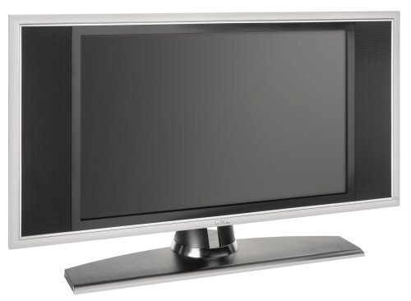
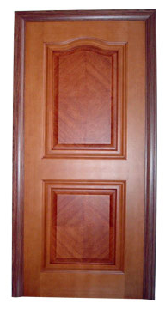
In this activity you will try to find some golden rectangles.
In a golden rectangle the length divided by the width is approximately Φ (phi) that is around 1.618.

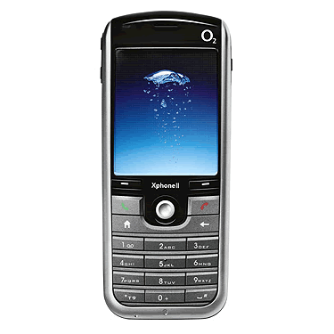
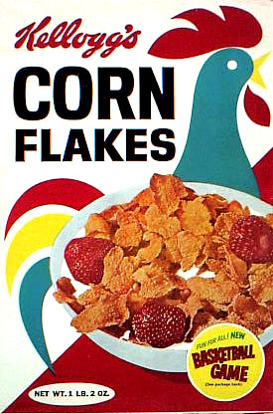
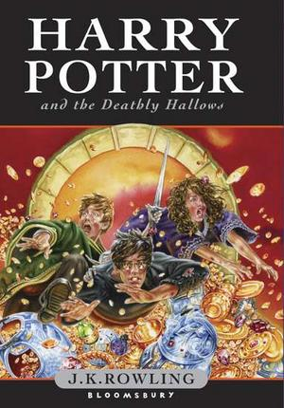
- Find some rectangles that you can measure. Measure the length and the width. Fill in the information in the table. Write the longer measurement in the length column and the shorter measurement in the width column.

- Divide the length by the width.

- When you have completed the table give a position to each of the items. Put 1 in the position column for the item that is nearest to a golden rectangle, 2 in the next and so on.

Item | Length (l) | Width (w) | l ÷ w | Position

Write a few sentences saying what you have discovered.
Golden Triangles Investigations
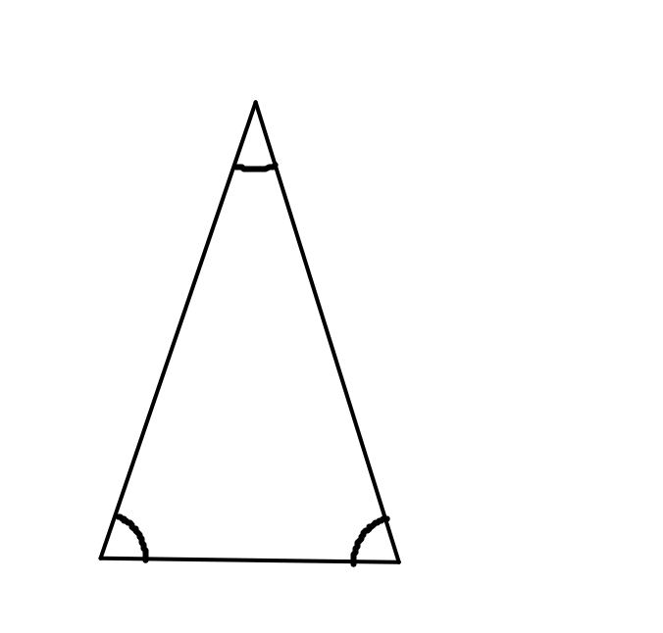
72º
72º
36º

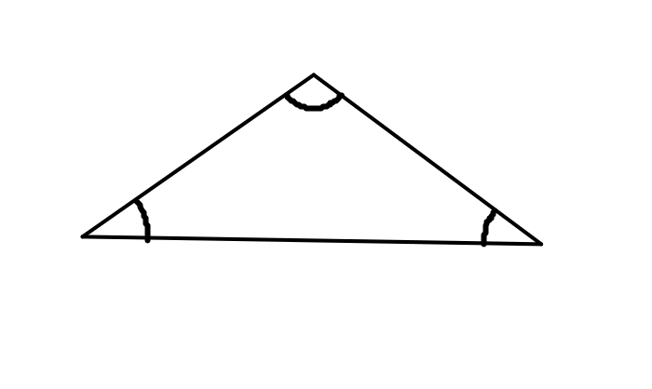
108º
36º
36º

Obtuse angled golden triangle

Acute angled golden triangle

You will need some card triangles to help you to do this activity. You will need two obtuse angled triangles and two acute angled triangles.

Quadrilaterals

- a) Make a quadrilateral by joining the sides of two obtuse angled golden triangles.

b) Use a card triangle to help you to draw the quadrilateral.

c) Measure the lengths of the sides and write them in.

d) Name the quadrilateral and say how you know what type of quadrilateral it is.

e) Without using a protractor, work out the sizes of the angles of the quadrilateral and write them in.

- a) Find two more different quadrilaterals that can be made by joining the sides if two obtuse angled triangles.

b) Use a card triangle to help you to draw the quadrilaterals.

c) Measure the lengths of the sides and write them in.

d) Name the quadrilaterals and say how you know what type of quadrilaterals they are.

e) Without using a protractor, work out the sizes of the angles of the quadrilaterals and write them in.

3. Repeat questions 1 and 2 using acute angled golden triangles.
Similar Golden Triangles

- Triangles that are the same shape but different sizes are called similar triangles.

- Two triangles are similar if all of their sides are the same size but the sides are different lengths.

- a) Use one obtuse and one acute angled triangle. Make a triangle similar to the obtuse angled triangle.

b) Use card triangles to help you to draw the new triangle.

c) Without using a protractor, work out the sizes of the angles of the quadrilaterals and write them in.

d) Measure the lengths of the sides and write them in.

e) Write down what you notice about the lengths of the sides of the new triangle.

- a) Use four obtuse angled triangles. Make a triangle similar to the obtuse angled triangle.

Repeat questions 1b) to 1e)

- a) Use one obtuse and two acute angled triangles. Make a triangle similar to the acute angled triangle.

Repeat questions 1b) to 1e)

- a) Use four acute angled triangles. Make a triangle similar to the acute angled.

Repeat questions 1b) to 1e)

- Investigate other shapes that can be made with golden triangles.

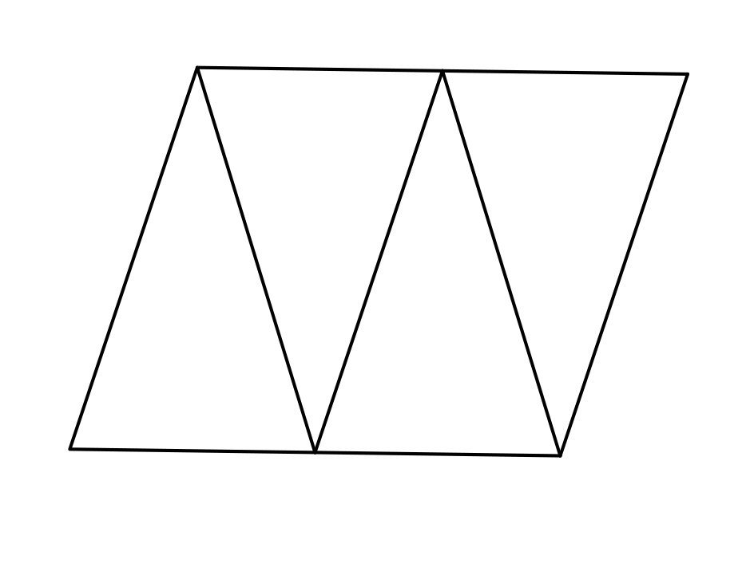

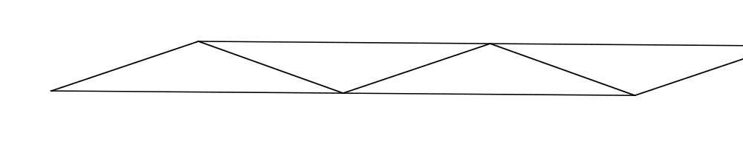
Pentagram Shapes
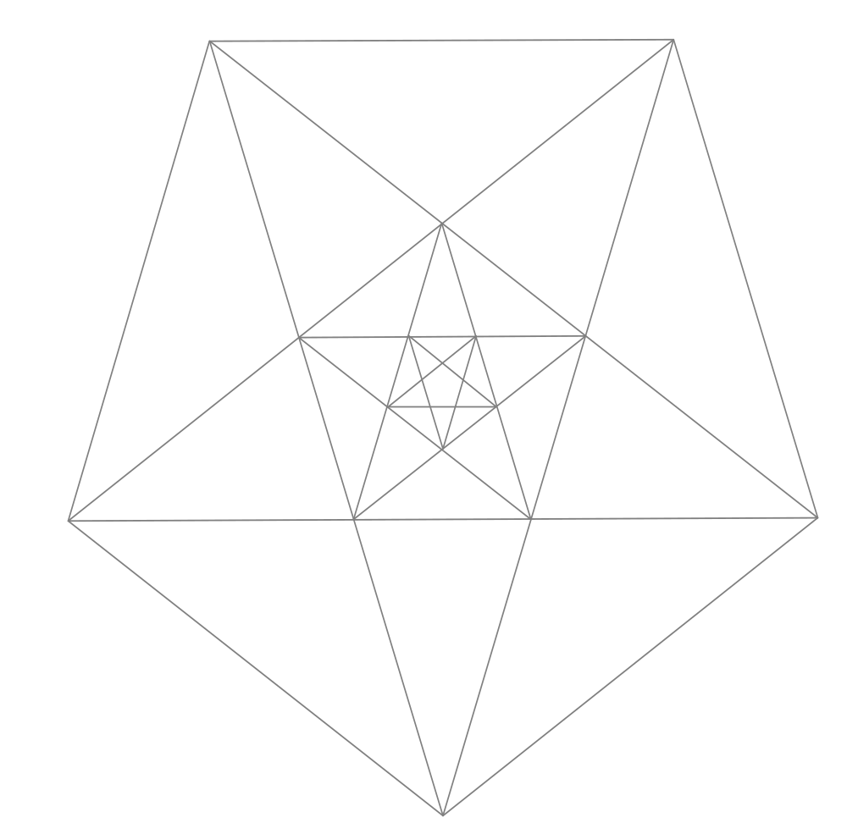
In each of the diagrams, colour in some examples of the shapes listed above the diagrams.
Colour as many examples of different shapes and shapes of different sizes as you can. Try not to colour shapes that are identical.
Write the name s of the shapes you have coloured under the pentagrams.

These are some of the shapes you can find.
- Kite
- Arrowhead kite
- Rhombus
- Trapezium
- Isosceles triangle with the two equal sides shorter than the third side.
- Isosceles triangle with the two equal sides longer than the third side.



