Year 8 intervention lessons and resources
Section
3
These lessons are designed to support teachers working with Year 8 pupils who need to secure level 5 at the end of Year 9. They are not appropriate for those pupils in Year 8 who are working on the main Year 8 teaching programme. When using the lessons, teachers need to take into account pupils’ prior knowledge and experience of the topics.
Most of the lessons are drawn from existing Key Stage 3 Strategy materials that support the main Year 7 mathematics teaching programme. The lessons focus on teaching strategies to address the stated learning objectives.
The lessons are linked to units of work corresponding to the sample medium-term plan: Year 8 intervention (see section 2). The order of the units is designed to ensure progression. Maintaining the order will help to ensure progression and continuity, building up pupils’ understanding systematically during the year.
Lesson starters provide opportunities to recall previously learned facts and to practise skills. Some of the starters introduce ideas that are then followed up in the main part of the lesson.
You can also base the teaching in a lesson on a single test question. This helps pupils realise the level of difficulty expected of them as well as helping them gain familiarity with the style of test questions.
You could complete the main part of a lesson by:
• extending your questioning of pupils;
• increasing the number of examples that you demonstrate.
It is important that while pupils are working on a task you continue to teach by rectifying any misconceptions and explaining key points.
Use the final plenary to check pupils’ learning against the lesson objectives. These define the standard required – what pupils need to know and be able to do in order to reach level 5 in mathematics at the end of Key Stage 3.
When you are preparing to use the lessons, read them through using a highlighter pen to mark key teaching points and questions. You can then refer to these quickly while you are teaching. Annotate the lesson plan to fit the needs of your pupils.
You will need to prepare overhead projector transparencies (OHTs) and occasional handouts. You also will need to select and prepare resources, matched to pupils’ needs, to provide practice and consolidation during the lesson and for homework.

From level 4 to level 5 in mathematics:
Year 8 intervention
Lesson | Description | Source
Lesson 8N1.1 | Solving number problems 1 | Transition unit: calculation and problem solving – lesson 1
Lesson 8N1.2 | Solving number problems 2 | Transition unit: calculation and problem solving – lesson 2
Lesson 8N2.1 | Exploring calculation methods | Transition unit: calculation and problem solving – lesson 5
Lesson 8N3.1 | Fraction operators | Year 7 fractions and ratio: mini-pack – key lesson plan: fraction operators and resource FR1
Lesson 8A2.1 | Using symbols to represent unknown numbers | Constructing and solving linear equations: Year 7 booklet – lesson 7A.1
Lesson 8N4.1 | Calculation methods | Transition unit: calculation and problem solving – lesson 3
Lesson 8N4.2 | Solving calculation problems | Transition unit: calculation and problem solving – lesson 4
Lesson 8N5.1 | Fractions, decimals and percentages 1 | New transition lessons: fractions, decimals and percentages – lesson 5.1
Lesson 8N5.2 | Fractions, decimals and percentages 2 | New transition lessons: fractions, decimals and percentages – lesson 5.2
Lesson 8A4.1 | Constructing simple equations | Key Stage 3 Strategy mathematics launch materials – Arithmagons lesson (Tom)

Solving number problems 1
Lesson
8N1.1
Objectives
• Understand and use decimal notation and place value.
• Understand negative numbers as positions on a number line; order and add positive and negative numbers.
• Consolidate the rapid recall of number facts, including multiplication facts to 10 × 10, and quickly derive associated division facts.
• Solve word problems and investigate in the context of number; compare and evaluate solutions.
Starter
5 minutes
Resources
Counting stick
Number fans or mini-whiteboards
Practise counting on and back from different starting numbers in steps of different sizes, including decimals.
Establish that pupils are familiar with negative numbers and can continue patterns below 0, using a counting stick or an empty number line. For example:
• Count back from 20 in steps of 3, 7, 11, …
• Count on from –11 in steps of 5, 20, 13, …
• Count back from 10 in steps of 0.2, 0.7, …
Main activity
50 minutes
Resources
Two large double-sided cards, with 7 and –2 on one card and 5 and –3 on the other
Sets of small double-sided cards, numbered as above; one set per pair
Framework examples, pages 36, 40, 48, 88
Introduce the main activity by asking the class to imagine that the Government has decided to issue only 3p and 5p coins. Practise quick calculations involving 3s and 5s by asking pupils questions such as:
Q I have seven 3p coins. How much is that?
Q I have 60p. How many 5p coins is that?
Q I have 6000p. How many 3p coins is that?
Now pose the following problems.
Q Using only 3p and 5p coins, you can pay for goods of any price.
Is this true or false?
Q What other sets of coins could the Government introduce? What about 7p and 10p?
Discuss with pupils how they could approach the problems, reminding them that they could receive change.
Ask pupils, in pairs, to consider then answer these questions:
Q How do you pay for an item costing 39p? Is there more than one way of paying 39p?
Q What about 7p and 10p coins?
Model some possible solutions and approaches to the problems, establishing the important steps in finding the answers and whether pupils are able to produce convincing arguments.
Highlight some important things to think about when solving problems, for example:
• being systematic;
• keeping a careful record of their findings as they go along;
• identifying patterns in their findings and drawing on these to come to some conclusions that they can explain and justify.
Explain that these are important skills that pupils will be expected to use.

Explore with pupils what would happen if they had to give an ‘exact amount’ and could not receive any change.
Q Could you still make every value?
Ask them to discuss this quickly, in pairs, considering either 3p and 5p coins or 7p and 10p coins. Draw out some responses, asking pupils to explain their answers. Summarise which values are not possible, and why.

Extend the problem to considering double-sided cards with positive and negative integers. Use some large cards, some with 7 on one side and –2 on the other, and others with 5 on one side and –3 on the other. Demonstrate the different values you can make. For example, using one of each card you can make:
7 + –3 = 4
Confirm that, using one of each card, these values are possible: 12, 4, 3, –5.
Ask pupils to work in pairs to establish how many different values they can find if they use two of each of these cards.
Plenary
5 minutes
Question pupils about what they have found, asking them to explain what they recorded, what conclusions they came to, and how.
Pose questions such as:
Q How did you know you had found all the possible values?
Q How could you convince someone else that you had found all the possible values?
Q Were there any values you couldn’t make? Can you explain why?
Summarise.
Set the following problem for homework:
Q I have two double-sided cards. Using both cards, I can make the values 7, 10, –1, –4. What integers are on each side of the two cards? (2, –1; 8, –3)
Key ideas for pupils
When solving problems, remember to:
• be systematic;
• keep a careful record of your findings as you go along;
• identify patterns in your findings and draw on these to come to some conclusions that you can explain and justify.

Solving number problems 2
Lesson
8N1.2
Objectives
• Understand negative numbers as positions on a number line; order, add and subtract negative numbers.
• Solve word problems and investigate in the context of number; compare and evaluate solutions.
Starter
10 minutes
Resources
Resource 8N1.2a – number cards printed back to back and cut out as cards; one set per pair
Framework examples, pages 40, 48
Draw a blank number line and write a number at each end. Put a mark or a cross halfway along the line and ask pupils what number will be at the mid-point. For example:
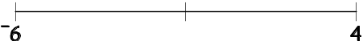
Ask pupils how they found the mid-point. Discuss their methods, using the number line to model their thinking.
Quickly model another two examples, such as the mid-point between –11 and 5, and between –3.5 and –1.
Ask pupils if their strategies change when they are dealing with different types of number, or when the end numbers are close or far apart.
Ask pairs of pupils to practise finding mid-points, using a set of number cards (resource 8N1.2a). Pupils each choose a card and then they find the number halfway between the numbers they have chosen, using a blank number line if they wish.
Main activity
45 minutes
Resources
Resource 8N1.2a
Framework examples, pages 48, 92, 94
Using blank number lines (horizontal and vertical) or by extending number patterns (Framework examples, page 48), model addition and subtraction of positive and negative integers. Ensure that pupils can record their number statements consistently.
Pose the problem:
Q Using any number of double-sided cards, some with 7 on one side and –2 on the other and others with 5 on one side and –3 on the other, what values could you find?
Discuss some of the possible values using both addition and subtraction.
5 + –2 + –2 + –2 = –1
7 + –3 – 5 = –1
–3 ––2 = –1
Ask pupils:
Q Can you find every value from –5 to 5?
Discuss responses, acknowledging different ways of obtaining the same value.
Support: Use only positive values, by allowing the use of any number of cards or by using addition only.
As an extension, ask pupils to consider whether values are impossible to find.
Q Can you find integers that produce all the values from –25 to 25?
Q Does this mean that any value could be found?
Q How can you justify your answer?
Plenary
5 minutes
Discuss results and strategies, for example by asking pairs:
Q Is it possible to make –6?
Q How many different ways are there to make –6?
Q Is it possible to make every value from –10 to 10?
Q How can you convince someone that this is true?
Summarise the results and, if possible, get a pupil to demonstrate a systematic way of recording them.
Set the following problem for homework.
Q Fill in the missing numbers so that each row, each column and each diagonal adds up to 3.
–2
3 | 1
2 |  | 4

Key ideas for pupils
When solving problems, remember to:
• be systematic;
• keep a careful record of your findings as you go along;
• identify patterns in your findings and draw on these to come to some conclusions that you can explain and justify.

Number cards
Resource
8N1.2a

–10 | –19
–8 | –17
–6 | –15
–4 | –13
–2 | –11

Number cards (cont.)
Resource
8N1.2a

1 | 12
3 | 14
5 | 16
7 | 18
9 | 20

Exploring calculation methods
Lesson
8N2.1
Objectives
• Understand and use decimal notation and place value; multiply and divide integers and decimals by 10, 100, 1000, and explain the effect.
• Enter numbers in a calculator and interpret the display in different contexts (decimals, money, metric measures).
• Solve word problems and investigate in the context of number; compare and evaluate solutions.
Starter
10 minutes
Resources
Framework examples,
page 6
Remind pupils that previously they have solved puzzles where they had to put numbers into boxes.
Ask pupils to work as quickly as they can, using the digits 2, 3, 7 and 8 as often as they like, to make these number sentences correct.
  +   = 54
155 –   =  
Discuss the different strategies used by pupils and clarify key points such as the difference between a digit (numeral) and a number (made up of digits or numerals), the need to have a sense of place value, and the need to have a sense of the number as a whole.
Set the following examples.
  +   = 69 105 –   =  
  +   = 99   +   = 110
Main activity
45 minutes
Resources
Resource 8N2.1a, one per pair
Framework examples, pages 6, 36
Give pairs of pupils one minute to discuss the following problem and to decide how they would tackle it.
Q Using each of the digits 1, 2, 3, 4, 5 only once, what is the largest addition calculation you can make?
   +  
Take feedback and establish that they will use what they know about place value and addition to make a decision. Which digit would they place first? Which one next? …
Acknowledge that addition is relatively easy. What if they used a different operation, while still looking for the highest result? For subtraction, for example, would they approach the problem in the same way? What about multiplication and division?
Give out resource 8N2.1a for pupils to work on, in pairs. Ask them to think carefully about how they will tackle the problem and how they can draw on what they already know about numbers and number operations.
Take feedback on answers, the ways pupils have thought about the problem and the prior knowledge and understanding that they have used.
Ask how the problem could be extended. For example:
Q What if …
• you could use any five digits from 1 to 9?
• you could group the digits in different ways, for example:
    × 
or   ×   ×  ?
• you could use a decimal point?
• you were trying to find the smallest result?
Ask each pair to decide upon the question they will pursue and give them 5 minutes to get started. Bring the class together to share their thinking so far and to establish their lines of investigation.
Plenary
5 minutes
Resources
Dice
Resource 8N2.1b; one per pair in lesson, one each for homework
To emphasise the importance of place value, play this game.
   ×  
Explain that the aim is for each pupil to make the largest possible product.
Roll a dice, call out the number (say, 3) and allow 10 seconds for pupils to decide what they think is the most advantageous position for the digit represented by the number on the dice. Play continues until everyone has placed all five digits. What is the largest product?
Ask pairs to play the same game, using resource 8N2.1b.
For homework, ask pupils to play this game with someone at home.
Key ideas for pupils
When solving problems, remember to:
• be systematic;
• keep a record of your findings;
• explain your answer.

Largest calculations
Resource
8N2.1a
Using each of the digits 1, 2, 3, 4 and 5 only once, what is the largest result you can find for each calculation?

◻ ◻ ◻ + ◻ ◻

◻ ◻ ◻ – ◻ ◻

◻ ◻ ◻ × ◻ ◻

◻ ◻ ◻ ÷ ◻ ◻

Largest product
Resource
8N2.1b

Rules
The aim of the game is to make the largest product.
Each player takes it in turn to roll a dice and decide where to place the number in their calculation.
After each player completes their calculation, the player with the largest product wins.

Game | Player A | Player B
1 | ◻◻◻ × ◻◻ | ◻◻◻ × ◻◻
2 | ◻◻◻ × ◻◻ | ◻◻◻ × ◻◻
3 | ◻◻◻ × ◻◻ | ◻◻◻ × ◻◻
4 | ◻◻◻ × ◻◻ | ◻◻◻ × ◻◻
Try a few games and see if you can improve your strategy.

Fraction operators
Lesson
8N3.1
Objectives
• Use fraction notation to describe parts of shapes and to express a smaller whole number as a fraction of a larger one; identify equivalent fractions.
• Calculate simple fractions of quantities (whole-number answers); multiply a fraction by an integer.
Starter
15 minutes
Vocabulary
decimal
equal
equivalent
fraction
of
percentage
Resources
Mini-whiteboards
Large sheets of plain paper
OHP or flipchart
Display the six key words in the vocabulary list.
Q Which key words do you recognise?
Q Can you give me a fact or expression related to one or more of the key words?
For example, ⁵/₁₀ is equivalent to ¹/₂; ¹/₁₀ is the same as 10%.
Take responses from pupils, perhaps using whiteboards. Encourage them to use words, numbers, symbols and pictures. Discuss some of their examples.
Q Can you give me another example, to include a statement with the equals sign?
Q Can you give me an example with a labelled diagram?
Q Can you use the same example for a different key word?
Ask pupils in pairs to record on blank paper particular things they know, related to the familiar words. Encourage a variety of expressions: equivalences, labelled diagrams, number lines, statements in words, etc. For example:
¹/₂ = ²/₄  ¹/₃ of 12 = 4  ¹/₄ = 25%  ¹/₂ = 0.5 | 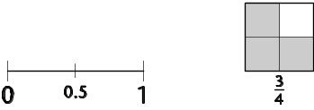
Circulate during this work and note examples that will be useful to share.
Next, invite pupils to the front of the class to write up an example chosen from their collection, preferably on an OHT or flipchart. Encourage a variety of responses:
Q Is there another way to write this?
Q Is there another diagram to show this?
Spend a few minutes discussing the collected examples, making links between them where appropriate. Conclude by explaining that in this lesson pupils will be linking their ideas together, meeting some new ideas and using fractions in practical contexts.
Main activity
35 minutes
Vocabulary
decrease
improper fraction
increase
mixed number
operator (‘of’)
Resources
Two copies each of OHTs 8N3.1a and 8N3.1b
Further copies of OHT 8N3.1b shaded to show 5 × ¹/₃ and ¹/₃ of 5
(If repeating for quarters, copies of OHTs 8N3.1a and 8N3.1c)
Lead into the main activity by saying that you will show some diagrams to help pupils illustrate facts they have noted. The diagrams will also link ideas together and help pupils to see why certain facts are true or certain calculations equivalent. If possible, start with an example from pupils’ contributions, finding a fraction of an amount, such as ¹/₃ of 15 = 5.
Q Can you give me more examples of finding ‘¹/₃ of’?
Record the examples given by the class.
Q Can you tell me what we are doing to the number 15 when we find one third of it?
Q Which operation is this?
Draw from pupils that the amount is divided into 3 equal parts and that this is what happens both when ‘dividing by 3’ and when finding ‘a third of’.

Use OHTs 8N3.1a and 8N3.1b to help make the connection between, for example, seven thirds and one third of seven.
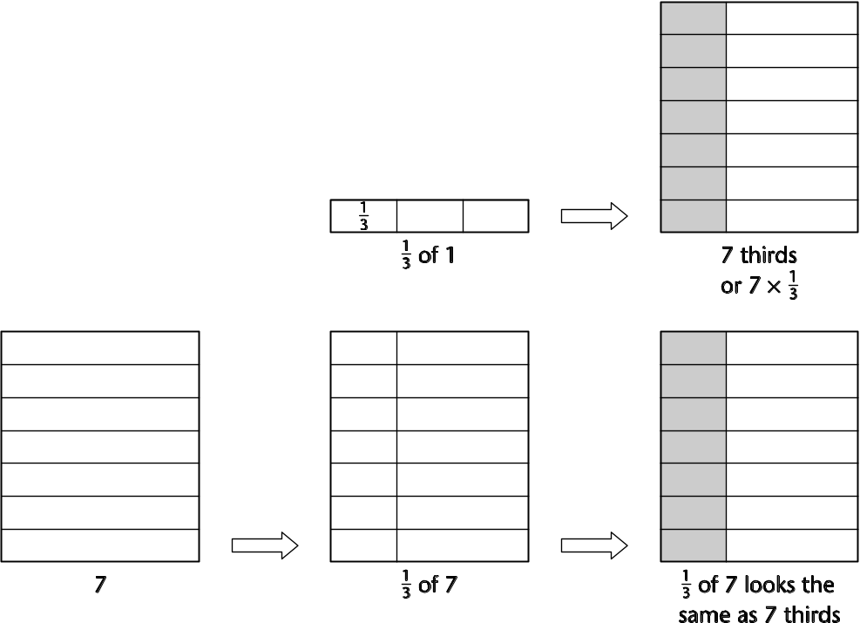

Now tell pupils that you are going to pool ideas from the start of the lesson, together with new links which the diagram may have helped them to make. Illustrate these links in a ‘web diagram’ of expressions equivalent to ⁷/₃:
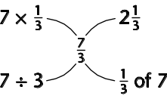
Draw attention to the connections illustrated in the diagram. Trace your finger along the links and ask pupils to find ways of summarising them.
Q What is the link between … and …?
Q How do we know?
Q Does anyone think of this in a different way?
Q Can anyone add to that explanation?
Note particularly that you have looked at a diagram which helps you to see that seven thirds is the same as 7 divided by 3.

Use the shaded copies of OHT 8N3.1b to show diagrams for 5 × ¹/₃ and ¹/₃ of 5. Ask pupils to work in pairs to draw a web diagram for ⁵/₃.

Depending on the time available you could now:
• either repeat the above sequence for quarters (OHTs 8N3.1a and 8N3.1c);
• or move on to the plenary.
Plenary
10 minutes
Copy one of the web diagrams produced. For example:
Rub out all entries except 2¹/₃.
Q What difference would it make to the other entries if this was 2²/₃?
Invite pupils to complete the diagram.
Q What if the entry was simply 2?
Invite pupils to complete the diagram. The following is likely to appear:
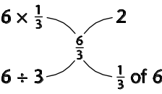
Q Is this the only web diagram that would have an entry of 2?
Invite other suggestions – you may need to suggest a starting point such as ⁸/₄ in the centre.
Encourage pupils to explain links as other examples are considered.

Remind pupils where the lesson started and how much they have revealed of what they know. Point to one of the web diagrams.
Q Is there any connection in the diagram that you understand in a new way?
Key points for pupils
• Fractions can be less than 1, equal to 1, or greater than 1.
• We can think of a fraction such as ⁷/₃ as seven lots of one third or as one third of 7. Seven thirds means the same as 7 divided by 3.
• Fractions are often drawn as points on a number line or parts of a shape (e.g. a pizza). Now we add to these images by using the idea of a stack (e.g. the seven stack) to demonstrate using fractions in multiplication.

Seven stack
OHT
8N3.1a



Seven stack in thirds
OHT
8N3.1b

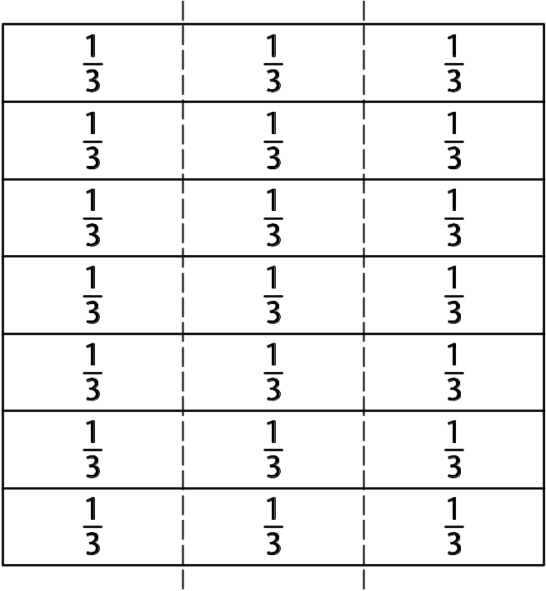

Seven stack in quarters
OHT
8N3.1c

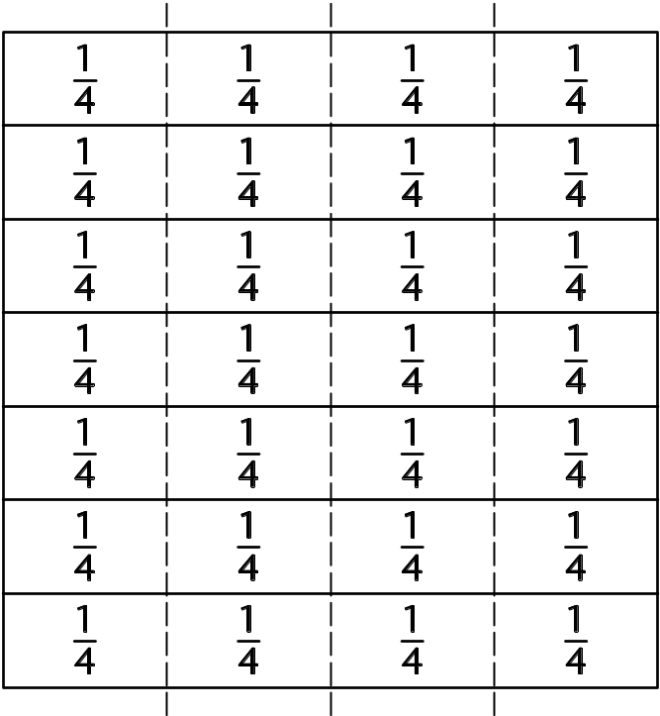

Using symbols to represent unknown numbers
Lesson
8A2.1
Objectives
• Understand that algebraic operations follow the same conventions and order as arithmetic operations (addition and subtraction only).
• Use letters or symbols to represent unknown numbers.
• Construct and solve simple linear equations.
• Represent problems mathematically, making correct use of symbols.
Starter
15 minutes
Vocabulary
symbols
operations
inverse
commutative
equation
Resources
Resource 8A2.1a, cut into cards; one set per pupil
Give each pupil a set of number and symbol cards (resource 8A2.1a). Write on the board:
3 + 4 = 7
Ask pupils to use their cards to rework the number sentence in as many different ways as they can. Invite pupils to share their answers on the board, encouraging them to use both the commutative rule and subtraction as the inverse of addition.
Now pose the questions:
Q Can you write an equation using a mix of numbers and symbols, for example 3 + a = 7?
Q Can you rearrange the equation you have written, keeping the same numbers and symbols? You can change the operation.
Discuss pupils’ suggestions and model on the board how to find the four related sentences associated with the initial equation.
Q What if you start with the equation a + m = 3?
Main activity
30 minutes
Vocabulary
expression
equation
symbol
value
Resources
Resources 8A2.1b and 8A2.1c as handouts
Briefly recap how number pyramids are constructed (Framework supplement of examples, page 122).
Draw a pyramid on the board with an unknown number represented by the symbol n in the top left box and 21 and 33 in the other two boxes in the top layer. Explain how the pyramid is formed: add adjacent cells to get the expression in the cell below.
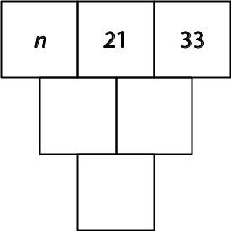
Invite pupils to tell you what expressions will go in the next layers of the pyramid. Verify that the mathematical expressions are all written correctly and then ask:
Q For this pyramid I was thinking of a number n and my number gave a value of 100 in the bottom box. What number was I thinking of?
When pupils offer an answer ask them:
Q How did you work the number out?
Q How can I write an equation using n?
Now say to pupils that you want them to design some similar examples. Tell them that first, on their own, they are going to draw a three-layer number pyramid at the back of their book, keeping their pyramid a secret from their partner. Then they will hand over to their partner a partially completed version of the pyramid with the top layer filled with two known numbers and an unknown number.
Ask each pupil to complete their partner’s pyramid with the correct mathematical expressions. When a pupil has completed the pyramid their partner (the originator of the pyramid) will ask:
Q I will tell you the number that goes in the box in the bottom layer. What is my unknown number?
Encourage higher-ability pupils to set challenges, for example to place the unknown number in the middle box of the top layer.
Circulate to observe pupils’ strategies and select two examples to illustrate easier and harder cases. Discuss these examples in a mini-plenary, asking:
Q How do you work out the unknown number n?
Set pupils to work in pairs on further examples using resources 8A2.1b and 8A2.1c. The pyramids on these resources span a range of difficulty from simple numbers and no unknowns to pyramids with four layers and decimal number inputs. Select different starting points for different pupils.
Plenary
15 minutes
Review the vocabulary used by asking pupils to define and give an example of an expression and an equation.
Draw a pyramid with three layers on the board.
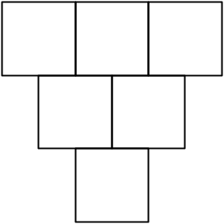
Set the following pyramid puzzle as a challenge.
• In the top layer:
– Box 1 contains an unknown number.
– Box 2 contains a number that is 5 more than the number in the first box.
– Box 3 contains a number that is 2 less than the number in the second box.
• The number in the box in the bottom layer of the pyramid is 28.
Invite pupils to suggest an expression that represents the number in each box and help them to construct and solve the equation that will give the value of the unknown number.
Key ideas for pupils
• Algebra uses symbols to represent unknown numbers.
• Each side of an equation has the same value.
• The solution of an equation is the number that makes the equation true.

Number and symbol cards
Resource
8A2.1a

m | 1 | 2
3 | 4 | 5
6 | 7 | 8
9 | 10 | +
– | = | a

Pyramids and equations (1)
Resource
8A2.1b
1  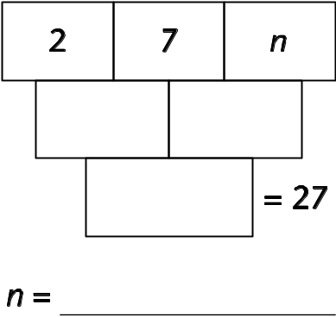 | 2  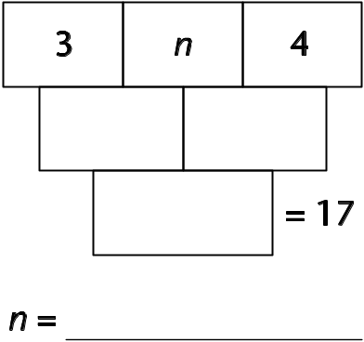
3  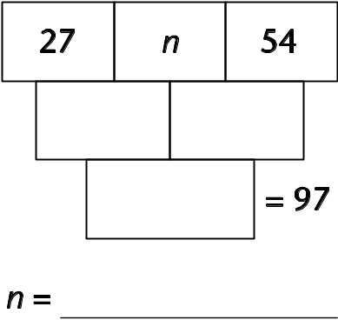 | 4  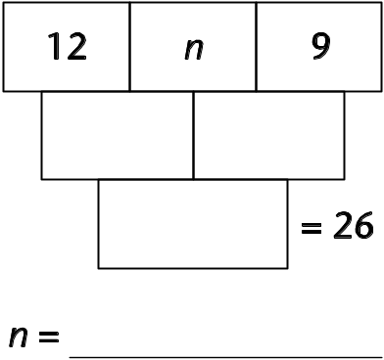
5  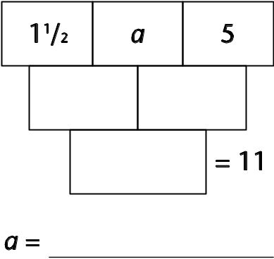 | 6  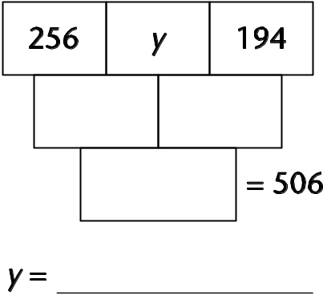
7  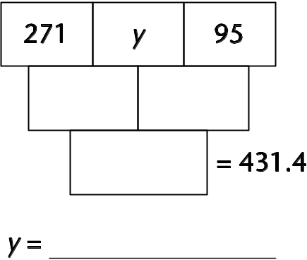 | 8  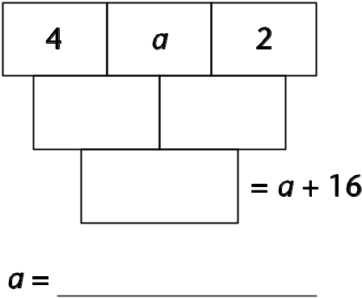

Pyramids and equations (2)
Resource
8A2.1b
9  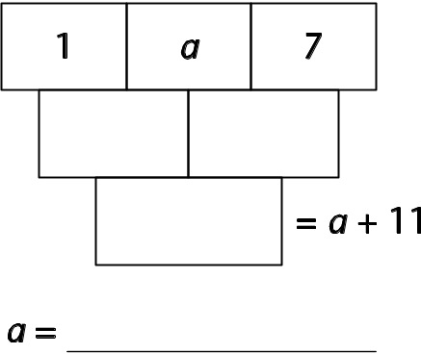 | 10  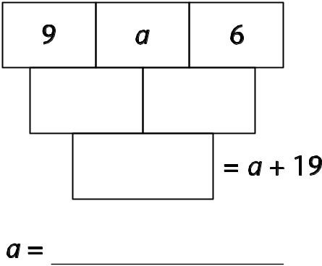
11  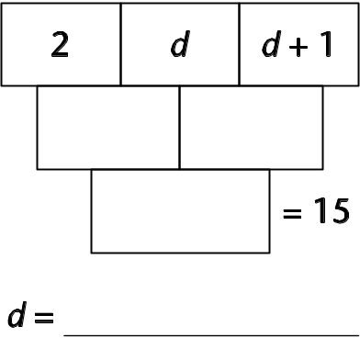 | 12  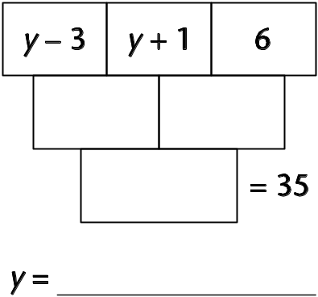
13  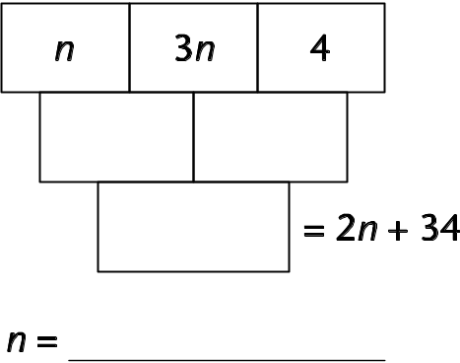 | 14  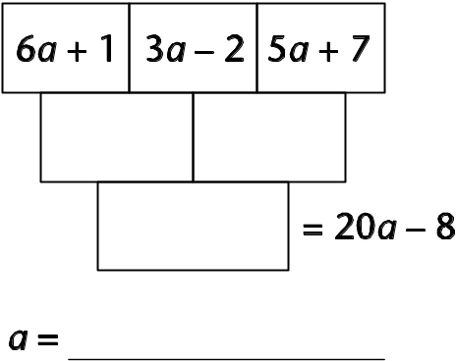
15
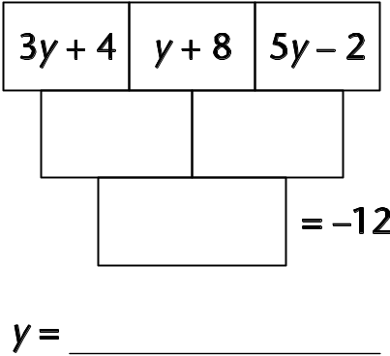

Pyramids (1)
Resource
8A2.1c
Complete these pyramids.
1  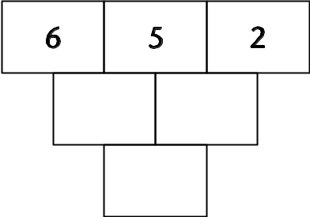 | 2  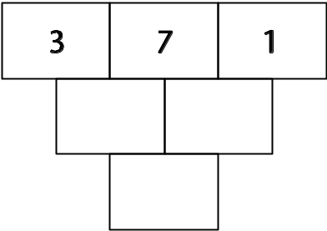 | 3  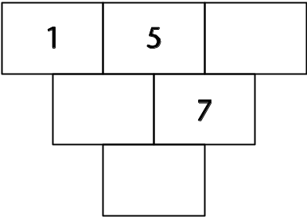
4  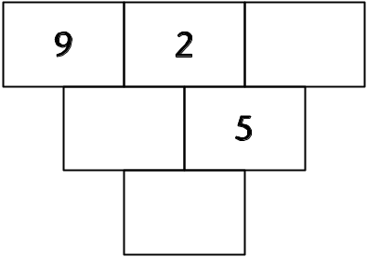 | 5  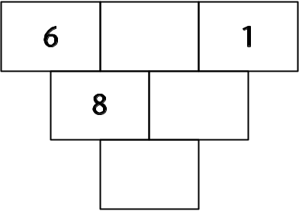 | 6  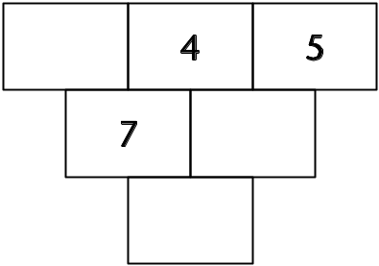
7  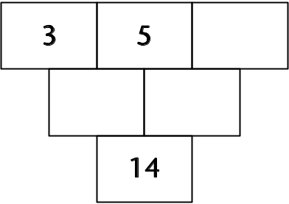 | 8  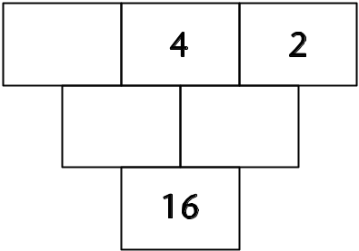 | 9  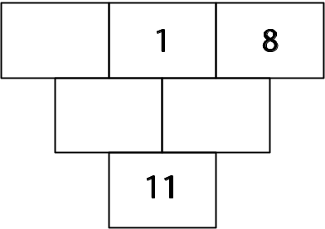
10
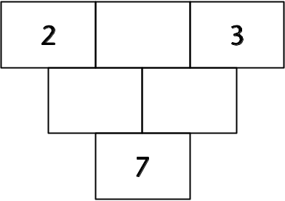

Pyramids (2)
Resource
8A2.1c
These pyramids use letters.
11  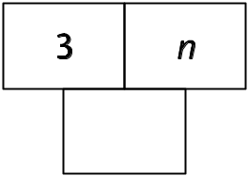 | 12  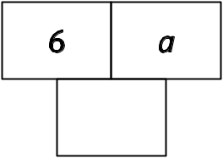 | 13  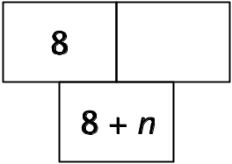 | 14  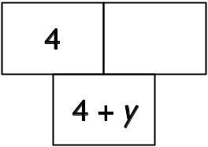
15  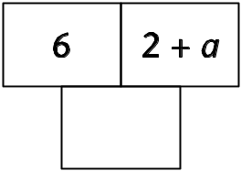 | 16  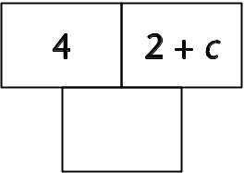 | 17  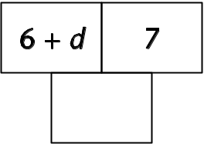 | 18  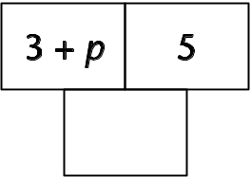
19  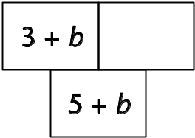 | 20  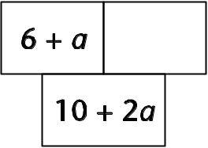 | 21  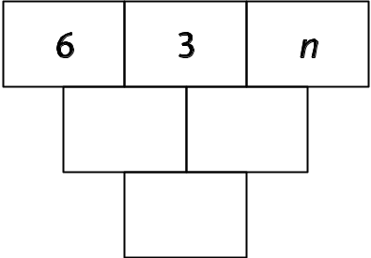

22  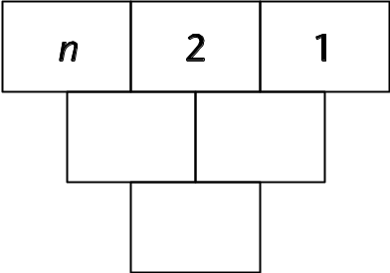 | 23  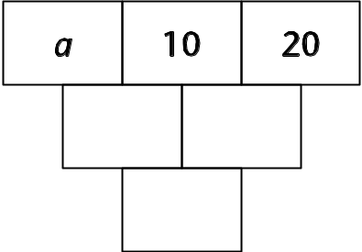 | 24  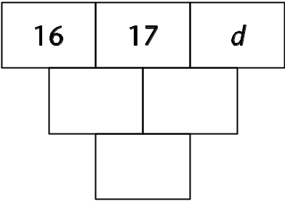
25  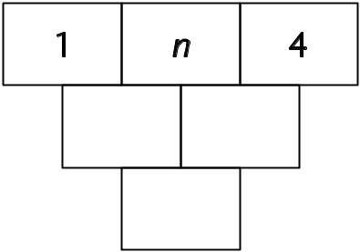 | Try making up some of your own  for your partner to solve.  You could even try using the number  from the bottom box to make up  some equations.

Calculation methods

Lesson
8N4.1
Objectives
• Understand and use decimal notation and place value.
• Consolidate the rapid recall of number facts, including positive integer complements to 100 and multiplication facts to 10 × 10, and quickly derive associated division facts.
• Use standard column procedures to add and subtract whole numbers and decimals with up to two decimal places.
• Multiply and divide three-digit by two-digit whole numbers; extend to multiplying and dividing decimals with one or two places by single-digit whole numbers.
Starter
10 minutes
Resources
OHTs 8N4.1a and 8N4.1b
Framework examples, pages 88, 96
Practise mental calculation skills and recall of number facts using a target number grid, for example OHT 8N4.1a. Ask questions such as:
Q What is the complement to 100 of this number?
Q What is this number multiplied by 100?
Q What is the sum of these two numbers?
Q What is this number divided by 4?
Q Which two of these numbers add to make 10?
Q What is double this number?
Q What is this number multiplied by 70?
Use OHT 8N4.1b or write 6.2 × 100 in the middle of the board. Invite pupils to give equivalent products, for example:
62 × 10, 3.1 × 200, 62 000 × 0.01, …
Main activity
45 minutes
Resources
Resource 8N4.1c,
one per pupil
Resource 8N4.1d,
one per pair
Framework examples, pages 48, 104, 106
Emphasise the importance of being able to calculate mentally and to use efficient written calculation methods.
Acknowledge that you know the sort of calculations they can already do, but you would like to find out more about the methods they use.
Ask one or two pupils to model examples of calculation methods they can use. Ask them to explain how they would estimate and check their answers.
Note: By the age of 11, pupils are expected to use a formal written method for calculations such as 460 – 237 or 23 × 17. The most common methods expected of 11-year-olds are column addition and subtraction, long multiplication or ‘grid’ multiplication, short division or ‘chunking’ – see Framework examples, pages 104, 106.
Distribute resource 8N4.1c and ask pupils to work through the examples, deciding for each one whether they would do it:
• mentally (with or without jottings); or
• using a formal written method.
Emphasise that you are particularly interested in how they calculate, not just the accuracy of their answers. You are also keen to know how they estimate what might be a reasonable answer and how they check their answers after they do the calculation.
Circulate to observe and note the different calculation strategies being used. Probe pupils’ understanding and help them extend and refine their strategies.
When pupils have completed all the questions they can tackle, say that you would like them to help you identify errors pupils have made in the past. Give out resource 8N4.1d and ask pupils to work in pairs to estimate an answer for each calculation, to identify what has gone wrong in each example and to correct the calculation.
Plenary
5 minutes
Review the errors pupils have identified and establish important points for them to remember when doing calculations. These could be written on a sheet of sugar paper so that they can be referred to at a later stage.
Write the following word problem on the board and ask pupils to think about how they would tackle it:
Q A shop sells sheets of sticky labels. On each sheet there are 36 rows and 18 columns of labels. How many labels are there altogether on 9 sheets?
Model a sensible way to approach the problem, for example:
• underline the important information;
• decide what operations are needed;
• estimate the answer, then do and check the calculation;
• write the answer as a sentence, checking that it makes sense.
Solve the problem together and ask pupils to try to use a similar approach to the following problem set for homework:
Q A teacher needs 220 booklets. The booklets are sold in packs of 16. How many packs must the teacher order?
Key ideas for pupils
• Always consider doing a calculation mentally.
• Check all calculations to make sure that the answer is sensible.

Target number grid
OHT
8N4.1a

65 | 702 | 1.5 | 23
720 | 0.3 | 27 | 3.5
7.3 | 56 | 2.7 | 91
11 | 8.6 | 1200 | 38
850 | 46 | 125 | 8

Equivalent products
OHT
8N4.1b

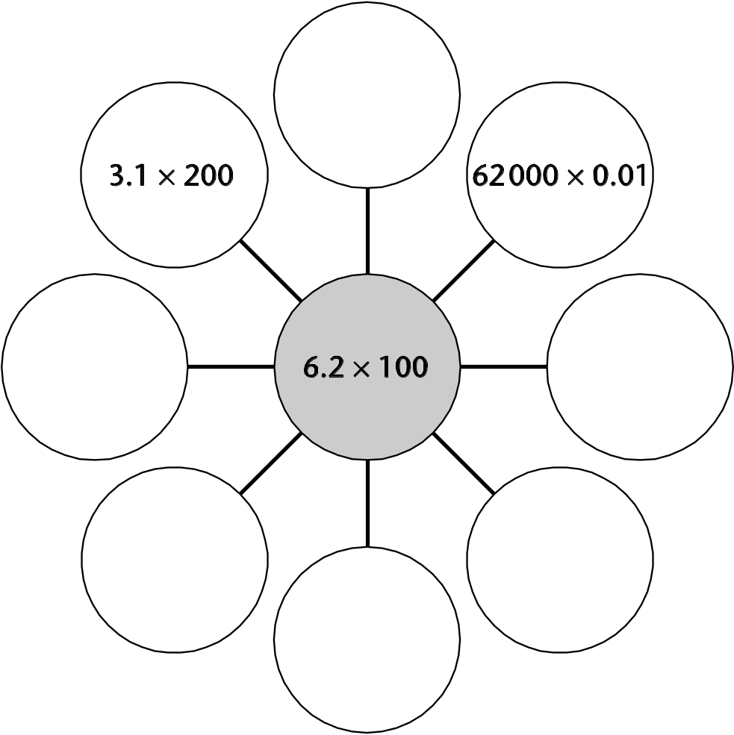

Calculations
Resource
8N4.1c

A 91 + ◻ + 48 = 250 | B 421.36 + 25.7 = ◻ | C ◻ + 1457 = 6924
D Find the total of  42, 64, 78, 3 and 4681. | E Subtract 2250 from 8500. | F 7.65 – 6.85 = ◻
G ◻ – 1457 = 2924 | H What must I add to 5.4 to make 9.3? | I 1040.6 – 89.09 = ◻
J 38 × ◻ = 190 | K Calculate  673 × 24. | L 9.9 ÷ ◻ = 1.1
M Divide 109.6 by 8. | N 0.3 × ◻ = 2.4 | O 428 ÷ 3.4 = ◻

Errors in calculations
Resource
8N4.1d

A  238  + 1487  3867 | B  720  – 196  536
C  234  × 52  468  1170  1638 | D  176  7 ) 123.2  123.2 ÷ 7 = 176

Solving calculation problems
Lesson
8N4.2
Objectives
• Understand and use decimal notation and place value; multiply and divide integers and decimals by 10, 100, 1000, and explain the effect.
• Enter numbers in a calculator and interpret the display in different contexts (decimals, money, metric measures).
• Solve word problems and investigate in the context of number; compare and evaluate solutions.
Starter
10 minutes
Resources
Mini-whiteboards
Calculators
OHP calculator
Framework examples, pages 2, 108
Put this calculation on the board: 950.4 ÷  = 49.5
Give pupils 30 seconds to agree, in pairs, an estimate for the answer. Take some feedback and establish a sensible estimate.
Now tell pairs they can use a calculator to find the missing number. Give them a couple of minutes, then invite someone to use an OHP calculator to demonstrate how they calculated the answer.
Ask if anyone tackled it in a different way. If so, ask them to demonstrate their method on the OHP calculator.
Ask pupils how they would check the answer. Establish how this can be done.

Ask pupils to calculate 136 ÷ 32 on their calculators. Ask them to write the answer on a mini-whiteboard and hold it up.
Now pose the question:
Q Jim took part in a charity cycle ride. He cycled 136 kilometres at 32 kilometres per hour. How long did he take to complete the cycle ride?
Confirm that the calculation is the same (136 ÷ 32). Ask pupils to discuss the answer, in pairs, and to decide how to interpret the answer displayed on the screen.
Establish how to interpret the answer. Set some other questions, involving money and measures, that illustrate the need to interpret calculator answers.
Main activity
45 minutes
Resources
Calculators
Resource 8N4.2a, one per pair
Framework examples, pages 2, 6, 108
Review the problem set for homework in lesson 8N4.1:
Q A teacher needs 220 booklets. The booklets are sold in packs of 16. How many packs must the teacher order?
Ask two or three pupils to explain:
• how they tackled the problem;
• what calculation they did;
• how they did the calculation (mentally? as a formal written calculation? using a calculator?);
• how they interpreted the answer on the calculator screen.
Ask pupils to work in pairs on the word problems on resource 8N4.2a. Ask them to read through each problem, estimate the answer and think about how they might solve it. Encourage them to jot down their methods of tackling the problem.
After about 5 minutes, check on progress and discuss the approaches pupils are adopting. If possible, draw on pupils’ own strategies, highlighting effective approaches to tackling the problems.
Give pupils time to work on some more examples, encouraging them to make sensible use of calculators and to take care in interpreting the calculator display.
Extension: Select more demanding problems from the Framework examples on pages 3, 7, 109.
Plenary
5 minutes
Resources
Calculators
Collect answers and discuss pupils’ approaches, using the OHP calculator to illustrate methods.
Round off the lesson by setting two number puzzles for pupils to solve, using a calculator. Ask pupils first to estimate each missing number, then to use a calculator to work it out.
 × 24.3 = 400.95
24 × 16.5 ÷  = 79.2
For homework, ask pupils to make up a similar number puzzle for someone in their class to solve.
Key ideas for pupils
When solving problems:
• always write down the calculation that you need to do.
When using a calculator:
• check that the answer is reasonable;
• interpret your answer to fit the question.

Problems in the millions!
Resource
8N4.2a
1 What is the smallest number you can subtract from a million to make the answer exactly divisible by 7893?
What is the smallest number you can add to a million to make the answer exactly divisible by 9821?

2 How long in days, hours, minutes and seconds is one million seconds? Are you a million seconds old?
How old are you in seconds?

3 Sharman is trying to get as close as she can to a million. She can use each of the digits 1 to 9, once and once only, any of the operations +, –, × and ÷, and brackets.
She has tried two examples and has started recording her answers and how far they are from a million.
Calculation | Answer | How far from a million?
(953 + 721) × 864 | 1 446 336 | 446 336
12 345 × 678 ÷ 9 | 929 990 | 70 010
How close can you get to one million?

4 Seven sisters were left £1 million by a rich aunt. How much will each of them receive?

Fractions, decimals and percentages 1
Lesson
8N5.1
Objectives
• Consolidate and extend mental methods to include decimals, fractions and percentages, accompanied where appropriate by suitable jottings; solve simple word problems mentally.
• Recognise the equivalence of percentages, fractions and decimals.
Starter
10 minutes
Vocabulary
equivalent
function
input
output
Resources
Mini-whiteboards or number fans
Draw a function machine on the board. Explain that the machine uses only multiplication and division. Write ×5 in the function machine and ask pupils to give you the output numbers for different inputs.
Q What is the output when the input is 12? or 1¹/₄? or 0.8?
Ensure maximum participation by asking pupils to use number fans or mini-whiteboards to display answers.
Repeat using different functions and whole-number, fraction and decimal inputs.
Now give 320 as the input.
Q What is the output when the function is ÷10, ×0.1, ×10% or ×¹/₁₀?
Q What do you notice about the outputs when you use these functions?
Record the equivalent functions on the board.
Repeat using mixed numbers as the functions; for example, use ×2¹/₄, ×225% and ×2.25 with the same input number.
Main activity
Vocabulary
equivalent
relationship
Resources
Resource 8N5.1a, cut into cards for sorting; one set per three or four pupils
Draw a 0.5 → 2 ‘card’ on the board. Explain that you want pupils to think of a function machine that would have 2 as the output given 0.5 as the input. Again, only the operations multiplication and division are allowed.
Q What is the relationship or ‘function’ between 0.5 and 2?
Take explanations, drawing out alternatives. Pupils may identify the operation as ‘×4’, or may think in two stages as ‘×2 then ×2 again’.
Give each group of three or four pupils a set of cards from resource 8N5.1a; ask them to look through the cards and find other pairs of numbers with the same relationship as 0.5 → 2.
Ask pupils to group cards with the same relationship, to arrange their cards onto a large sheet of paper and to label each group. Encourage pupils to discuss the relationship between the input and output numbers in each group.
Write on the board 20 → 15, 4 → 3, 10 → 7.5. As a mini-plenary, ask:
Q Why have you grouped these cards together?
Q What patterns do you notice? Can you describe them?
Q Can you give another pair of numbers that belong to this set?
Discuss equivalent ways of describing the relationship. Pupils might describe the relationship as ‘divide by 4 then multiply by 3’ or ‘multiply by 3 then divide by 4’ or ‘multiply by ³/₄’ or ‘multiply by 0.75’ or ‘multiply by 75%’.
Ask pupils in pairs to ask each other the same questions for another set of cards.
Plenary
15 minutes
Resources
Resource 8N5.1b, one per pupil
Hand out resource 8N5.1b and ask pupils to complete both questions. Encourage them to record the relationships in as many ways as they can, using fraction, decimal and percentage equivalences.
Key ideas for pupils
• It is useful to know that there are different ways of expressing relationships. For example, for 16 → 10, the relationship could be described as ‘×5 then ÷8’, ‘×⁵/₈’, ‘×0.625’, ‘×62.5%’, ‘÷1.6’.
• When solving a problem you need to decide which relationship is the most efficient to use.

What’s my function?
Resource
8N5.1a

8 → 12 | 21 → 7 | 16 → 10
10 → 25 | 6 → 9 | 10 → 7.5
8 → 32 | 7 → 2¹/₃ | 14 → 35
¹/₄ → 1 | 4 → 3 | 2 → 3
150 → 50 | 20 → 15 | 4 → 10
80 → 50 | 0.5 → 2 | 4 → 2.5

Mystery functions
Resource
8N5.1b

What are the mystery functions below? Try to find each function
from the three inputs and their corresponding outputs.
Write down as many different ways as you can to describe each function.

Mystery function 1  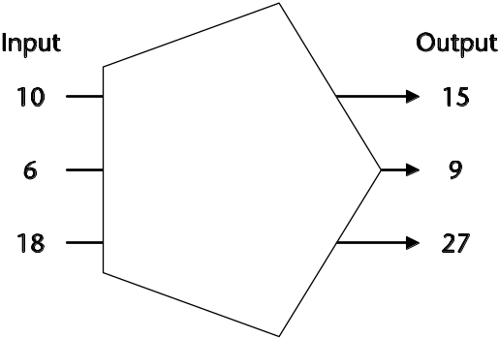 | Mystery function 2  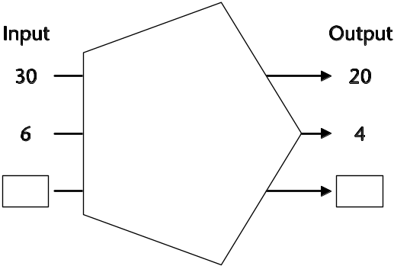  Try to find two numbers to go in the boxes.

Jane says the two mystery functions are the same. Do you agree?
Explain why you think she is right or wrong.

Fractions, decimals and percentages 2
Lesson
8N5.2
Objectives
• Consolidate and extend mental methods to include decimals, fractions and percentages, accompanied where appropriate by suitable jottings; solve simple word problems mentally.
• Recognise the equivalence of percentages, fractions and decimals.
Starter
20 minutes
Vocabulary
operation
inverse
Resources
Resource 8N5.2a, one per pair; copy as OHT
OHP calculator
Calculators
Use an OHT of resource 8N5.2a to introduce the game ‘Back to the start’. Ask pupils to look at the first two numbers, running clockwise from the start.
Q How can you move from 4 to 6 using multiplication and division only?
Q How can you do this in one step?
Tell pupils they can use a calculator to find the missing function. Give them a minute, and then invite someone to use an OHP calculator to demonstrate how they calculated the answer.
If anyone tackled it in a different way, ask them to demonstrate their method on the OHP calculator.
Now ask pupils to play the game in pairs. Each pair will need a copy of resource 8N5.2a and calculators. Establish the game’s rules:
• This is a game for two players. Each player begins at ‘Start’. One player moves around the track clockwise, the other anticlockwise.
• Players move by performing calculations on the calculator to change the number displayed to the next number on the track. Only multiplication and division can be used. One or several operations can be used; for example, to change 4 to 6 you could multiply by 3 and then divide by 2, or you could multiply by 1.5.
• The aim of the game is to move around the track until you get back to ‘Start’. You do not take turns. This is a race to see who gets back to the start first. Start at the same time.
Give pupils time to play the game a couple of times in their pairs. After the game, discuss some of the calculations used when moving clockwise from one number to another. Compare these with the calculations used when moving anticlockwise.
Main activity
30 minutes
Vocabulary
equivalent
relationship
Resources
Resource 8N5.2b, cut into cards
Resource 8N5.2c, one per pair
Display the cards from resource 8N5.2b, arranged into groups as in lesson 8N5.1, or ensure that pupils have their recording sheets from the activity in that lesson.
Write the first word problem from resource 8N5.2c on the board:
A map is drawn so that 1 cm represents 2.5 km in real life.
On the map the length of a road is 14 cm.
How long is the road in real life?
Ask pupils to discuss, in pairs, how to solve the problem. Remind them to think carefully about the units used.
Together, as a class, compare and discuss some of the methods used. Encourage pupils to look at the numbers in the problems and ask themselves whether the answer will be bigger or smaller and to check that their answers are reasonable.
Point out that the relationship and numbers used in this problem match one of the cards from 8N5.2b (14 → 35). Ask if anyone had noticed this.
Using the same problem – and referring to the cards on display – ask another question.
Q If a road in real life is 25 km, how long would it be on the map?
Ask pupils to suggest other questions they could ask and answer using cards in the set.
Remind pupils that they can use the patterns within the groups to generate other pairs of numbers with the same relationship; for example, 14 cm represents 35 km so 28 cm represents 70 km.
Choose some of the problems from 8N5.2c to give to pairs of pupils. Explain that all the problems on the sheet are linked to the groups of cards from 8N5.2b. Once pupils have answered the given questions, encourage them to suggest other questions that their partners can answer using the same starting point.
Plenary
10 minutes
Resources
Resource 8N5.2d, one per pupil
Spend some time getting pupils to talk about their methods for solving each other’s problems.
Now ask them to complete resource 8N5.2d, ‘Peanut problems’, making up and solving two questions using the fact that has been given.
Key ideas for pupils
• When you start to solve a problem, look at the numbers in the question and ask yourself whether the answer will be bigger or smaller than them.
• When you have a solution, read the question again and check whether your answer is reasonable.

Back to the start
Resource
8N5.2a

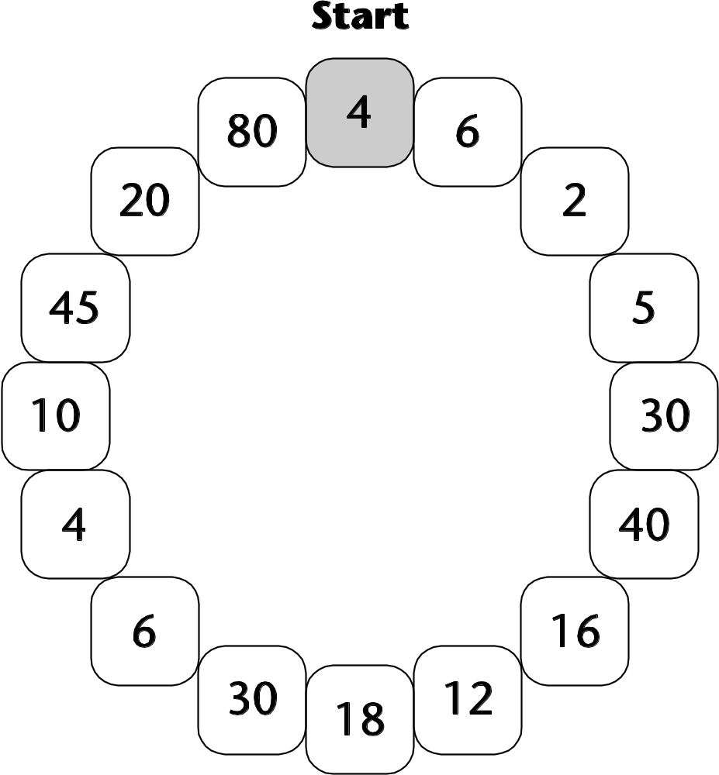

What’s my function?
Resource
8N5.2b

8 → 12 | 21 → 7 | 16 → 10
10 → 25 | 6 → 9 | 10 → 7.5
8 → 32 | 7 → 2¹/₃ | 14 → 35
¹/₄ → 1 | 4 → 3 | 2 → 3
150 → 50 | 20 → 15 | 4 → 10
80 → 50 | 0.5 → 2 | 4 → 2.5

Word problems
Resource
8N5.2c

A map is drawn so that 1 cm represents 2.5 km in real life.  On the map the length of a road is 14 cm. How long is the road in real life?  My question | When you change £1, you get about one and a half euros.  How much British money do you need to change to get 12 euros?  My question
For every three tokens you collect, you can send off for a free T-shirt.  How many tokens do you need for seven T-shirts?  My question | Three quarters of a box of chocolates are milk chocolate.  There are 15 milk chocolates. How many chocolates are in the box altogether?  My question
Orange squash is mixed with water in the ratio 1 to 4.  The bottle of squash contains 0.5 litres. How much water do I need to mix with this?  My question | 8 km is about the same distance as 5 miles.  My journey to the cinema is 16 km. About how many miles is this?  My question

Peanut problems
Resource
8N5.2d

Peanuts cost 60p for 100 g.
• Make up two questions using this fact. Question 1 should be easy to answer but question 2 should be harder.
• For each question, show one way of calculating the answer.

Question 1

How to calculate the answer

Question 2

How to calculate the answer

Constructing simple equations
Lesson
8A4.1
Objectives
• Generate and describe sequences.
• Use letters or symbols to represent unknown numbers.
• Construct simple linear equations.
• Solve problems and puzzles in the context of algebra.
Starter
5 minutes
On the board, draw a number line from 0 to 1 with ten steps; mark 0, 0.5 and 1.
Ask pupils to chant along the number line, including silent counting to generate sequences such as 0, 0.2, 0.4, 0.6, 0.8, 1.0.
Use a range of intervals: 0.2, 0.25, 0.4, 0.15.
Main activity
40 minutes
Vocabulary
algebra
arithmagon
equation
Resources
Framework examples,
page 124
Give a brief recap of what an arithmagon is.
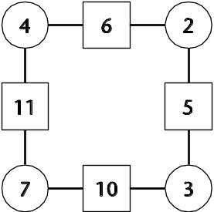
Remind pupils that the number in each square box is the sum of the numbers in the adjacent circles.
Ask pupils, working in pairs, to complete an arithmagon that has the numbers 8, 3, 7 and 12 in the square boxes.
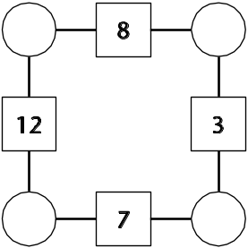
Pupils will need 10–15 minutes for this. Support the pairs as they work on the problem. If necessary prompt pupils to find more than one solution.
Ask volunteers to explain their solutions on the board.
Transfer the solutions to a table, making sure that numbers in the same position are transferred to the same columns.
Check pupils’ understanding of the problem.
Q How many solutions are there?
Q When might there be no solution?
Explore with the class any relationships between the columns of the table and any patterns that they can see.
Q Describe in words any relationships that you can see. For example, columns 1 and 2 add up to … what?
Express the relationships described using algebraic equations.
Write some algebraic equations on the board and discuss equivalent statements. For example, using a to stand for the number in the first column and b for the number in the second column:
a + b = 8 8 – b = a
Set pupils to work in pairs to find their own patterns.
Plenary
15 minutes
Ask pupils to explain their findings and look for equivalent expressions.
Q What is the best way of finding all the solutions?
Q When might there be no solutions?
Explain that some algebraic expressions may look different but are really the same.
Introduce the idea of a triangular arithmagon.
For homework ask pupils to complete given triangular arithmagons and invent some.
Key ideas for pupils
• You can construct equations to show simple relationships, such as:
a + b + c + d = 15 or a + b = 8
• There are different ways to write the same equation, for example:
6 + 2 = 8, so 8 – 6 = 2 or 8 – 2 = 6
a + b = 8, so 8 – a = b or 8 – b = a

