Chorley Weather Station
Activity using the wind speed data
Comparing two sets of data using box and whisker diagrams

The wind speed is recorded daily by the Chorley Weather Station. The objective for this activity is to compare the wind speed data from two different days in one month and to draw inferences.

Notes on how to draw a box and whisker diagram using raw data from excel using Autograph 3

- Load up Autograph 3 and make sure the ‘Advanced Level’ is selected
- Maximise the screen
- Select the interactive whiteboard icon. This is useful to be selected at the beginning even if an interactive whiteboard is not being used.
- Open the statistics page in Autograph 3.
‘File – New 1D Statistics Page’, or double click on the sigma icon.

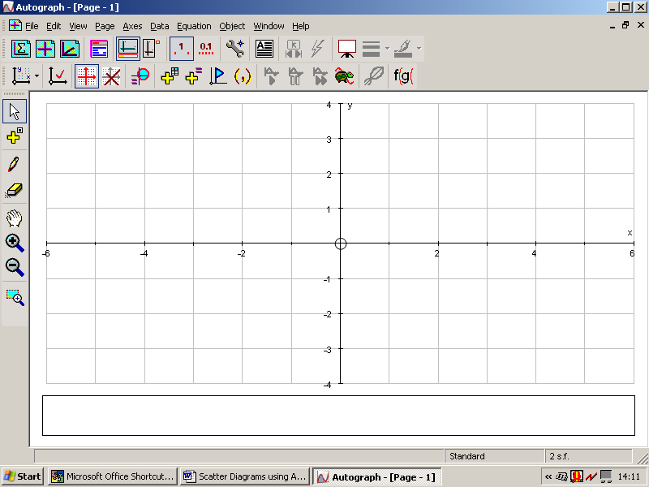

- To enter the wind speed from Excel, minimise the Autograph 3 page and open up the spreadsheet. Highlight the wind speed column and select edit-copy. Minimise Excel and maximize Autograph 3.
- Select the icon ‘Enter Raw Data…’

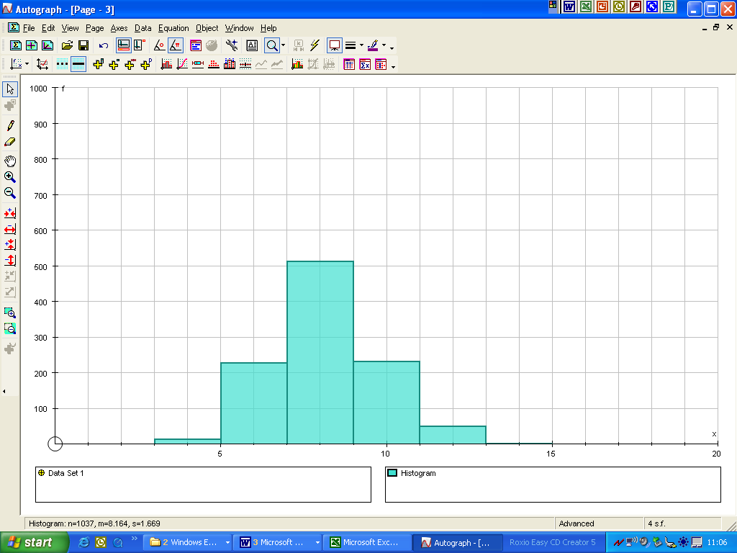

- Paste in the data the data from Excel (Right-click on the mouse and chose ‘Paste’ and Select ‘OK’.

- Now select the final ‘OK’ on Data Type
- Select the Box and Whisker diagram and select ‘OK’. A Box and whisker diagram will be automatically produced. At the bottom of the screen will be some statistical values median, semi-interquartile range (we use the interquartile range, so what is this?), n = number of data

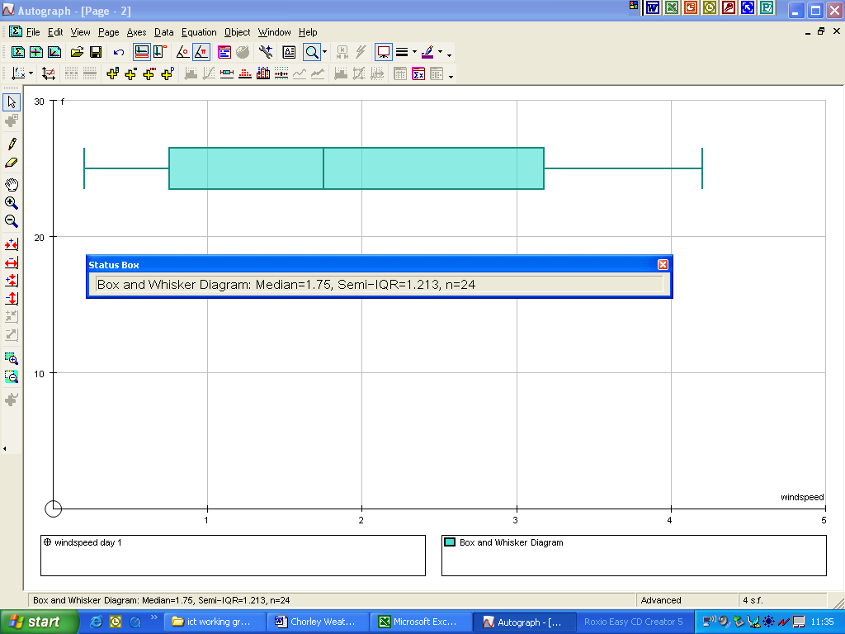

Pint out this box and whisker diagram and attach to the pupils sheet (File – Print). Note that Autograph 3 automatically labels the axes x and f (these are variables) but the x-axis has not been identified as wind speed. You can label this manually on the print out or find the function within Autograph 3 to do this for you.

Repeat the same process to enter in the wind speed for the second day
You will need to edit the data set so it is named day 2.

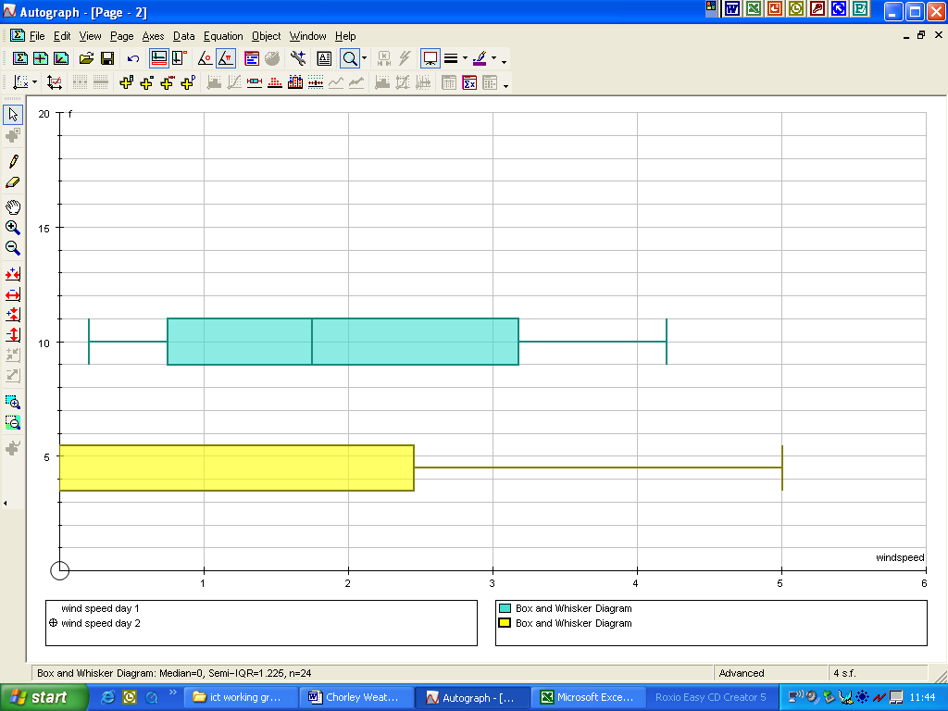
The software will automatically place the second box and whisker diagram over this first, simply pick it up and drag it down. You should have a screen shot like the one below:-

If you edit your x-axis, you can change the spacing on the intervals. You need to deselect auto and change the x pips to 0.1. Now you can determine
- Median wind speed
- Minimum wind speed
- Maximum wind speed
- Lower quartile
- Upper quartile
- Interquartile range

