Chorley Weather Station – Activity using the wind speed data

The wind speed is recorded daily by the Chorley Weather Station. The first objective for this activity is to find the average daily wind speed. An appropriate average can be calculated by hand and by using ICT. The second objective would be to compare this data with a second set of results from a second day and to draw inferences.
A final task would be to test a hypothesis that states that the wind speed in the summer months is less variable in the winter months

The wind speed is recorded hourly every day.
When there is a large amount of data to analyse and draw conclusions when comparing two sets of data, it is often easier to group the data to display statistical graphs and chart.

The first task is to find the average daily wind speed using the excel function
Highlight the cell where the answer is to be displayed. Next click in the formula bar and type in ‘=Average(?:??)’
? = Cell reference for the first wind speed value
?? = Cell reference for the last wind speed value
Enter the formula. The average value for the daily wind speed will now be displayed in the cell that was originally highlighted. This value is known as the mean

Next the data is to be grouped by hand in order to calculate the estimate of the mean, median and modal wind speed

It is now important to determine the minimum and maximum wind speed values in order to set the upper and lower limits and to determine the size of the class intervals.

Eg minimum wind speed value = 3; maximum wind speed value = 13

This can be done quickly using the excel functions in the formula bar ‘=min(?:??)’
‘=max(?:??)’
? = Cell reference for the first wind speed value
?? = Cell reference for the last wind speed value

If the minimum value = 3 and the maximum value = 13, then
The range = 13 – 3 = 10
To create a good frequency diagram we need no less than 5 intervals. Our intervals in this instance could be:
3 ≤ w < 5, 5 ≤ w < 7 etc.

Using your pupil sheet, determine the maximum and minimum wind speeds and therefore the range and determine the size of your class intervals. Next complete the table using the following below as a guideline:-

Wind speed | Frequency | Mid-point | Mid-point x Frequency
3 ≤ w < 5 |  | 4
5 ≤ w < 7 |  | 6
7 ≤ w < 9 |  | 8
9 ≤ w < 11 |  | 10
11 ≤ w < 13 |  | 12
13 ≤ w < 15 |  | 14
Totals

To determine the frequencies by hand would be a long laborious task. For this activity a statistical software package called Autograph 3 will do this very effectively and efficiently.

In this activity below, the wind speed was recorded every minute for 1 day. How much primary data would that generate?

Notes on how to enter grouped data using Autograph 3

- Load up Autograph 3 and make sure the ‘Advanced Level’ is selected
- Maximise the screen
- Select the interactive whiteboard icon. This is useful to be selected at the beginning even if an interactive whiteboard is not being used.
- Open the statistics page in Autograph 3.
‘File – New 1D Statistics Page’, or double click on the sigma icon.

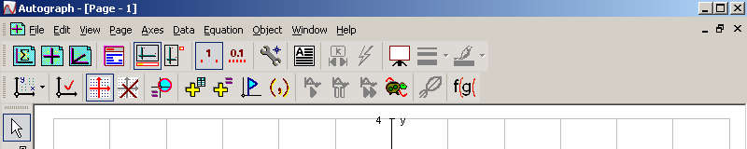

- To enter the wind speed from Excel, minimise the Autograph 3 page and open up the spreadsheet. Highlight the wind speed column and select edit-copy. Minimise Excel and maximize Autograph 3.
- Select the icon ‘Enter Grouped Data…’
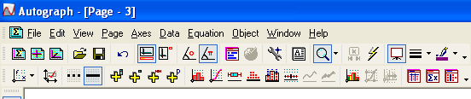

- Rename the data set with Wind speed Day 1. Select ‘Use Raw Data’ under Frequencies, select ‘Edit’, and then paste in the data (Right-click on the mouse and chose ‘Paste’ and Select ‘OK’.
- Next enter the correct min value, max value and Class width value. Once these have been correctly entered, select Recalculate on both the Class Intervals and Frequencies boxes.
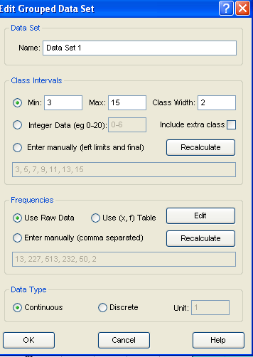

Inside the Frequencies box are the recalculated frequencies for the specified values. These need to be copied into the frequency table on the pupil sheet, for example 13,227,513,232,50,2 and the last column Mid-point x Frequency can be calculated and hence the estimated mean can be determined

Wind speed | Frequency | Mid-point | Mid-point x Frequency
3 ≤ w < 5 | 13 | 4 | 13 x 4 = 52
5 ≤ w < 7 | 227 | 6 | 227 x 6 = 1362
7 ≤ w < 9 | 513 | 8 | 513 x 8 = 4014
9 ≤ w < 11 | 232 | 10 | 232 x 10 = 2320
11 ≤ w < 13 | 50 | 12 | 50 x 12 = 600
13 ≤ w < 15 | 2 | 14 | 2 x 14 = 28
Totals | 1037 |  | 8376

To calculated the estimated mean = Total mid-point x frequency
Total frequency
= 8376
1037
= 8.1 (1dp)

Modal wind speed = class interval with highest frequency value
= 7 ≤ w < 9
Median wind speed = 1037 / 2 = 518.5
= 7 ≤ w < 9
(What interval includes the 518thand 519th wind speed values?)

Now go back to Autograph 3. The next step would be to draw a frequency diagram and to calculate the estimated wind speed mean using the software package and to compare it with the hand calculations.

- Now select the final ‘OK’ on Data Type
- Select the Frequency diagram icon (Histogram) and select ‘OK’. A frequency diagram will be automatically produced. At the bottom of the screen will be some statistical values n = number of data; m = estimated mean; s = standard deviation (not needed here)

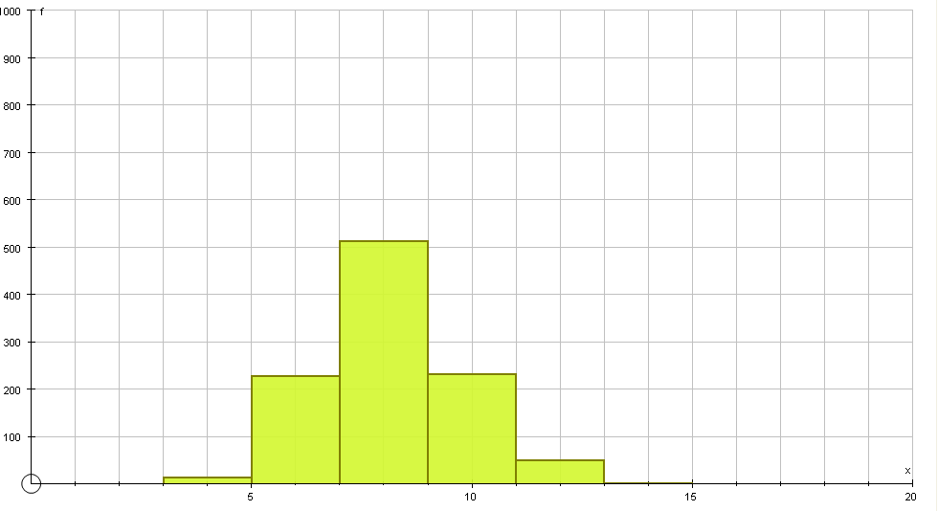
Pint out this histogram and attach to the pupils sheet (File – Print). Note that Autograph 3 automatically labels the axes x and f (these are variables) but the x-axis has not been identified as wind speed. You can label this manually on the print out or find the function within Autograph 3 to do this for you. This frequency diagram can be easily modified if the class intervals are not appropriate. On the bottom left-hand side of the screen will be the data-set. Right-click on this and select ‘edit data set’. Change the min, max and class interval values and once these have been correctly entered, select Recalculate on both the Class Intervals and Frequencies boxes, select the final ‘OK’ and redraw the histogram. What happens to the shape of the diagram and the statistical values?

Write two sentences on what you have found from your analysis on the daily wind speed. Why is the mean different when calculated in excel, from the estimated mean calculated from the frequency table?

