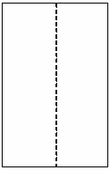
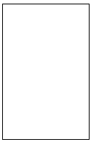
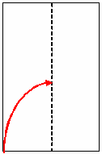
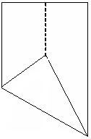
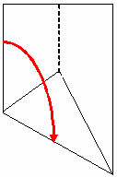
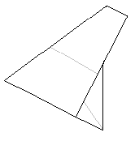
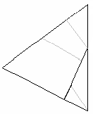
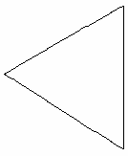
To Make an Equilateral Triangle
Step 1
Fold in half lengthways and then open out again
Hold bottom right corner;
Fold bottom left corner to centre crease
Step 2
Fold the upper part so that the left edge lies along the sloping edge

Step 3
Fold small triangle over to line up with edge
Step 4
Turn over
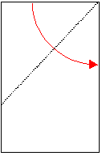
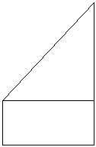
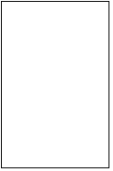
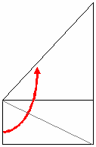
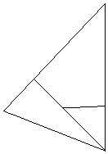
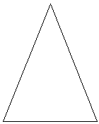
To Make an Isosceles Triangle
fold top left corner until ‘top’ edge lines up along right hand ‘long’ edge
Step 1
Step 3
flip over and turn round
Fold left edge of rectangle to fit along the sloping edge.
Step 2
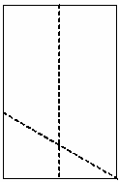
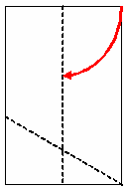
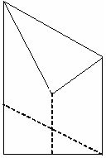
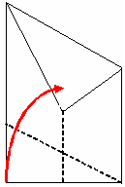
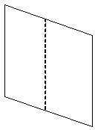
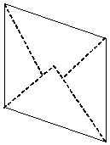
To Make a Parallelogram
Step 1
Fold in half lengthways and then open out again
Hold bottom right corner;
Fold bottom left corner to centre crease
Step 2
Unfold
Repeat with the top right corner

Step 3
Fold bottom left corner back up to the centre crease edge
Step 4
Turn over
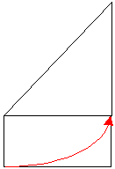
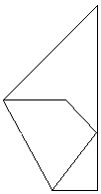
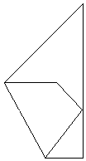
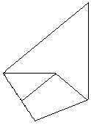
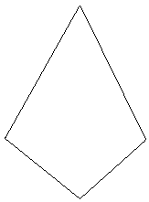
To Make a Kite (2)
Fold top left corner until ‘top’ edge lines up along right hand ‘long’ edge
Fold bottom left corner onto the right-angle of the triangle as shown
(edges should line up)
Flip over and turn round
Step 4
Fold lower right corner to the point shown

Step 1
Step 2
Step 3
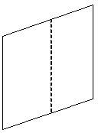
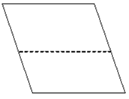
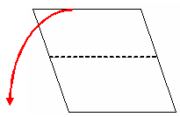
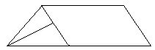
To Make a Trapezium
Step 1
Make a parallelogram
Fold the top backwards along the horizontal crease
Step 2
Turn it round (quarter turn)
Step 3
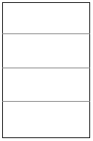
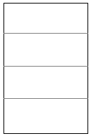
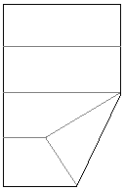
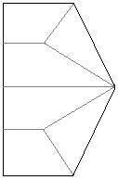
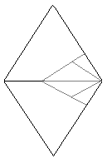
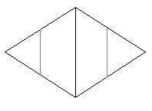
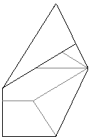
To Make a Rhombus
Step 1
Fold in half, then in half again, and unfold
Hold middle right-hand point and fold the bottom right-hand corner to the quarter line (stretching to middle right-hand point)
Repeat for the top right-hand corner
Flip over and turn round
Fold over ‘edge-to-edge’

(top first; then bottom)
Step 2
Step 3
Step 4
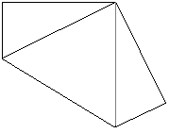
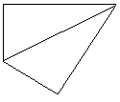
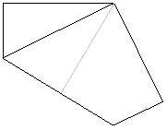
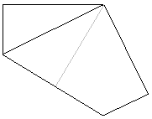
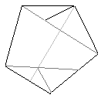
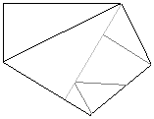
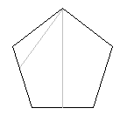
To Make a Pentagon
Fold the bottom left corner to the top right corner
Fold in half …

… and then unfold to show centre crease
Fold lower edge to line up along centre crease
repeat from left side

and turn over
Step 1
Step 2
Step 3
Step 4
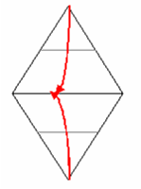
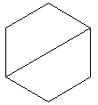
To Make a Hexagon
Step 1
Fold in half, then in half again, and unfold
Hold middle right-hand point and fold the bottom right-hand corner to the quarter line (stretching to middle right-hand point)
Repeat for the top right-hand corner
Step 2
Step 3
Step 4
Fold back along ‘quarter’ lines so that points meet at centre
Fold over ‘edge-to-edge’

(top first; then bottom)
To Make a Football

Use A5 size paper to make 20 hexagons.
(make a rhombus and fold back over quarter folds)

Use A6 size paper to make 12 pentagons.

Begin with a pentagon and stick hexagons to each edge.

Continue the pattern and as the shapes are sellotaped edge-to-edge the 3D football is formed.

