The Story of the Three Bears
Once upon a time there were three bears. There was Father Bear, Mother Bear and Baby Bear. 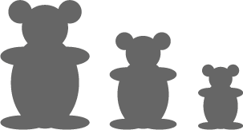
Mother Bear was three quarters the size of Father Bear.
Baby Bear was half the size of Father Bear.
And all the things they had were in the same proportions.

This means that Father Bear's chair was twice as big as Baby Bear's chair and Mother Bear's chair came exactly in between.
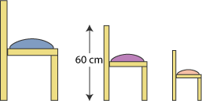

Mother Bear's chair was 60 cm high. How high were the other two chairs?

The diameter across the top of each Bear's porridge bowl was three times the height.

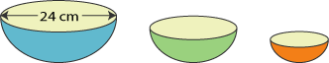

Father Bear's bowl was 24 cm across. What was the diameter of Mother Bear's bowl and the height of Baby Bear's bowl?

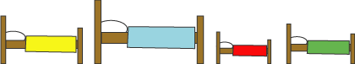
A little girl called Goldilocks lived with the three Bears. Goldilocks had all the same things as the bears, but hers were all sorts of odd sizes, some nearly as big as Father Bear's, and some almost as small as Baby Bear's!

Who did all these beds belong to? You might need to do some measuring!

Father Bear's spoon was 30 cm long. Goldilocks' spoon was five sixths of that.

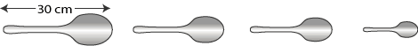
What proportion of Goldilocks' spoon was Baby Bear's spoon?

