Rounding Numbers Activity
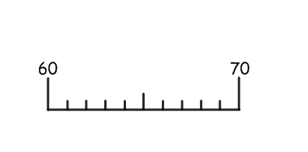 | 3429 | A  600 rounded to the nearest 100
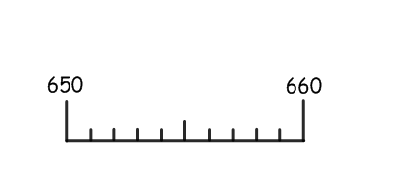 | 3429 | B  8 rounded to the nearest whole number
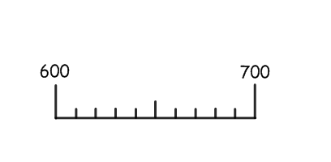 | 3429 | C  14 rounded to the nearest whole number
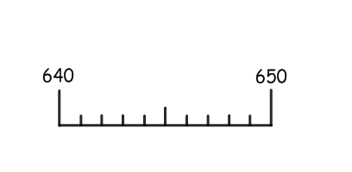 | 67 | D  3400 rounded to the nearest 100
 | 657 | E  34.3 rounded to one decimal place
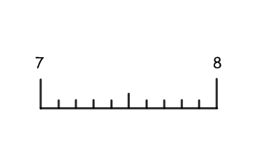 | 657 | F  70 rounded to the nearest 10
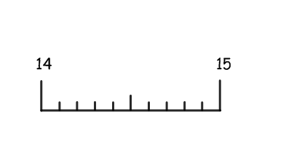 | 34.29 | G  3600 rounded to the nearest 100
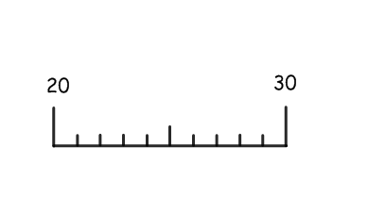 | 34.29 | H  660 rounded to the nearest 10
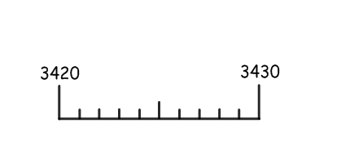 | 649 | I  20 rounded to the nearest 10
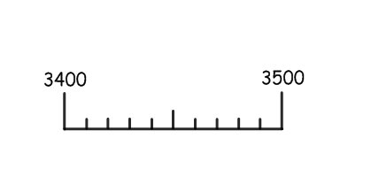 | 649 | J  700 rounded to the nearest 100
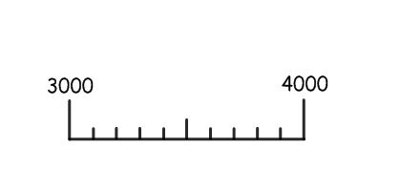 | 7.6 | K  3430 rounded to the nearest 10
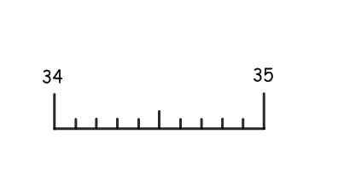 | 34.92 | L  650 rounded to the nearest 10
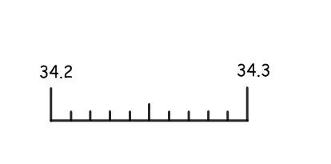 |  | M  3000 rounded to the nearest 1000
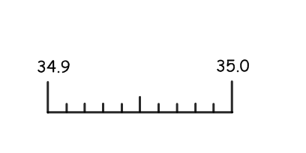 | 14.3 | N  34 rounded to the nearest whole number
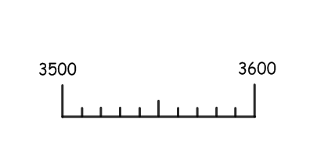 | 24.3 | O

