Number Systems

Babylonian | 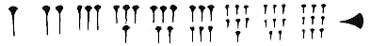
Egyptian | 
Greek | 
Roman | 
Ancient Chinese | 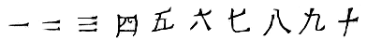
Maya
Hindu
Arabic / European  15th Century | 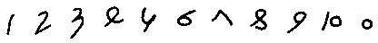
Modern  Arabic / European | 