Early Years Education Plan for Previously looked after children (EPPLAC) and Children with a Social Worker ( CWSW)

Picture of me

All about: (insert name) Date:

I am happy when / I like….:

I am not so happy when / I don't really like…:

I am good at / I'm interested in:

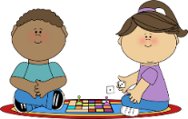
I am trying to get better at:

I wish for:
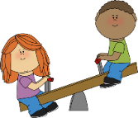
My friends are:

What my parent / carer says about me:

What my key person / teacher says about me:

What other professionals who are supporting me say about me:

My development

In Personal, Social and Emotional Development I can:

In Communication and Language I can:

In Physical Development I can:

In Literacy I can: | In Mathematics I can:
In Understanding the World I can: | In Expressive Arts and Design I can:

My Targets
SMART targets: | How you can help me-include use of EYPP/PP/PPG+ | Evaluation

Transitions
What transitions are due for the child? (please also include changing rooms/key workers etc) *
What will be done to prepare the child for a smooth transition? | Action | By Whom? | When?
*For transitions between Pre-School and reception, it is advisable to plan transition activities and events over a whole year to help the child to prepare.

Signatures
Parent/Carer (name and sign)
School/childcare provider (name and sign)
