[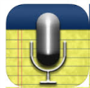](https://itunes.apple.com/gb/app/audionote-notepad-voice-recorder/id369820957?mt=8)[](https://itunes.apple.com/gb/app/morfo/id418900007?mt=8)[](https://itunes.apple.com/gb/app/speak-it!-text-to-speech/id308629295?mt=8)[](https://itunes.apple.com/gb/app/socrative-teacher/id477620120?mt=8)

Secondary Phase iPad Apps to support EAL learners

[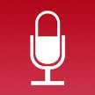](https://itunes.apple.com/gb/app/quickvoice2text-email-pro/id285877935?mt=8)[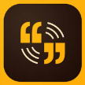](https://itunes.apple.com/gb/app/adobe-voice-show-your-story/id852555131?mt=8)[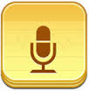](https://itunes.apple.com/gb/app/audio-memos-voice-recorder/id338550388?mt=8)[](https://itunes.apple.com/gb/app/socrative-student/id477618130?mt=8)

[](https://itunes.apple.com/us/app/english-news-in-levels/id1044945336?mt=8)[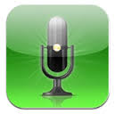](https://itunes.apple.com/gb/app/speakeasy-voice-recorder/id284652710?mt=8)[](https://itunes.apple.com/gb/app/imovie/id377298193?mt=8)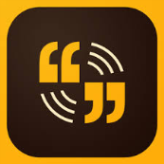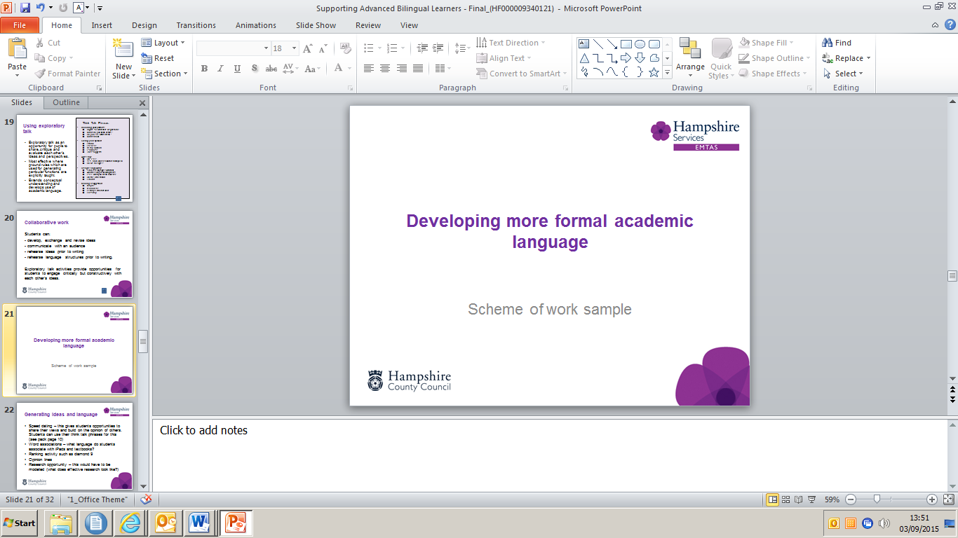

[](https://itunes.apple.com/gb/app/plickers/id701184049?mt=8)[](https://itunes.apple.com/gb/app/qrafter-qr-code-barcode-reader/id416098700?mt=8)

[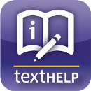](https://itunes.apple.com/gb/app/ireadwrite/id600829238?mt=8)[](https://itunes.apple.com/gb/app/co-writer/id674099732?mt=8)[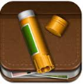](https://itunes.apple.com/gb/app/story-creator-easy-story-book/id545369477?mt=8)[](https://itunes.apple.com/gb/app/halftone-2-comic-book-creator/id603139024?mt=8)[](https://itunes.apple.com/gb/app/comic-life/id432537882?mt=8)[](https://itunes.apple.com/gb/app/bilingual-books/id1138361105?mt=8)[](https://itunes.apple.com/us/app/meegenius!-kids-books/id364734296?mt=8)[](https://tinybop.com/apps/the-human-body)[](https://itunes.apple.com/gb/app/google-earth/id293622097?mt=8)[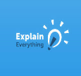](https://itunes.apple.com/gb/app/explain-everything-interactive/id431493086?mt=8)[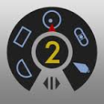](https://itunes.apple.com/gb/app/multi-measures-2-all-in-1/id933528345?mt=8)[](https://itunes.apple.com/gb/app/refme-referencing-made-easy/id553222694?mt=8)[](https://itunes.apple.com/gb/app/wordsalad-beautiful-word-clouds/id545164778?mt=8)[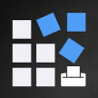](https://itunes.apple.com/gb/app/bingo-card-generator-create/id757575893?mt=8)[](https://itunes.apple.com/gb/app/learnenglish-grammar-uk-edition/id488099900?mt=8)[](https://itunes.apple.com/gb/app/book-creator-for-ipad-create/id442378070?mt=8)[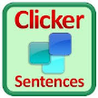](https://itunes.apple.com/gb/app/clicker-sentences/id575603433?mt=8)[](https://itunes.apple.com/gb/app/dragon-dictation/id341446764?mt=8)[](https://itunes.apple.com/gb/app/comic-touch-2/id692819867?mt=8)[](https://itunes.apple.com/gb/app/sayhi-translate/id437818260?mt=8)[Dictionary.com](https://itunes.apple.com/gb/app/dictionary.com-dictionary/id308750436?mt=8)[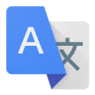](https://itunes.apple.com/gb/app/google-translate/id414706506?mt=8)[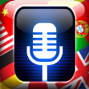](https://itunes.apple.com/gb/app/voice-translate-pro/id539943615?mt=8)[](https://itunes.apple.com/gb/app/itranslate-translator-dictionary/id288113403?mt=8)[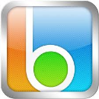](https://itunes.apple.com/gb/app/blio/id409370678?mt=8)[](http://en.childrenslibrary.org/)

Vocabulary

Tools

Writing

Reading

Translation

Speaking and listening