[](https://itunes.apple.com/gb/app/socrative-teacher/id477620120?mt=8)[](https://itunes.apple.com/gb/app/speak-it!-text-to-speech/id308629295?mt=8)[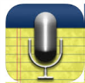](https://itunes.apple.com/gb/app/audionote-notepad-voice-recorder/id369820957?mt=8)[](https://itunes.apple.com/gb/app/morfo/id418900007?mt=8)

Primary phase iPad Apps to support EAL learners

[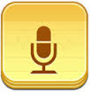](https://itunes.apple.com/gb/app/audio-memos-voice-recorder/id338550388?mt=8)[](https://itunes.apple.com/gb/app/socrative-student/id477618130?mt=8)[](https://itunes.apple.com/gb/app/quickvoice2text-email-pro/id285877935?mt=8)[](http://en.childrenslibrary.org/)

[](https://itunes.apple.com/gb/app/biff-chip-kipper-me-books/id949529768?mt=8)[](https://itunes.apple.com/gb/app/imovie/id377298193?mt=8)[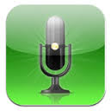](https://itunes.apple.com/gb/app/speakeasy-voice-recorder/id284652710?mt=8)[](https://itunes.apple.com/gb/app/qrafter-qr-code-barcode-reader/id416098700?mt=8)[](https://itunes.apple.com/gb/app/book-creator-for-ipad-create/id442378070?mt=8)[](https://itunes.apple.com/gb/app/learnenglish-grammar-uk-edition/id488099900?mt=8)[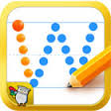](https://itunes.apple.com/gb/app/letter-workbook-learn-to-write/id598875799?mt=8)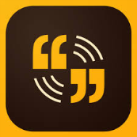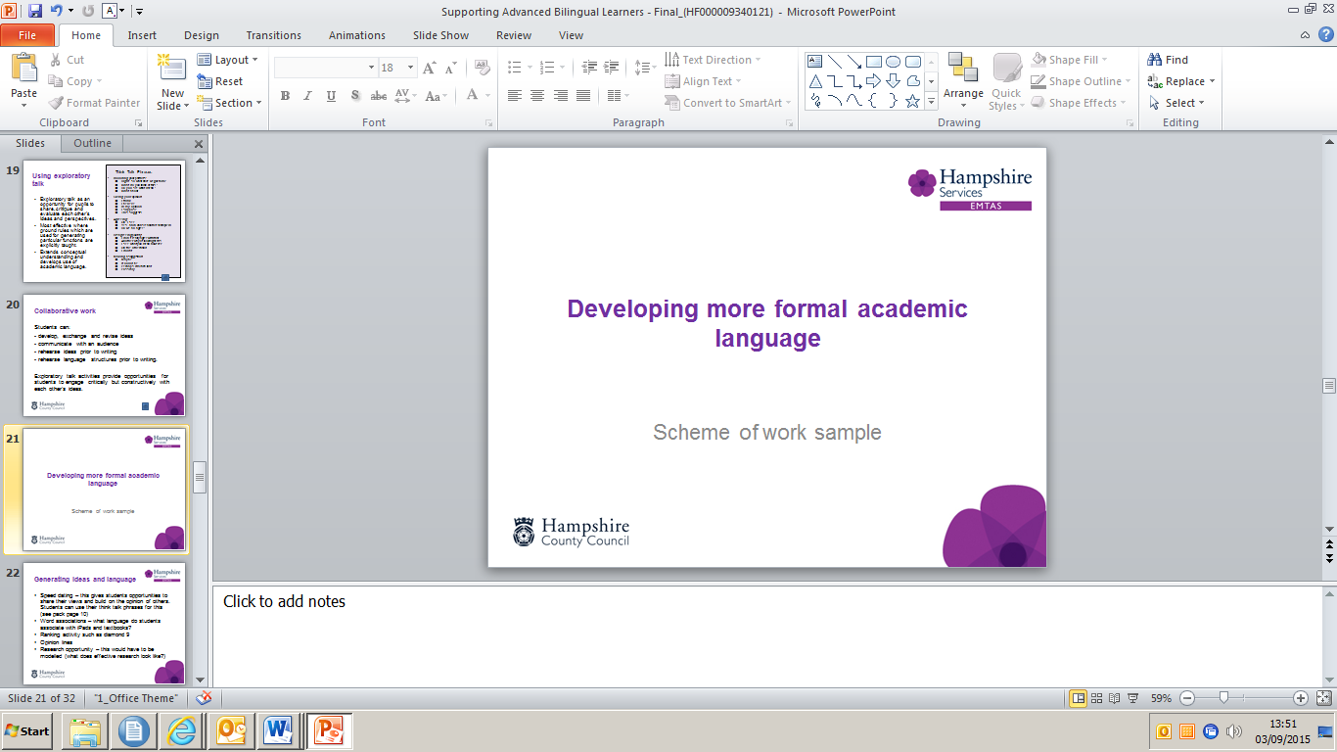

[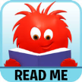](https://itunes.apple.com/gb/app/read-me-stories-learn-to-read/id688065382?mt=8)[](https://itunes.apple.com/gb/app/plickers/id701184049?mt=8)[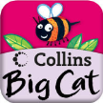](https://itunes.apple.com/gb/app/collins-big-cat-in-garden/id499208536?mt=8)

[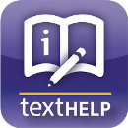](https://itunes.apple.com/gb/app/ireadwrite/id600829238?mt=8)[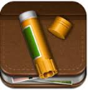](https://itunes.apple.com/gb/app/story-creator-easy-story-book/id545369477?mt=8)[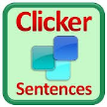](https://itunes.apple.com/gb/app/clicker-sentences/id575603433?mt=8)[](https://itunes.apple.com/gb/app/dragon-dictation/id341446764?mt=8)[](https://itunes.apple.com/gb/app/comic-life/id432537882?mt=8)[](https://itunes.apple.com/gb/app/halftone-2-comic-book-creator/id603139024?mt=8)[](https://itunes.apple.com/gb/app/itranslate-translator-dictionary/id288113403?mt=8)[](https://itunes.apple.com/gb/app/sayhi-translate/id437818260?mt=8)[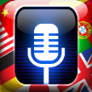](https://itunes.apple.com/gb/app/voice-translate-pro/id539943615?mt=8)[](https://itunes.apple.com/gb/app/bilingual-books/id1138361105?mt=8)[](https://itunes.apple.com/us/app/english-news-in-levels/id1044945336?mt=8)[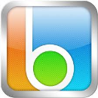](https://itunes.apple.com/gb/app/blio/id409370678?mt=8)[](https://itunes.apple.com/gb/developer/tri-software/id413551271?ign-mpt=uo%3D4)[](https://itunes.apple.com/gb/app/google-earth/id293622097?mt=8)[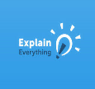](https://itunes.apple.com/gb/app/explain-everything-interactive/id431493086?mt=8)[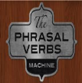](https://itunes.apple.com/gb/app/phrasal-verbs-machine/id593374912?mt=8)[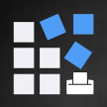](https://itunes.apple.com/gb/app/bingo-card-generator-create/id757575893?mt=8)[](https://itunes.apple.com/gb/app/flashcards*/id403199818?mt=8)[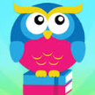](https://itunes.apple.com/us/app/meegenius!-kids-books/id364734296?mt=8)[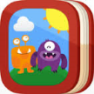](https://itunes.apple.com/gb/app/my-story-book-creator-school/id449232368?mt=8)[](https://itunes.apple.com/gb/app/puppet-pals-hd/id342076546?mt=8)[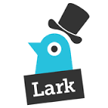](https://itunes.apple.com/us/app/lark-by-storybird.-make-share/id930495608?mt=8)[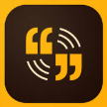](https://itunes.apple.com/gb/app/adobe-voice-show-your-story/id852555131?mt=8)[](https://itunes.apple.com/gb/app/co-writer/id674099732?mt=8)[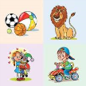](https://itunes.apple.com/MO/app/id591680029?mt=8&ign-mpt=uo%3D4)[](https://itunes.apple.com/gb/app/comic-touch-2/id692819867?mt=8)[](https://itunes.apple.com/gb/app/wordsalad-beautiful-word-clouds/id545164778?mt=8)[Dictionary.com](https://itunes.apple.com/gb/app/dictionary.com-dictionary/id308750436?mt=8)[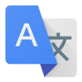](https://itunes.apple.com/gb/app/google-translate/id414706506?mt=8)

Translation

Storytelling

Reading

Vocabulary

Writing

Tools

Speaking and listening