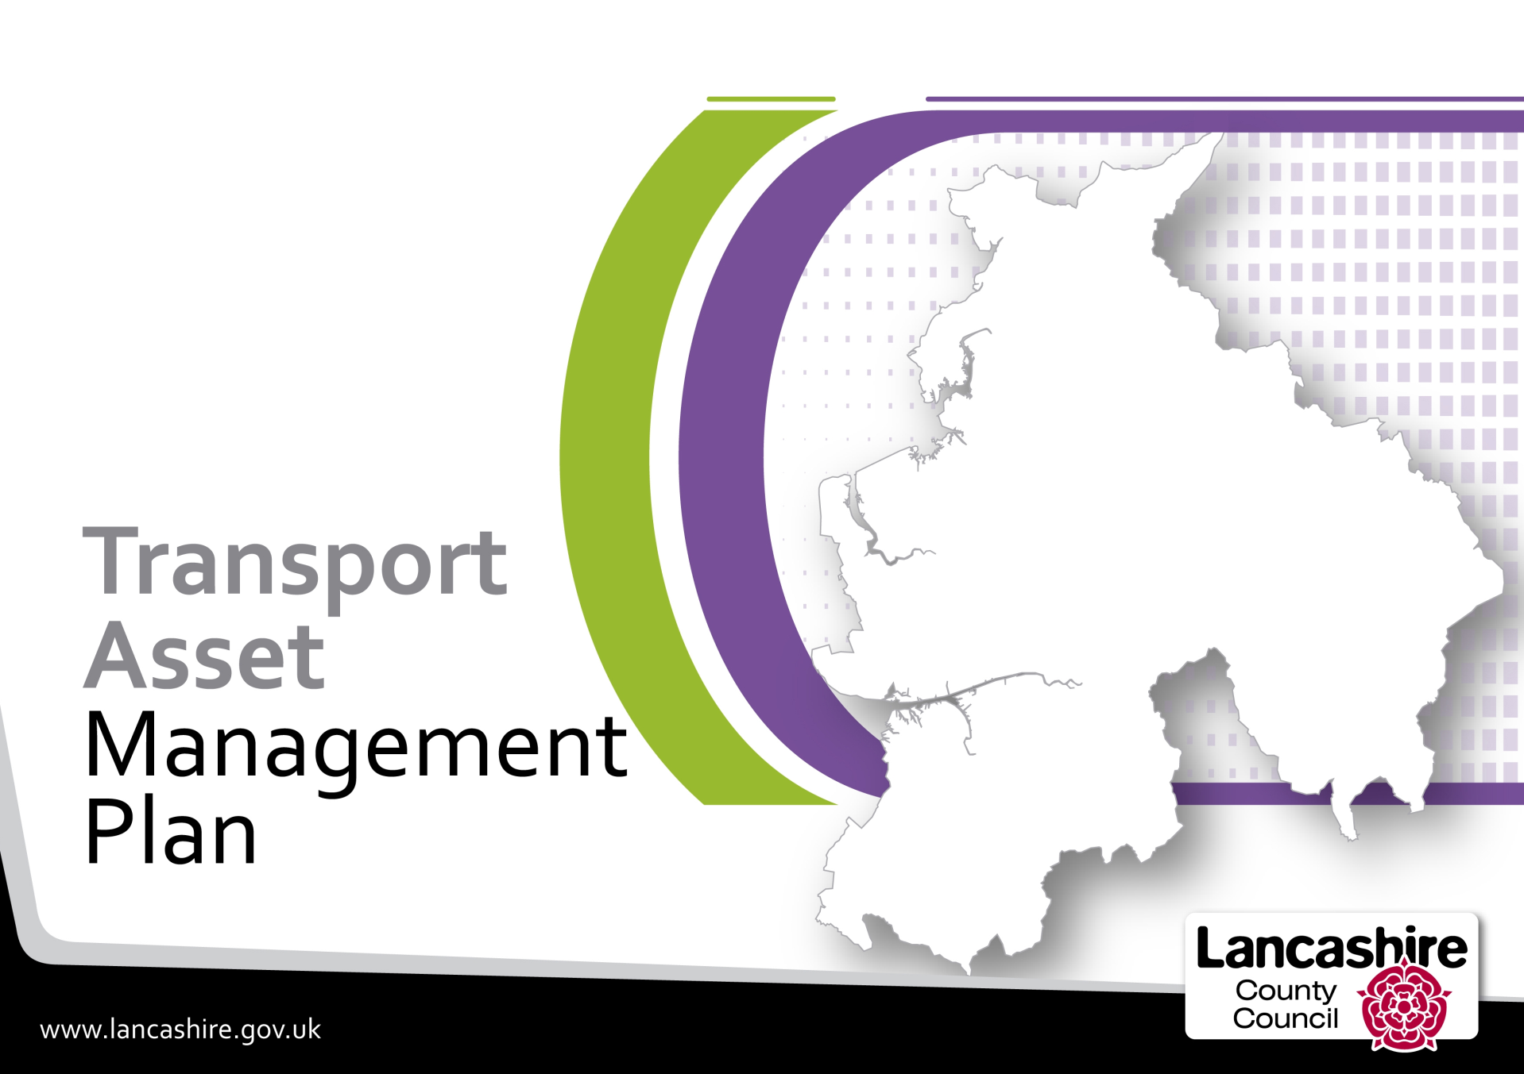
Phase 2 Data Refresh - July 2021
Contents
Section | Description | Page
 | Executive Summary | 3
1 | Introduction | 5
2 | Climate Change challenges and journey towards net zero carbon | 5
3 | Changes to Department for Transport Self-Assessment Criteria | 6
4 | Performance Management | 7
5 | Other Inspections | 8
6 | Customer Feedback | 9
7 | New Service Standards | 10
8 | Revised Asset Condition Data | 11
 | A, B & C Roads | 12
 | Urban Unclassified Roads | 16
 | Rural Unclassified Roads | 17
 | Footways | 18
 | Bridges and Similar Structures | 19
 | Retaining Walls | 20
 | Street Lighting | 21
 | Traffic Signals | 22
9 | Service Standards | 23
10 | Conclusion | 26

Transport Asset Management Plan – Data Refresh July 2021

Executive Summary

The Transport Asset Management Plan (TAMP) was approved by the Cabinet Member for Highways and Transport on 10 June 2014 and identified the key strategic priorities of the county council, as the highway authority for Lancashire, during the period 2015/16 to 2029/30.

TAMP Phase 1 ran from April 2015/16 to March 2020. During this phase our focus of attention was the A, B & C and Footway assets. As a result of works carried out over this period the condition of both these assets as measured by SCANNER (A, B & C Roads) and defects (Footways) showed an improvement.

As we move into Phase 2, our life cycling modelling suggested that additional works were needed to the A, B & C out in order to maintain the progress made in Phase 1 and that the Unclassified Roads which are the focus of Phase 2, are in a poor condition.

The financial constraints that we experienced in Phase 1 are now more acute following a further reduction in funding from the Department of Transport. Throughout Phase 1 we adopted an approach whereby the underlying condition of the network was addressed via the use of early intervention preventative maintenance strategies, as we believed this would enable us to make more efficient use of our resources and this will continue into Phase 2.

This approach has seen improvements in the condition of our A, B & C roads which are now in a better condition than they were in 2009 and since 2014, we now have 513.65 km less of 'red' or 'amber' sections of road which is a reduction of almost 44%.

More than a quarter of the unclassified residential and unclassified rural roads are end of life (RED) and this backlog will not be addressed before the end of Phase 2 (March 2025) or even by the end of the TAMP (March 2030) without substantial investment. At the same time, we have been able to currently maintain most many of other assets in a similar condition to what they were in 2015; however the scale of the backlog for all asset groups is now becoming apparent as result of Lifecycle Modelling and the overall TAMP objective of getting all assets to a 'good' standard by the end of the TAMP period is unlikely to be met

Emerging problems have been identified with regards street lighting and traffic signal equipment which are showing signs of increased decay due to insufficient funding to address the backlog. Increased column testing (lighting) and funding (signals) are being used to risk manage these assets.

Using the TAMP methodology outlined in Section 6 the overall condition of our highway and transport assets has reduced slightly from last year and is now down from 2.17 to 2.06 which means that overall condition of our assets is regarded as being ACCEPTABLE. Real progress is improving the condition score of our assets dependent upon the condition of our unclassified roads improving.

The principal challenges facing us are:

- How to address the back log in the unclassified network in Phase 2 of the TAMP whilst maintaining the other asset in a safe condition
- Understand the backlog for Street Lights, Traffic Signals and Structures and develop an approach to manging these whilst seeking funding sources
- Develop and understanding of the impact of Highway Maintenance activities on carbon (CO₂e) generation and develop strategies to reduce this during Phase 2 of the TAMP and develop a provisional plan to work towards net zero.

A further report will be produced once we have developed further our understanding of the backlog and the implications for future funding and the road to net zero through lifecycle and carbon modelling.

- Introduction
The Transport Asset Management Plan (TAMP) was approved by the Cabinet Member for Highways and Transport on 10 June 2014 and sets out how the county council intends to manage its transport assets over the 15-year period from 2015/16 to 2029/30.

In order that the TAMP can remain a live and current document we have provided provide annual updates which contain additional information to supplement the TAMP. It is intended that these updates will provide a summary of external pressures within the highway sector and internal initiatives that will impact of the county council's highway and transport asset network. This first update relating to TAMP Phase 2 includes information relating to:-

- Climate Change challenges and journey towards net zero carbon
- Changes to Department for Transport (DfT) self-assessment criteria,
- Performance Management Information
- Customer Feedback
- Revised asset condition data,
- Overall Condition Assessment

- Climate Change challenges and journey towards net zero carbon
In February 2021, Full Council adopted a resolution to set out on an ambitious carbon reduction and nature recovery strategy that seeks to 'transition the Lancashire economy away from carbon by 2030 and address the biodiversity crisis'.

Progress has already been. Work is nearing completion to convert all of our 152,000 streetlights to LED. Since 2009 the county council has cumulatively: -

- reduced carbon emissions by over 86,400 tonnes,
- reduced energy consumption by over 48,189MWh
- saved almost £40m in energy costs.

Through Highway Asset Management and Highway Services we continue to meet with suppliers to understand better the innovations and development in the industry to allow us to assess carbon saving potential in material use and processes.

Fleet Services are purchasing electric vehicles and when opportunities arise highways operational electric vehicles will be purchased and charging facilities developed in the depots.

We recognised that the planned highway capital surfacing programme is a highly carbon intensive programme of works so have begun a journey to ascertain the carbon output of our planned highway carriageway surfacing programme, record and measure changes made to reduce carbon outputs and develop tools to eventually allow us to integrate carbon usage into the asset lifecycle modelling.

The introduction of warm mix asphalt saved 94 tonnes of CO2_{e} last year, while the trialling of foam mixed recycled asphalt saved 97 tonnes. The expansion of the use of foam mix asphalt in 2021 has resulted in a year to date reduction in CO2_{e} of 144 tonnes. The ongoing use of the in-situ recycling process also provides significant CO2_{e} savings.
Monitoring of further opportunities to reduce CO2_{e} emissions associated with the highway capital surfacing programme is ongoing. This includes increasing the recycled aggregate content within asphalt mixes, use of recycled or synthetic binders and additives and alternative manufactured aggregates, all of which are actively being explored.
Our objectives in undertaking this approach are:

- To work in collaboration through the highways sector to establish best practice in carbon modelling and to agree consistency and consensus across the sector in how to measure and model carbon usage for highway works.
- To understand the CO₂e of different products and process.
- To inform the decision-making process when it comes to choice of materials, treatments and intervention timing.

With the overall aim to reduce CO₂e of the highway surfacing programme both in the immediate term and whole life cycle.
Further work will be required on the back of this to produce a road map to establish a provisional plan to work towards net zero.
- Changes to Department for Transport (DfT) self-assessment criteria
In order to encourage local authorities to adopt better asset management policies, strategies and lifecycle planning the DfT introduced changes to the highway maintenance formula funding mechanism.

From 2015/16 each authority was required to undertake a self-assessment against a set of criteria aimed at assessing performance in relation to asset management, resilience, customer, benchmarking and efficiency and operational delivery.

In the first assessment, submitted in January 2016, we considered ourselves to be band 2 authority. As a result of continued progress in 201/17 and onwards, we have considered ourselves to be a band 3 authority which has enabled us to attract 100% of the Incentive funding element. Band 2 authorities are currently only receiving 30% of the Incentive fund.

To ensure that the self-assessment questionnaire remains fit for purpose and continues to incentivise improvement with highway asset maintenance and management, the 2020/21 survey contained additional, non-scoring elements on sustainability. It is anticipated that scope of the questionnaire will be expanded shortly to also include decarbonisation within lifecycle planning and enhancement of net biodiversity. We are currently waiting for guidance on this and on indicative funding levels for 2022/23 and beyond.
Work is ongoing to ensure that we put the necessary policies and procedures in place that will enable us to collect robust evidence in respect of these new areas so that we can retain our Band 3 status.

- Performance Management Information
When the TAMP was introduced in 2014 our emphasis shifted to the use of early intervention preventative maintenance strategies, as we believed this would enable us to make more efficient use of our resources. The emphasis was on collecting condition data for the various highway asset groups to inform investment decisions and to report progress. The condition of the main asset groups as March 2021 is reported further in this document. Additionally, other Key Performance Indicators (KPIs) are collected and reported regularly to the Cabinet Committee for Performance Improvement and the management teams in order to measure the health of the highway service. Below is a summary of those KPIs.

Highway Safety Inspections
An important aspect of this is identifying defects at an early stage in order that repairs can be carried out quickly to stop assets from deteriorating further which may then lead to more expensive repairs being required or increased incidence of injury, damage and third part claims.

In order that we can do this we aim to maintain all aspects of our highway network with specified timescales as set out in our Highway Safety Inspection Policy which can be accessed here.

Our Highway Safety Inspectors look for a range of defects affecting the carriageway, footway, streetlights, signs, bollards and trees.

Highway Safety Inspections
 | 2017/18 | 2018/19 | 2019/20 | 2020/21
Number of Inspections | 34,567 | 35,788 | 34,834 | 34,843
Number on time | 30,473 | 26,142 | 28,337 | 33,286
% on time | 88.16% | 73.05% | 81.35% | 95.53%

Highway Defect Repairs
Having either found a defect, or having a defect reported by members of the public, its important these are fixed as within the timescales specified in the Highway Safety Inspection Policy.

The table below shows our performance over the past 4 years: -

All Safety Defects by Financial Year
Year | Total Found | Emergency and Urgent (Category 1) |  |  | Non-Urgent (Category 2)
 |  | Found | Fixed | % Fixed on time | Found | Fixed | % Fixed on time
2020/21 | 58,681 | 1,341 | 1,165 | 87% | 57,340 | 50,645 | 88%
2019/20 | 49,295 | 1,263 | 1,165 | 92% | 48,032 | 44,614 | 93%
2018/19 | 43,848 | 1,335 | 646 | 48% | 42,513 | 35,591 | 84%
2017/18 | 55,166 | 1,793 | 152 | 8% | 53,373 | 35,477 | 67%

Category 1 defects include those that are extremely hazardous and require either emergency or urgent attention because they pose an immediate danger to highway users.

Category 2 defects are those which are deemed not to represent an immediate or imminent hazard and are categorised according to their likely impact and risk probability.

Repair times for both category of defects are contained in Highway Safety Inspection Policy. A summary of 2020/21 highway defects is provided below: -

- 19% overall increase in the number of defects found in 2020/21 compared with 2019/20
- 6,031 more defects fixed on time during 20/21 than the previous year, despite the overall increase in defects found
- Increase in numbers predominantly due to more Category 2 defects being identified,
- distribution of defects found across the year is similar to previous years with 34% of the overall defects found in the period January to March
- Public reported defects represented 31% of all found defects overall

Third Party Claims
Having an effective Highway Safety Inspection and highway defect repair regime helps us to defend ourselves against third party claims under Section 58 of the Highways Act 1980. Our successful repudiation rates with regards third party / vehicle damage claims are increasing as set out in the table below: -

Third Party Claims - Repudiation Rates
Type of Claim | 2019/20 | 2020/21
Personal Injury | 77% | 80%
Vehicle Damage | 56% | 68%

Street Lighting
During the year we have carried out in the region of 3,200 street lighting repairs that caused the light not to work. Whilst most repairs can be carried out without the need for expensive traffic management a small number do so that staff can work safety.

Where traffic management is not required, we aim to fix 90% of faults require within 5 working days. Where traffic management is required, we aim to fix 90% of faults within 20 working days. The results for both category of repairs is shown below: -

non-Traffic Management Repairs |  |  | Traffic Management Repairs
Found | Fixed | % | Found | Fixed | %
3006 | 2742 | 91% | 209 | 185 | 89%

- Other Inspections
In addition to carrying out the above as part of our performance management framework we also carry out other inspections of other asset types as shown below: -

Street Lighting
During the year we also carry out a different type of inspections to our street lighting columns. The table below sets out the number of streetlighting inspections in 2020/21: -

Inspection Type | Number
Routine Column Inspections | 6,991
Column Testing | 3,908

Bridge Inspections
The table below sets out the number of inspections to bridges and similar structures in 2020/21 for which inspection reports have been received: -

Bridges | No.
General Inspections | 1,158
Principal Inspections | 39
Confined Space Inspections | 48
Underwater Inspections | 9
Post tensioned special inspections | 2
Retaining Walls
General Inspections | 708
Signal Gantries / High Mast Lighting Columns
General Inspections | 13

- Customer Feedback
Since 2015 the county council has taken part in the annual National Highways & Transport Network (NHT) survey which collects the public's views on different aspects of highway and transport assets / services in local authority areas. The 2020 survey was sent to 4,800 households and had an overall response rate of 25.7% compared with just above the national average.

We also take part in the On-Line Highway Maintenance Themed Survey in order to get a broader view of opinion. Below are extracts of the Surveys:

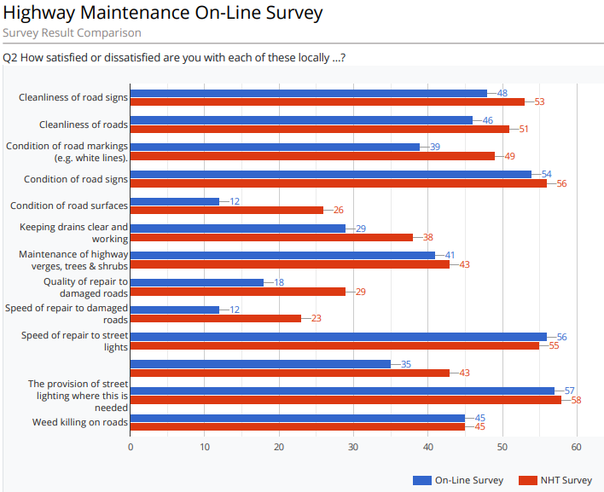

Condition of Road Surfaces, Quality of Repair to Damaged Roads and Speed of Repair to Damaged Roads remain an issue for the majority of residents of Lancashire.

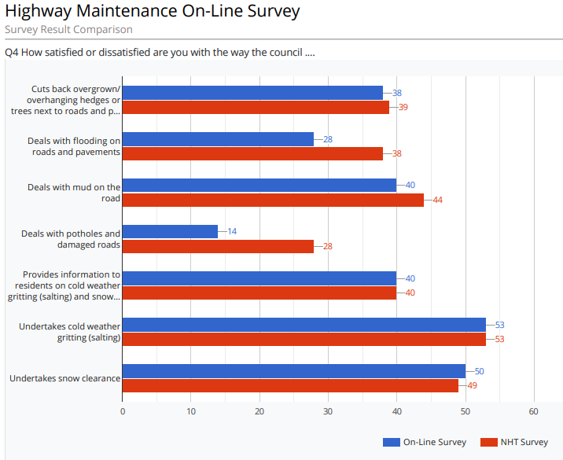

As a result of this feedback over the last few years the county council has undertaken improvements to the way we fix potholes and is introducing improvements in our communications to the public around planned carriageway and footway repairs; including designated webpages explaining various aspects of our approach to carriageway and footway maintenance, which can be found here.

- New Service Standards
New service standards for our Residential Unclassified and Rural Unclassified roads and the footway network are being presented to the September 2021 meeting of the Cabinet for approval. These are based Detailed Video Survey. Currently for which no national standards currently exist. The Department for Transport (DfT) have however started a consultation exercise and it is expected that advice will be available before the end of the current TAMP Phase 2.

Therefore, the Service Standards below are provisional and will be updated the outcome of the consultation exercise is known. Lifecycle modelling during 2021 will help develop targets for end of Phase2 (March 2025) and end of the TAMP (March 2030)

Asset Category | Condition Measure | POOR | ACCEPTABLE | FAIR | GOOD | EXCELLENT | End of Year 1 2020/21
Residential Unclassified | % RED | >25% | 25% - 20% | 20% - 15% | 15% - 10% | ≤10% | 26.74%
 | % AMBER | >40% | 40%-35% | 35%-30% | 30%-25% | ≤25.00% | 20.16%
Rural Unclassified | % RED | >25% | 25% - 20% | 20% - 15% | 15% - 10% | ≤10% | 25.28%
 | % AMBER | >40% | 40%-35% | 35%-30% | 30%-25% | ≤25.00% | 22.33%
Footways | % RED | >25% | 25% - 20% | 20% - 15% | 15% - 10% | ≤10% | 11%
 | % AMBER | >40% | 40%-35% | 35%-30% | 30%-25% | ≤25.00% | 39%

- Revised Asset Condition Data
Since the TAMP was first introduced in 2014 much work has gone into collecting and updating asset condition data and procedures have now been put in place whereby we are able to collect and refresh this data at intervals that are considered appropriate.

The following pages provide a brief summary of the condition of each of the asset groups covered by the TAMP together with a summary of the main points arising out of our analysis of each group. A full explanation of the service Standards can be found in the TAMP Phase 2 document which can be found here

Each section follows a similar basic structure. Where possible graphs will show simultaneously the condition as at the end of Phase 1 and the end of Year 1 (Phase 2). Where possible this will be broken down on a district by district basis.

A summary provides key bullet points which seek to outline briefly the key facts relating to the category of the asset.

A, B and C Roads

Most Cost Effective Strategy: Investment in preventative maintenance using appropriate surface treatments determined through deterioration modelling.
The service standard for this asset grouping is shown below: -
Asset Type | Service Standard | Start Phase2 2019/20 | End Year 1  2020/21 | 2024/25 End of TAMP Phase2 - 5-year target
 |  |  |  | Current Funding Levels | Capital Strategy: Acceptable Risk Managed Funding
A Roads | % Amber | 20.5% | 16.8% | 25.06% - 20.47% | 20.47% - 18.86%
 | % Red | 2.1% | 1.43% | 2.88% - 2.01% | 2.01% - 1.53%
B Roads | %Amber | 22.7% | 21.1% | 29.13% - 22.73 % | 22.73% - 19.63%
 | % Red | 3.09% | 2.7% | 3.73% - 2.19% | 2.19% - 1.95%
C Roads | % Amber | 28.9% | 27.1% | 31.40% - 27.77% | 28.87% - 24.92%
 | % Red | 5.23% | 4.2% | 6.02% - 5.1% | 5.1% - 3.54%

Summary
- The asset consists of a total of 2,567km of highway,
- The length of A, B and C roads classified as RED or AMBER in 2014 was in the region of 1,180 km.
- According to the May 2021 SCANNER survey the quantity of RED or AMBER has reduced by 514km down to 666km, a reduction of 43%
- The general improvement in the A, B & C road network has returned many of these roads to their pre-2014 condition across all district areas,
- All districts have seen an overall improvement in the condition of the A, B & C road network

- The proportion of RED or AMBER A, B and C roads varies across the district areas and is shown in the graph above
- Between 2014 and 2021 the Km of RED or AMBER on:-
  - A roads reduced by almost 97 km,
  - B roads reduced by almost 111 km,
  - C roads reduced by neatly 306 km

Provided below are various graphs and charts showing the condition of this asset grouping over time

Urban Unclassified Roads

Most Cost Effective Strategy: Investment in preventative maintenance which is based on appropriate surface treatment in preference to more costly resurfacing of roads.

Summary

- The asset includes approximately 3,130 km of residential roads.
- The rural unclassified and urban unclassified road networks are the main focus of our attention in Phase 2 of the TAMP.
- A new service standard for this asset type was introduced for the start of TAMP Phase 2 and reflects the % of square Kms that are RED or AMBER
- Asset condition is determined by video survey. As this is a different type of survey to SCANNER the results are not directly comparable to the A, B & C road network
- A review is currently taking place by the Department for Transport to help determine common means for expressing carriageway condition across the different mechanisms for measuring condition. This review will help us to develop target conditions for the Unclassified Roads
- Provisionally 26.74% of this network is regarded as RED, 20.16% is AMBER and 53.10% is GREEN and using this condition data is considered to be in a POOR condition

Rural Unclassified Roads

Most Cost Effective Strategy: Investment in preventative maintenance which is based on appropriate surface treatment in preference to more costly resurfacing of roads.

Summary

- The asset consists of approximately 990 km.
- This asset is important to the rural economy and to rural communities
- The rural unclassified and urban unclassified road networks are the main focus of our attention on Phase 2 of the TAMP.
- A new service standard for this asset type was introduced for the start of TAMP Phase 2 and reflects the % of square Kms that are RED or AMBER
- Asset condition is determined by video survey. As this is a different type of survey to SCANNER the results are not directly comparable to the A, B & C road network
- A review is currently taking place by the DfT to help determine common means for expressing carriageway condition across the different mechanisms for measuring condition. This review will help us to develop target conditions for the Unclassified Roads
- Provisionally 25.28% of this network is regarded as RED, 22.33% is AMBER and 52.39% is GREEN and using this condition data is considered to be in a POOR condition

Footways

Most Cost Effective Strategy: Investment in preventative maintenance which is based on appropriate surface treatment in preference to more costly resurfacing of footways.

Summary

- There are over 8,500km of footways in Lancashire.
- Condition data of this asset has been assessed, with effect from April 2020, via video survey.
- Due to several changes since 2014 with regards reporting software and reporting procedures the defects numbers stated in TAMP Phase 1 are not comparable to TAMP Phase 2 figures.
- Almost 7,800 defects were reported in 2020/21, a reduction of almost footway 2,800 defects (26%) from last year. All districts have seen reductions apart from Lancaster (1% increase), Pendle (12%) and Rossendale (37%)
- A review is currently taking place by the DfT to help determine common means for expressing footway condition using different methodologies for measuring condition. This review will help us to develop target conditions for our footway assets. Once we have received this guidance, we will set new service standards.
- Provisionally, 11% of our footways are regarded as RED, 39.2% are AMBER and 50.08% are GREEN and using this condition data are considered to be in a POOR condition.

Bridges and Similar Structures

Most Cost-Effective Strategy: Investment in preventative maintenance which is not based on reconstruction of bridges but on intervention at the appropriate time.

Average BCI CRIT  District No. of Bridges March-2020 March-2021  Burnley 133 80.4 80.4  Chorley 108 87.9 86.5  Fylde 49 82.0 81.6  Hyndburn 78 70.8 69.9  Lancaster 268 83.2 83.4  Pendle 157 83.9 83.5  Preston 142 77.0 76.0  Ribble Valley 265 77.0 77.6  Rossendale 160 78.1 77.1  South Ribble 86 78.6 77.4  West Lancashire 254 81.9 81.9  Wyre 127 85.5 84.6  Total 1827 80.76 80.45 | Maintenance Category Total % Deck Area No. of Bridges March 2020 BCI CRIT March 2021 BCI CRIT  Planned Targeted 69% 566 79.1 78.67  Planned Preventative 21% 663 80.7 80.47  Planned Do Minimum 10% 597 82.46 82.19  Total 100% 1827 80.76 80.45

Summary

- We are responsible for just under 1,850 bridges & similar structures,
- We have good condition information relating to this asset type,
- The service standard was changed at the start of Phase 2 to calculate bridge condition by maintenance category, so funds can be directed more towards our priority structures.
- The condition of our Planned Targeted structures, which are located on strategic and priority routes and account for 69% of all bridge deck area, is considered to be FAIR.
- The condition of our Planned Preventative & Planned Do Minimum structures, which account for just 31% of bridge deck area, but 69% of our bridge stock is considered to be GOOD.
- The Bridges and Similar Structures asset group will be the focus of attention in Phase 3 of the TAMP. During Phase 2 we are looking to maintain the condition of this asset group as close to their April 2020 condition as possible.
- There has been a slight fall in the condition of this asset grouping across all maintenance categories over the past 12 months.

Retaining Walls
Most Cost-Effective Strategy: Investment in preventative maintenance which is not based on reconstruction of retaining walls but on intervention at the appropriate time.

2020/21 | Owner
 | Lancashire CC |  |  |  | Unknown |  | Combined
No. of Walls | 789 |  |  |  | 620 |  | 1409
Length of Walls | 70km |  |  |  | 54km |  | 124km
Maintenance Category | % No. of Walls | % Length | Average of CRIT |  | Average of CRIT |  | Average of CRIT
 | 2021 |  | 2020 | 2021 | 2020 | 2021 | 2020 | 2021
Planned Targeted | 38% | 49% | 74.99 | 75.74 | 69.18 | 69.85 | 72.80 | 73.58
Planned Preventative | 45% | 42% | 74.20 | 73.11 | 65.89 | 66.40 | 69.97 | 69.78
Planned Do Minimum | 17% | 9% | 77.76 | 78.21 | 68.33 | 68.22 | 73.32 | 73.32
Total | 100% | 100% | 75.07 | 74.98 | 67.23 | 67.68 | 71.49 | 71.74

Summary
- Our knowledge of this asset is incomplete in terms of ownership but is slowly improving. We currently have information relating to 1,409 retailing walls which have a combined length of 124km.
- Condition data for retaining walls is collected using the same inspection methodology as we use for bridges.
- We propose to monitor the condition of this asset using the same maintenance categories as we do for bridges,
- Whilst we are aware that some walls have failed in places, resulting in a low wall condition indicator, many of these occurrences are at sections that are in a stable condition and the land supported has found a natural angle and is also stable. In such instances we do not intend to carry out any repairs unless they start to present a safety issue or support to the highway is compromised.
- As unknown walls are an important fabric of the highway, we are collecting condition data in order to monitor their condition and also get an idea as to the extent of these throughout Lancashire,
- Establishing ownership is not always a straightforward issue to resolve, so due to limited resources we would only seek to establish ownership for walls that require works.
- Whilst we have not yet set a formal service standard for this asset type, they are considered to be in a FAIR condition.

Street Lighting
Most Cost Effective Strategy: The risk to the public from a column falling over is generally low; however, over 60% of our columns exceed the age when they should be regularly tested or considered for replacement or removal. The best strategy is to carryout widespread column testing to in order to extend the service life of our columns. Testing will help us to identify and remove those columns most likely to fail. Wherever funds allow, removed columns will be replaced.

Summary
- We are responsible for approximately 151,000 streetlights and 18,097 illuminated signs, bollards, and similar installations.
- LED replacement works commenced in 2009 and using a variety of funding mechanisms it is anticipated that all our streetlights will be LED by October 2021.
- We spend in the region of £4m per year on electricity to run our streetlights, sign, bollards and traffic signals etc,
- At the end of March 2021, we had 14,544 lighting columns that were aged 40 years or older, up from 13,639 at the start of Phase 3. By March 2024 we anticipate that this will have increased to over 31,000
- The current condition of the stock is considered to be ACCEPTABLE and is expected to deteriorate further by 2024 as shown above.
- In order to maintain the keep pace with the rate of deterioration it is estimated that a capital investment of the order of £6m per annum would be required. The capital investment available for 2021/22 is £1m.
- £500,000 has been allocated from the DfT Incentive Fund for column testing / column replacement work.
Traffic Signals
Most Cost Effective Strategy: Investment in preventative maintenance which is based on replacement of obsolete units at key junctions which will not be covered by Highways and Transport Masterplan activities.

The new traffic signal service standard was only agreed in December 2020 – as a result there is no April 2019/20 start of Phase 2 comparator data.

Traffic Signals Service Standards
Condition Measure | Outturn 2020/21 | Target 2024/25
No. of obsolete and vulnerable traffic signal sites | 337 | 289

Service Standard Grade Boundary
POOR | ACCEPTABLE | FAIR | GOOD | EXCELLENT
>270 | 270 - 201 | 200 -135 | 134 - 70 | <70

Summary
- There are 678 sites in Lancashire which are controlled by traffic signal / pelican crossing installations.
- The condition of the stock is measured in terms of the vulnerable sites, which refers to installations that are older than their 20-year design life and additionally have obsolete controllers age both of which are no longer supported by the manufacturer.
- We currently have a total of 337 installations (50% of the stock) which are classed as vulnerable.
- The condition of this asset type is considered to be POOR
- A breakdown of vulnerable sites traffic signal and pedestrian crossing sites by district is shown in the graph above.
- It is anticipated that without significant investment, the condition of this asset type will remain POOR at the end of Phase 2 in March 2024.
- It is estimated that a replacement programme at a value of £2.2m per year to improve the condition of this asset group to ACCEPTABLE by the end of TAMP Phase 3

- Service Standards

The Service Standards in the TAMP are derived wherever possible from condition data collected by engineering analysis and is used to: -

- Monitor the overall condition of assets,
- Monitor our year on year performance, and
- Compare overall progress against the targets contained in the main TAMP document.

As more condition data becomes available for more asset groupings the performance targets will be updated as appropriate and will be included in a future TAMP refresh documents.

Where it is necessary to change service standard, we will clearly explain why such changes are required and obtain the necessary Member approval.

The main TAMP Phase 2 document identifies 5 service standards of POOR, ACCEPTABLE, FAIR, GOOD and EXCELLENT, against which the benefits to the users of the asset can be measured. Details of the generic levels of service that each of the transport asset groups are likely to provide to users at each service standard are contained in Appendix 1 of the TAMP Phase 2 document which can be accessed here.

The condition data contained in this data refresh document enables us to compare our performance against the baseline figure contained in the TAMP and our direction of travel.

The TAMP set an overall indicative service standard target of GOOD to be achieved at the end of period 2020/21-2024/25. In setting an overall indicative service standard target of GOOD it is recognised that it is not possible or affordable to maintain all asset groups to the same level. The targets for individual asset groups have, therefore, been set according to county council priorities, risk and affordability.

The following table details those assets covered in the TAMP and shows the service standards currently being provided by the transport assets.

Given the range of assets covered by this TAMP, there will inevitably be differences in the condition of each asset grouping. To some extent this is determined not only by the intervention intervals but also treatment and remediation options.

Condition at the start of TAMP Phase 2, end of Year 1 and the end of Phase 2 target at current funding levels as at 2024/25 are shown in the table below. We would have liked to set targets for the end of Phase 3 but due to uncertainty with regards DfT funding this isn't possible at this moment in time.

Asset Category | Start Phase 2 | End Year 1 | End Phase 2
A Roads  (% RED SCANNER) | 2.1% | 1.32% | 2.88% -2.01%
A Roads  (%AMBER - SCANNER) | 20.47% | 15.32% | 25.06% -20.47%
B Roads  (% RED SCANNER) | 3.09% | 2.61% | 3.73 - 2.19%
B Roads  (%AMBER - SCANNER) | 22.73% | 20.55% | 29.13% – 22.73%
C Roads  (% RED SCANNER) | 5.23% | 4.15% | 6.02% - 5.1%
C Roads  (%AMBER - SCANNER) | 28.87% | 26.46% | 31.40% - 27.77%
Residential Unclassified Roads  (% RED– Video Survey) | Not Set | 26.74% | Not Set
(% Amber– Video Survey) | Not Set | 20.16% | Not Set
Rural Unclassified Roads  (% RED – Video Survey) | Not Set | 25.28% | Not Set
(% Amber– Video Survey) | Not Set | 22.33% | Not Set
Footways  (% RED Video Survey)  (% AMBER Video Survey)  Defect Nos | Not Set  Not Set  <10,000 | 11%  39%  7,799 | Not Set  Not Set  <10,000
Bridges & Similar Structures BCI CRIT  Planned Targeted | 78.89 | 78.67 | 80≤ - <90
Planned Preventative | 80.59 | 80.47 | 72 -79
Planned Do Minimum | 83.01 | 82.19 | 65 - 72
Street Lighting  (Number cols ≥ 40 years old) | >16,000 | 14,544 | >16,000
Traffic Signals  (% of vulnerable installations)  *new Service standard agreed December 2020 | 337* | 337 | <289*

The overall condition of the transport infrastructure asset has been determined by assigning scores to each service standard. A weighted score has been produced by multiplying each score by the asset valuation. A weighted average is calculated by dividing the total weighted scoring by the total value of the asset, as detailed below

Scores per Service Standard
POOR | ACCEPTABLE | FAIR | GOOD | EXCELLENT
1 | 2 | 3 | 4 | 5

We are no longer required to collect Whole of Government Account information for highways. Therefore, for consistency purposes and to allow us to monitor progress against the start of the TAMP in April 2015, we will continue to use 2018/19 data throughout Phase 2 of the TAMP.

Asset Condition Summary March 2021

Asset Group | Valuation £ Million | Service Standard | Score | Weighted Score
A Roads % Red | 855 | EXCELLENT | 5 | 4,275
A Roads % Amber |  | EXCELLENT | 5
B Roads % Red | 504 | FAIR | 3 | 1,764
B Roads % Amber |  | GOOD | 4
C Roads % Red | 1,445 | FAIR | 3 | 3,613
C Roads % Amber |  | ACCEPTABLE | 2
Residential Unclassified Roads % Red | 3703 | POOR | 1 | 3,703
Residential Unclassified Roads % Amber
Rural Unclassified Roads % Red | 1161 | POOR | 1 | 1,161
Rural Unclassified Roads % Amber
Footway & Cycleways | 727 | POOR | 1 | 727
Bridges & Similar Structures
Planned Targeted | 1201 | FAIR | 3 | 4,404
Planned Preventative |  | GOOD | 4
Planned Do Minimum |  | GOOD | 4
Retaining Walls | 205 | FAIR | 3 | 615
Street Lighting | 155 | ACCEPTABLE | 2 | 310
Traffic Signals | 19 | POOR | 1 | 19
Total | 9,975 |  |  | 20,591
Weighted Average Score |  | = |  | 2.06

Overall grade boundaries have been determined as follows: -

Overall Service Standard – Grade Boundaries
POOR | ACCEPTABLE | FAIR | GOOD | EXCELLENT
1 to 1.9 | 2 to 2.9 | 3 to 3.9 | 4 to 4.9 | 5

The initial TAMP assessed the service standard to be 2.26 which determined the transport asset to be in an ACCEPTABLE condition. As a result of this data refresh the condition of the service standard has been calculated at 2.06 which places us near the bottom of ACCEPTABLE. As the unclassified roads are our largest and valuable asset we will only be able to bring about significant overall improvements once the conditions of this asset improves.

According to the general service standards set out in Appendix 1, of the TAMP Phase 2 document which can be accessed here, our highway and transport asset network should be regarded as being generally free from critical safety defects, although considerable maintenance backlogs do exist which have accumulated, in general, due to insufficient resources being made available over a period of time to maintain the whole asset base.

- Conclusion
By tracking condition data it has been shown that a change in approach from 'worst first' to a preventative maintenance regime has already had a big impact particularly on the A, B and C road network which has seen the condition of many roads in a number of district areas improve to at least those enjoyed in 2012, as measured by the % or RED or AMBER roads across this network.

A change in approach from allocating funds on a district basis purely according to asset numbers/lengths in favour of a countywide approach where funding is based on 'need', as determined by the relevant condition data, is starting to have the desired effect of 'normalising' the condition of each asset grouping across Lancashire. This approach needs to be continued so that all our residents and service users are able to benefit from the same service standard regardless of district area.
Due to continued pressures from the DfT the county council cannot afford to stand still. It needs to continue to adapt and evolve if it is to secure the same level of funding as it does now. Failure to attract sufficient funding will threaten the county council's ability to apply the TAMP principles in future years.
Employing video surveys to determine carriageway and footway condition, as well as using traditional SCANNER surveys, has significantly enhance the county council's knowledge of the condition of all highway and footway assets and will enable us for the first time to carryout 'scenario planning' so that we are able to assess future maintenance costs etc. using different material choices and different intervention levels.

The results of the video survey data may require us to revisit the service standards contained in the main TAMP document as we will for the first time in many years have engineering data for the whole of footway and unclassified road networks.

