Lancashire Archives
Box Making Service
Archival Box Enquiry Form
Please complete both pages of this enquiry form in full and return to: box.clever@lancashire.gov.uk
We will acknowledge your enquiry and send you a quotation by email
Box Clever Job Ref: |  | Customer Ref:
Name / Position: | Click here to enter text.
Organisation: | Click here to enter text.
Billing Address: |  | Delivery Address (if different):
Click here to enter text. |  | Click here to enter text.
Phone No.: | Click here to enter text. | Tick this box if you wish to collect goods: |  | ☐
Email: | Click here to enter text. | Fax No.: | Click here to enter text.

HOW TO MEASURE FOR BOXES
Please give the maximum dimensions of the object(s) to be stored inside the box, in millimetres.
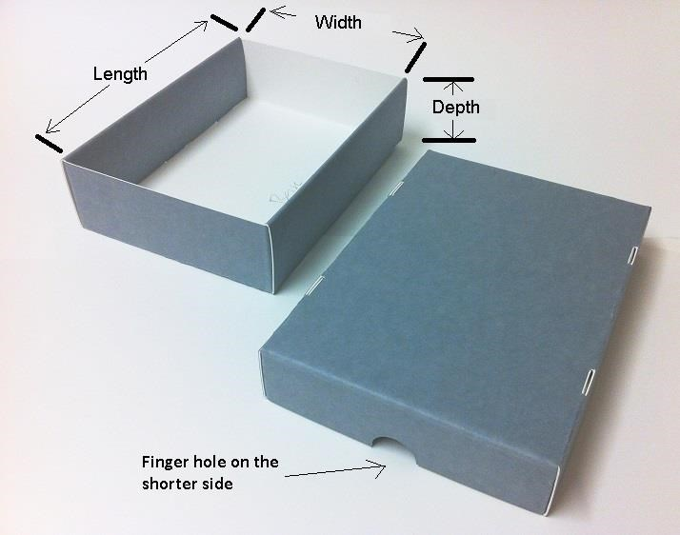
- LENGTH:
The measurement from end to end.
- WIDTH:
The measurement from side to side
- DEPTH:
The measurement of the thickness of the item.
This method of measurement applies to all material including:
- Books and bound items
- Loose sheet items
- Bundled or rolled items
- Photographic, CD, and modern media
- Textiles and garments

Lancashire Archives Box Making Service
Lancashire Record Office, Bow Lane, Preston, PR1 2RE
Email: box.clever@lancashire.gov.uk
Box No. | Qty. | Single Piece Drop Spine | Two Piece Tray and Lid | Size of object to go inside box Dimensions (mm)
FOR INTERNAL USE |  | Please select as required |  | Length | Width | Depth
 | Click | ☐ | ☐ | Click | Click | Click
 | Click | ☐ | ☐ | Click | Click | Click
 | Click | ☐ | ☐ | Click | Click | Click
 | Click | ☐ | ☐ | Click | Click | Click
 | Click | ☐ | ☐ | Click | Click | Click
 | Click | ☐ | ☐ | Click | Click | Click
 | Click | ☐ | ☐ | Click | Click | Click
 | Click | ☐ | ☐ | Click | Click | Click
 | Click | ☐ | ☐ | Click | Click | Click
 | Click | ☐ | ☐ | Click | Click | Click
 | Click | ☐ | ☐ | Click | Click | Click
 | Click | ☐ | ☐ | Click | Click | Click
 | Click | ☐ | ☐ | Click | Click | Click
 | Click | ☐ | ☐ | Click | Click | Click
 | Click | ☐ | ☐ | Click | Click | Click
 | Click | ☐ | ☐ | Click | Click | Click
 | Click | ☐ | ☐ | Click | Click | Click
 | Click | ☐ | ☐ | Click | Click | Click
 | Click | ☐ | ☐ | Click | Click | Click
 | Click | ☐ | ☐ | Click | Click | Click
 | Click | ☐ | ☐ | Click | Click | Click
 | Click | ☐ | ☐ | Click | Click | Click
 | Click | ☐ | ☐ | Click | Click | Click
 | Click | ☐ | ☐ | Click | Click | Click
 | Click | ☐ | ☐ | Click | Click | Click
 | Click | ☐ | ☐ | Click | Click | Click
 | Click | ☐ | ☐ | Click | Click | Click
 | Click | ☐ | ☐ | Click | Click | Click

